Record of Revisions

Revision | Date | Description of Changes
0 | 10/XX/2006 | Initial Issue

Applicability
This procedure covers the process for archiving construction information for the NCSX Project.

Introduction
Currently PPPL has both a UNIX-based and a Windows-based server. Both are accessible via the PPPL ‘P’ Drive on the PPPL Network. The NCSX Engineering Web resides on the UNIX-based server and contains design and other information applicable to the ongoing construction project. This includes technical documentation such as specifications, NCRs, RFDs, ECPs, ECNs, and links to drawings within the INTRALINK system via Fro Tools or Pro/E.

On the Windows-based server, a NCSX Department Page has already been established to store pertinent NCSX administrative information. However, there is also a need to archive pertinent construction information from contracts and in-house manufacturing activities in order to facilitate retrieval of this information if needed to resolve issues that may arise during machine operation that require an understanding of the basis for the machine assembly and final as-built configuration. Currently much of this information resides on individual computers rather within a central repository. The central repository for this information will be a folder (and subsequent subfolders) entitled “Construction Information” that is located within the NCSX Department folder on the PPPL ‘P’ Drive.

This “Construction Information” shall be configured such that contract and PPPL manufacturing activity information is stored in a series of subfolders. Subfolders have been created for major contracts such as the MCWF, VVSA, TF Coils, etc. have been established as well as other internal PPPL activities such as Modular Coil Winding, Dimensional Control and Metrology Data, NCSX Test Cell, etc.. Other subfolders will be added at the appropriate time.
The organization of these major subfolders and lower level subfolders will be left to the Cognizant Engineer/ATI/Job Manager/PTR who heads up that specific area. All personnel within the PPPL domain will have “read” access to the folders within the “Construction Information” folder. Read-Write privileges will be limited to a small number of NCSX personnel and will be based on recommendations by the Cognizant Engineer/ATI/Job Manager/PTR who heads up that specific area. Personnel not normally within the PPPL domain can also have access provided that they have established PPPL accounts and have a secure key fob needed for authentication through the PPPL firewall.
The administration of the Window-based server rests within the Operations and User Support Group within the PPPL Computer Division. They initially set up the “Construction Folder” and its subfolders and have the established the groupings of personnel having read-write privileges for each folder and subfolder. Once established, these groups can change permissions, but only the Operations and User Support Group can add or delete persons within a group.
What should be posted in these folders? The following bullets provide general guidelines as to what and should not be included:
- What Should be Archived?
  - Project discussions/basis of decisions on NCRs, RFDs, etc.
  - Schedules, periodic status reports, etc.
  - Internal correspondence (e-mails, internal NCRs, etc.)
  - Pictures, etc.
  - Other info deemed retainable by the Cog Engineer or PTR
- What Should NOT be Archived?
  - Routine daily correspondence (e-mails, memos, etc.) that are not pertinent to Project decisions.
  - Project design basis information – this resides on the NCSX Engineering Web
  - Contract sensitive and/or proprietary information or PPPL assessments of supplier performance – this should be filed within very controlled sites or the contract files maintained by the PPPL Procurement Department.
  - Hard copy information (e.g., coil winding data books and run procedures, etc.) that are filed in the PPPL Operations Center.
The “Construction Folder” is intended to be a “user-friendly” media for storing and retrieving construction information. However, it is recognized that, while convenient, electronic information is constantly evolving. Accordingly, the NCSX Project (whether the MIE Construction Project or NCSX Operations) much maintain vigilance to ensure that “new” electronic media systems for CAD and office processing still enable access to the archived information.
Part A of this procedure provides the general process for setting up, storing information, and accessing the folders and subfolders for personnel within the PPPL domain. Part B of this procedure provides the step-by-step process for personnel outside the PPPL domain to gain access.
Referenced Documents
Procedure

Part A – Access to the NCSX Construction Information Within the PPPL Domain
Systems Engineering Support Manager works with the PPPL Computer Division Operations and User Support Group to:
Define and create the initial structure and configuration for the “Construction Information” folder and subfolders within the “NCSX Department” folder on the PPPL ‘P’ Drive. This is a Windows-based folder.
Creates the initial listing of groups with “read” access privileges and those with “read-write” access. Note: all personnel within the PPPL domain should have “read” access.
Notifies lead engineer for each major subfolder that the “Construction Information” folders are available for posting construction-related information.

Lead Engineers post construction information from their personnel computer on the appropriate “Construction Information” subfolders. Notifies the Systems Engineering Support Manager that the information is posted.

NOTE: The organization of the subfolders is left to the Lead Engineer – however, it should be in a logical configuration such that users can easily understand and navigate.
Systems Engineering Support Manager inspects posted information and, if necessary, iterates with the Lead Engineer to improve clarity of information. Once that is done, notifies NCSX Project personnel of that the information is posted and the URL: P:\departments\NCSX\Construction Info
Project Personnel using a PC within the PPPL domain, access this site by:
On “My Computer” select Network Drives => files on ‘pppl.gov’ (P:)
Once on the ‘P’ Drive, select Departments => NCSX => Construction Info
Once within the Construction Info folder, Project Personnel may access any of the subfolders (“read” access only).

NOTE: Attachment 1 to this procedure provides selected screen shots of the expected computer screens a P Cor MAC user should expect to see.

END
A1
(for Macs)

A1

Project Personnel using a MAC within the PPPL domain, access this site by:
Select Go menu => Connect to Server
Will get “Connect to Server Screen” => type in: smb//filesrv.pppl.gov/departments-ncsx$ and hit “Connect”
Authenticate on the SMB/CIFS File CIFS System Authentication screen by typing in:
Work Group or Domain should read: PPPL
Name: Enter PPPL Domain User Name (e.g., HTowner)
Password: Enter PPPL Domain Password
Click “OK”
Should now be on the NCSX Department folder with the “Construction Info” displayed.
Once within the Construction Info folder, Project Personnel may access any of the subfolders (“read” access only).

NOTE: Attachment 1 to this procedure provides selected screen shots of the expected computer screens a P C or MAC user should expect to see.
END

Part B – Access to the NCSX Construction Information from Outside the PPPL Domain

Note: Must have a PPPL User Account and Secure Key Fob in order to access this information.

Project Personnel not on the PPPL Domain, access this site by:
Authenticate through the PPPL Firewall using the VPN: vpn.pppl.gov

Once authenticated, Project Personnel using a PC outside the PPPL domain, then access this site by:
Selecting Map Drive => get a screen that shows:
The Drive => likely will show ‘Z’
File : Insert \\pppl..gov\files
On the same screen, Check the “Another User Block”
Log in using their PPPL User Name (the one they established when they obtained their PPPL secure key fob) => usually in format of XYYYYYY@pppl.gov , where X is typically the user’s first initial and YYYYYYY is the user’s last name.
Complete the login with their PPPL domain user password (the one that was established) when they obtained their PPPL secure key fob.
Once this is done, the user should now be connected to the PPPL Network on the ‘P” Drive.
Once on the ‘P’ Drive, select Departments => NCSX => Construction Info
Once within the Construction Info folder, Project Personnel may access any of the subfolders (“read” access only).

NOTE: Attachment 2 to this procedure provides selected screen shots of the expected computer screens a PC or MAC user should expect to see.

END

Once authenticated, Project Personnel using a MAC outside the PPPL domain, then access this site by using the same processes as for a MAC within the PPPL Domain. (See Part A of this procedure).

NOTE: Attachment 2 to this procedure provides selected screen shots of the expected computer screens a PC or MAC user should expect to see.

END

Using a PC

Step 1: Select “My Computer” and click on “files on ‘pppl.gov’(P)

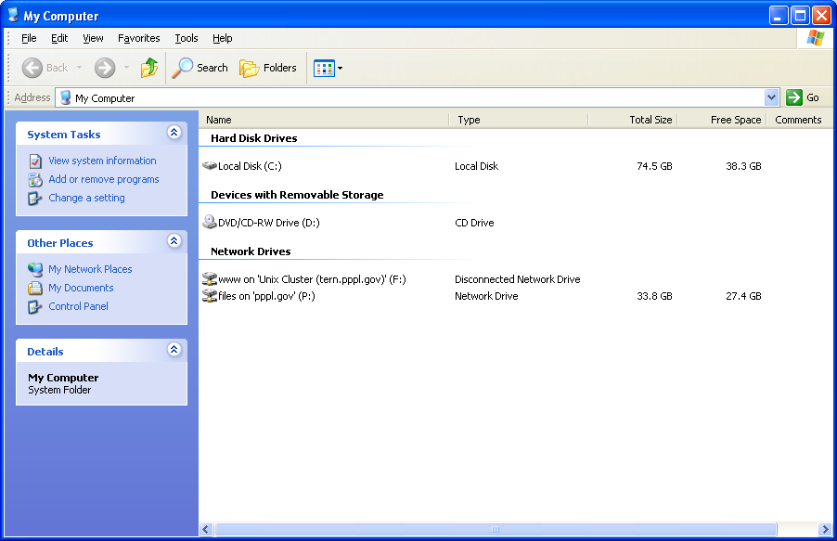
files on ‘pppl.gov’ (P)

Step 2: Select “Departments”

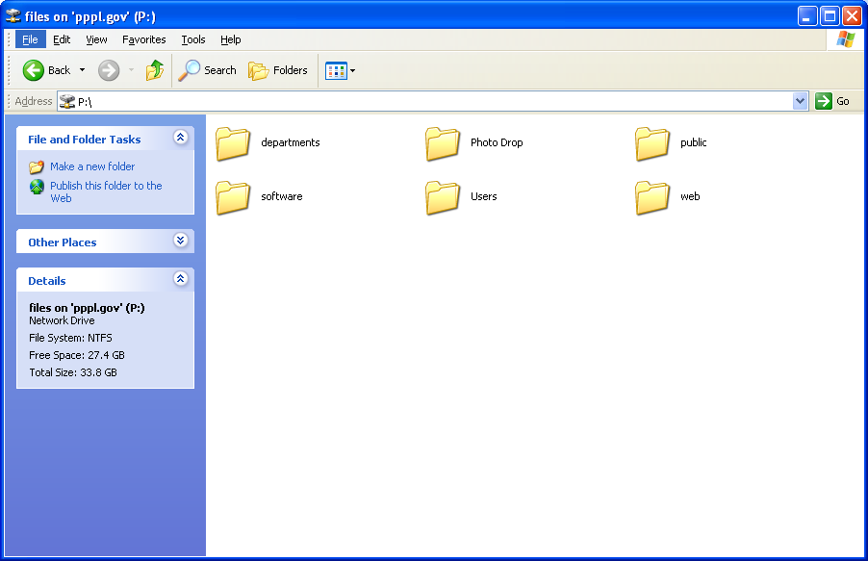
Select “Departments”
Step 3: Select “NCSX”

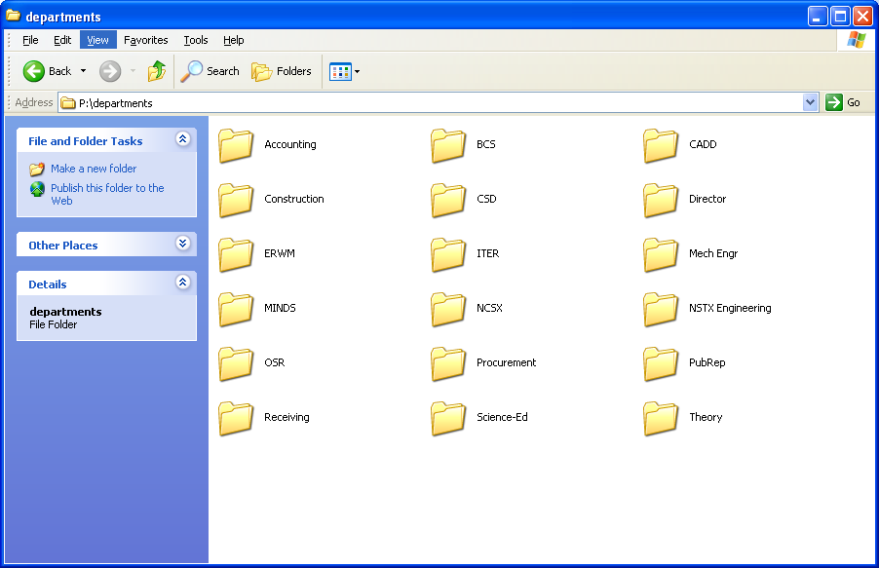
Select “NCSX”

Step 4: Select “Construction Info”

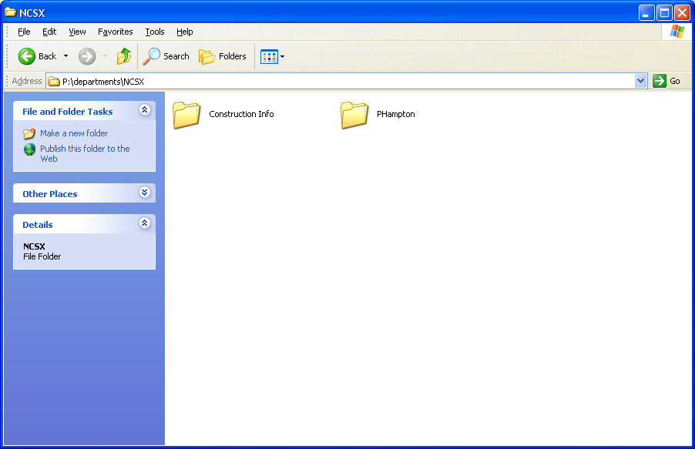
Select “Construction Info”
Step 5: Access Major Subfolders Desired

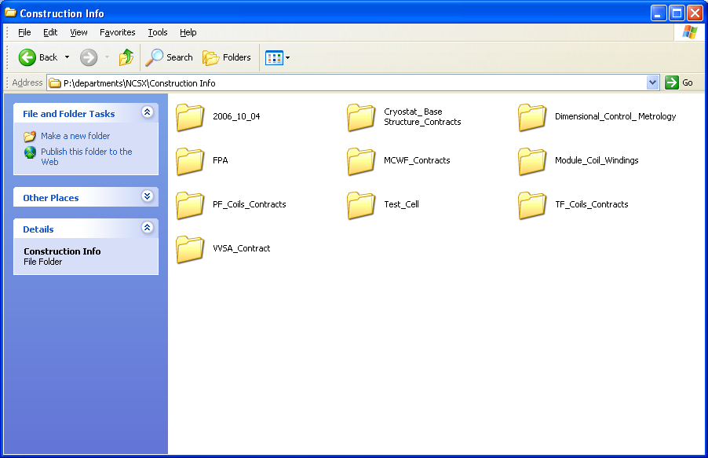
Select Major Subfolder Desired

For Example: Dimensional_Control_Metrology

Step 6: Sample of Subfolders

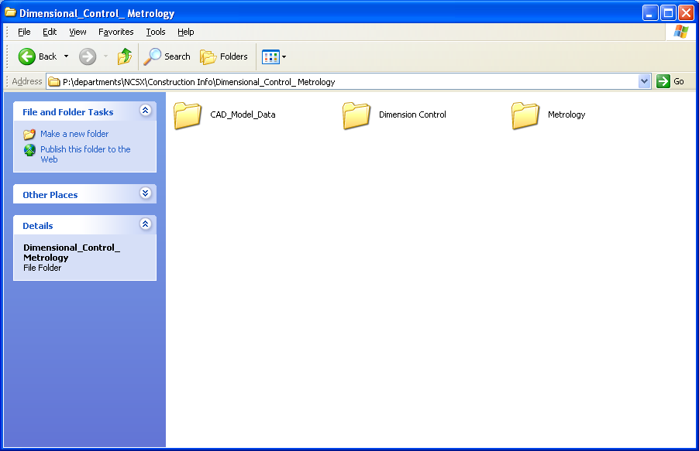
Dimensional_Control_Metrology
Subfolders
Using a MAC

Step 1: Accessing PPPL File Server

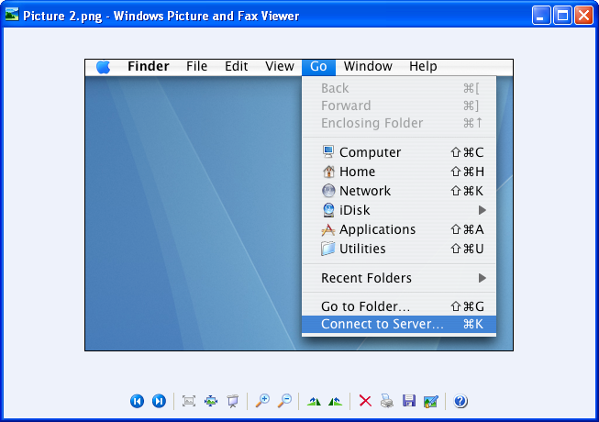
Select “Go” and then “Connect to Server”

Step 2: Insert Server Address: smb://filesrv.pppl.gov/department-ncsx$ to connect to the SMB/CIFS Files. click “Connect”.

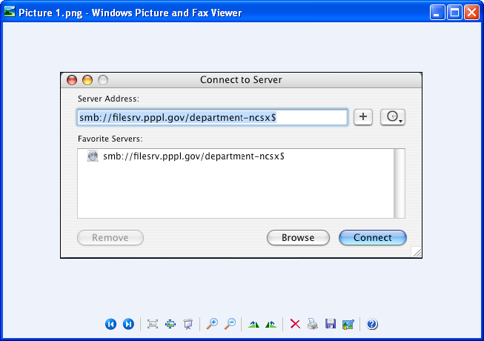

Step 3: SMB/CIFS File System Authentication

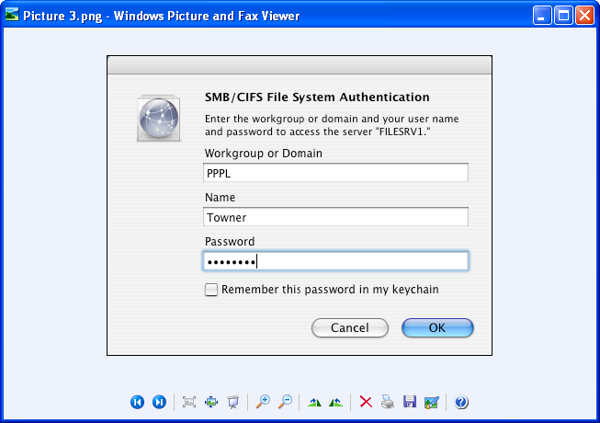
Enter PPPL User Name and Password and Select OK

Step 4: Access “Construction Info” Folder and Subfolders

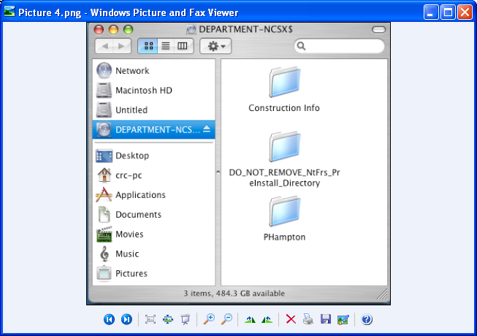
Access “Construction Info” folder and subfolders

In order to access this site from off-site (outside the PPPL domain), the user must have a PPPL User Account and secure key fob.

Using a PC

Step 1: Authenticate Through PPPL Firewall Using VPN

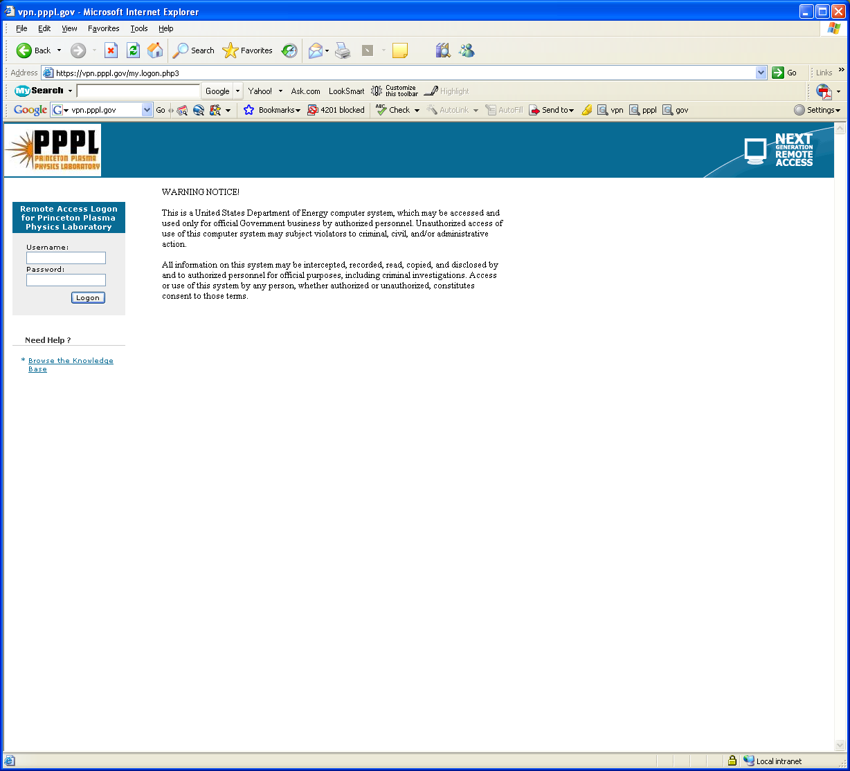
Authenticate through the PPPL Firewall using VPN (vpn.pppl.gov) by:
- Entering your PPPL User name and password (the one you were given once
- Click Logon

Step 2: Map Network Drive (Right Click on My Computer)

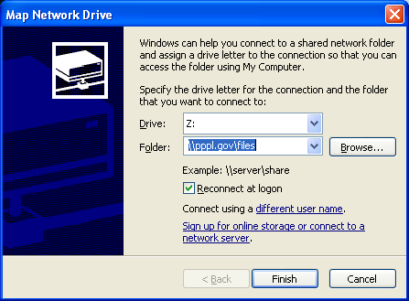
- Drive will likely show up as ‘Z’ or other drive.
- Enter \\pppl.gov\files
- Select “Connect using a different user name.”

Step 3: Logon to \\pppl.gov\files Using PPPL User name in format of XYYYYYY@pppl.gov , where X is typically the user’s first initial and YYYYYYY is the user’s last name (e.g., htowner@pppl.gov) and PPPL Domain password (the one set up when user established his/her PPPL User Account and Secure Key Fob.

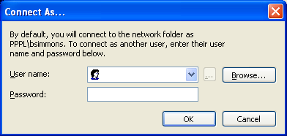

Step 4: Accesss PPPL Network ‘P’ Drive & Select “Departments”

Select “Departments”

Step 5: Follow Steps #3 - #6 from Attachment 1 for the PC

For the MAC

Step 1: Authenticate Through PPPL Firewall Using VPN Using the Process Shown on Step # 1 for the PC.

Step 2: Once Authenticated, Follow Steps #1 - #4 Shown on Attachment 1 for the MAC.

