Record of Revisions

Revision | Date | Description of Changes
0 | 11/XX/2006 | Initial Issue

Applicability
This procedure covers the process for archiving construction information for the NCSX Project.

Introduction
Currently the NCSX Engineering Web resides on the PPPL file server and contains design and other information applicable to the ongoing construction project. This includes technical documentation such as specifications, NCRs, RFDs, ECPs, ECNs, and links to drawings within the INTRALINK system via Fro Tools or Pro/E. This site is open to personnel within either the PPPL or ORNL domain, however, personnel outside these domains will need to authenticate through the PPPL firewall and then enter a user name and password for access.

There is also a need to archive pertinent construction information from contracts and in-house manufacturing activities in order to facilitate retrieval of this information if needed to resolve issues that may arise later in NCSX’s life cycle that require an understanding of the basis for the machine assembly and final as-built configuration. Currently much of this information resides on individual computers rather than a central repository. The central repository for this information will be a web site entitled “Construction Information” that is also located on the PPPL file server. Like the NCSX Engineering Web page, personnel within either the PPPL or ORNL domains will have access while personnel off-site will need to enter a user name and password for access.
This “Construction Information” shall be configured such that contract and PPPL manufacturing activity information is stored in a series of subfolders. Subfolders/Subwebs for major contracts such as the MCWF, VVSA, TF Coils, etc. have been established as well as other internal PPPL activities such as Modular Coil Winding, Dimensional Control and Metrology Data, NCSX Test Cell, etc.. Other subfolders will be added at the appropriate time.
The organization of these major subfolders and lower level subfolders will be left to the Cognizant Engineer/ATI/Job Manager/PTR who heads up that specific area. All personnel within the PPPL or ORNL domains (or those authenticating and entering the proper user name and password) will have “read” access to the folders within the “Construction Information” web. Read-Write privileges will be limited to a small number of NCSX personnel and will be based on recommendations by the Cognizant Engineer/ATI/Job Manager/PTR who heads up that specific area. Personnel not normally within the PPPL domain can also have “read-write” access provided that they have established PPPL accounts and have a secure key fob needed for authentication through the PPPL firewall.
The computer administration of this new web page will be within the Operations and User Support Group within the PPPL Computer Division. They initially set up the “Construction Information Web” and its subfolders and have the established the groupings of personnel having read-write privileges for each folder and subfolder. Once established, these groups can change permissions, but only the Operations and User Support Group can add or delete persons within a group. The User Name and Password can be obtained by an off-site user contacting the NCSX Systems Engineering Support Manager.
What should be posted in these folders? The following bullets provide general guidelines as to what and should not be included:
- What Should be Archived?
  - Project discussions/e-mails/memos that provide the basis of decisions (if not on original documents) on NCRs, RFDs, etc.
  - Schedules, periodic status reports, etc.
  - Internal correspondence (e-mails, memos, etc.)
  - Metrology dimensional control data
  - Pictures, etc.
  - Other info deemed retainable by the Cog Engineer or PTR
- What Should NOT be Archived?
  - Routine daily correspondence (e-mails, memos, etc.) that is not pertinent to Project decisions.
  - Project design basis information – this resides on the NCSX Engineering Web
  - Contract sensitive and/or proprietary information or PPPL assessments of supplier performance – this should be filed within very controlled sites or the contract files maintained by the PPPL Procurement Department.
  - Hard copy information (e.g., coil winding data books and run procedures, etc.) that are filed in the PPPL Operations Center.
The “Construction Folder” is intended to be a “user-friendly” media for storing and retrieving construction information. However, it is recognized that, while convenient, electronic information is constantly evolving. Accordingly, the NCSX Project (whether the MIE Construction Project or NCSX Operations) much maintain vigilance to ensure that “new” electronic media systems for CAD and office processing still enable access to the archived information.
Part A of this procedure provides the general process for accessing the folders and subfolders for personnel within the PPPL domain. Part B of this procedure provides the step-by-step process for personnel outside the PPPL domain to gain access. Part C and D of this procedure address the processes for posting information (for those personnel having “write” access), both within either the PPPL domain (Part C) as well as from outside the PPPL domain (Part D).
Procedure

Part A – Access to the NCSX Construction Information Web Within the PPPL or ORNL Domains (Applicable to PC or MAC Platform)
Systems Engineering Support Manager works with the PPPL Computer Division Operations and User Support Group to:
Define and create the initial structure and configuration for the “Construction Information” web and subwebs within the “NCSX Constuction Information” folder on the PPPL file server. This is a UNIX-based web.
Creates the initial listing of groups with “read” access privileges and those with “read-write” access. Note: all personnel within the PPPL or ORNL domain should have “read” access. Those outside these domains will need to follow the processes outline in Part B of this procedure.
Notifies lead engineer for each major subfolder that the “Construction Information” folders are available for posting construction-related information.

Lead Engineers post construction information from their personal computer on the appropriate “Construction Information” subfolders per Part C of this procedure and notifies the Systems Engineering Support Manager that the information is posted.

NOTE: The organization of the subfolders is left to the Lead Engineer – however, it should be in a logical configuration such that users can easily understand and navigate. Attachment 1 to this procedure outlines the general guidelines to be followed when posting to this web.
Systems Engineering Support Manager inspects posted information and, if necessary, iterates with the Lead Engineer to improve clarity of information. Once that is done, notifies NCSX Project personnel of that the information is posted.
Project Personnel within the PPPL or PPPL domain, access this site by connecting to the NCSX Project Web page (URL: http://ncsx.pppl.gov/) and then selecting the NCSX Construction Information tab (URL: http://ncsx.pppl.gov/NCSX_Construction/Construct_index.html ) under the “Restricted” portion of this web page. Browse to desired subfolder and file.

END
Part B - Access to the NCSX Construction Information from Outside the PPPL or ORNL Domains (Applicable to a PC or MAC Platform)

User connects to NCSX Project Home and NCSX Construction Info page per Part A of this procedure.
Upon prompt dialogue box, User enters proper User Name and Password.
Project Personnel within the PPPL or PPPL domain, access this site and browse subfolders to desired file.

END

Part C Posting Information to the NCSX Construction Information Site from Within PPPL Domain

Project Personnel within the PPPL domain with “write” access, select “My Computer” on the desktop and then “files on ‘pppl.gov’ (P). Next select “web” icon and then “ncsx.pppl.gov”. Finally, select “NCSX_Construction” icon and browse to desired subfolder.
Project Personnel drag and drop desired (files/folders) from personal computer to the desired NCSX_Construction subfolder and notifies the Systems Engineering Support Manager that the information is posted.

NOTE: The organization of the subfolders is left to the Lead Engineer – however, it should be in a logical configuration such that users can easily understand and navigate. Attachment 1 to this procedure outlines the general guidelines to be followed when posting to this web.

NOTE: The organization of the subfolders is left to the Lead Engineer – however, it should be in a logical configuration such that users can easily understand and navigate. Attachment 1 to this procedure outlines the general guidelines to be followed when posting to this web.

C1

C1
Systems Engineering Support Manager inspects posted information and, if necessary, iterates with the Lead Engineer to improve clarity of information. Once that is done, notifies NCSX Project personnel of that the information is posted.

NOTE: Attachment 1 to this procedure provides selected screen shots of the expected computer screens a PC user should expect to see.

END

Part D Posting Information to the NCSX Construction Information Site from Outside the PPPL Domain (ORNL Domain or from Off-Site)

Note: Must have a PPPL User Account and Secure Key Fob in order to access this information.

Project Personnel with “write” access, not on the PPPL Domain, access this site by authenticating through the PPPL Firewall using the VPN: vpn.pppl.gov
PC or MAC?
PC
D1
MAC
D2
Once authenticated, Project Personnel using a MAC outside the PPPL domain, then access this site by :
Access the File Server by selecting “Go” menu item and “Connect to Server”
When “connect to Server” screen appears type in the server address: smb://samba1.pppl.gov and select “Connect.”
When SMB/CIFS File System Authentication appears, enter:
PPPL as the Domain
PPPL User Name
PPPL User Account Password
Select “Okay”
Once on the PPPL File Server (‘P’ Drive) select ncsx.pppl.gov => NCSX_Construction
Once on this site, Project Personnel with “write” access may access post (via drag and drop processes) in accordance with Part C of this procedure.

NOTE: Attachment 2 to this procedure provides selected screen shots of the expected computer screens a MAC user should expect to see.

END

D1
Once authenticated, Project Personnel using a PC outside the PPPL domain, then access this site by:
Selecting Map Drive => get a screen that shows:
The Drive => likely will show ‘Z’
File : Insert \\pppl..gov\files
On the same screen, Check the “Another User Block”
Log in using their PPPL User Name (the one they established when they obtained their PPPL secure key fob) => usually in format of XYYYYYY@pppl.gov , where X is typically the user’s first initial and YYYYYYY is the user’s last name.
Complete the login with their PPPL domain user password (the one that was established) when they obtained their PPPL secure key fob.
Once this is done, the user should now be connected to the PPPL Network on the ‘P” Drive.
Once on the ‘P’ Drive, select Web => NCSX (ncsx.pppl.gov) => NCSX_Construction.
Once within the NCSX_Construction folder, Project Personnel with “write” access may access post (via drag and drop processes) in accordance with Part C of this procedure.

NOTE: Attachment 1 to this procedure provides selected screen shots of the expected computer screens a PC user should expect to see.

END

D2
Attachments:

(1) Selected Screen Shots a PC User Should Expect to See If Posting

(2) Selected Screen Shots a MAC User Should Expect to See If Posting
In order to access this site from off-site (outside the PPPL domain), the user must have a PPPL User Account and secure key fob.

Step 1: If Not on PPPL Domain or Off-Site, Authenticate Through PPPL Firewall Using VPN (Note: Personnel within the PPPL Domain, proceed to Step 4)

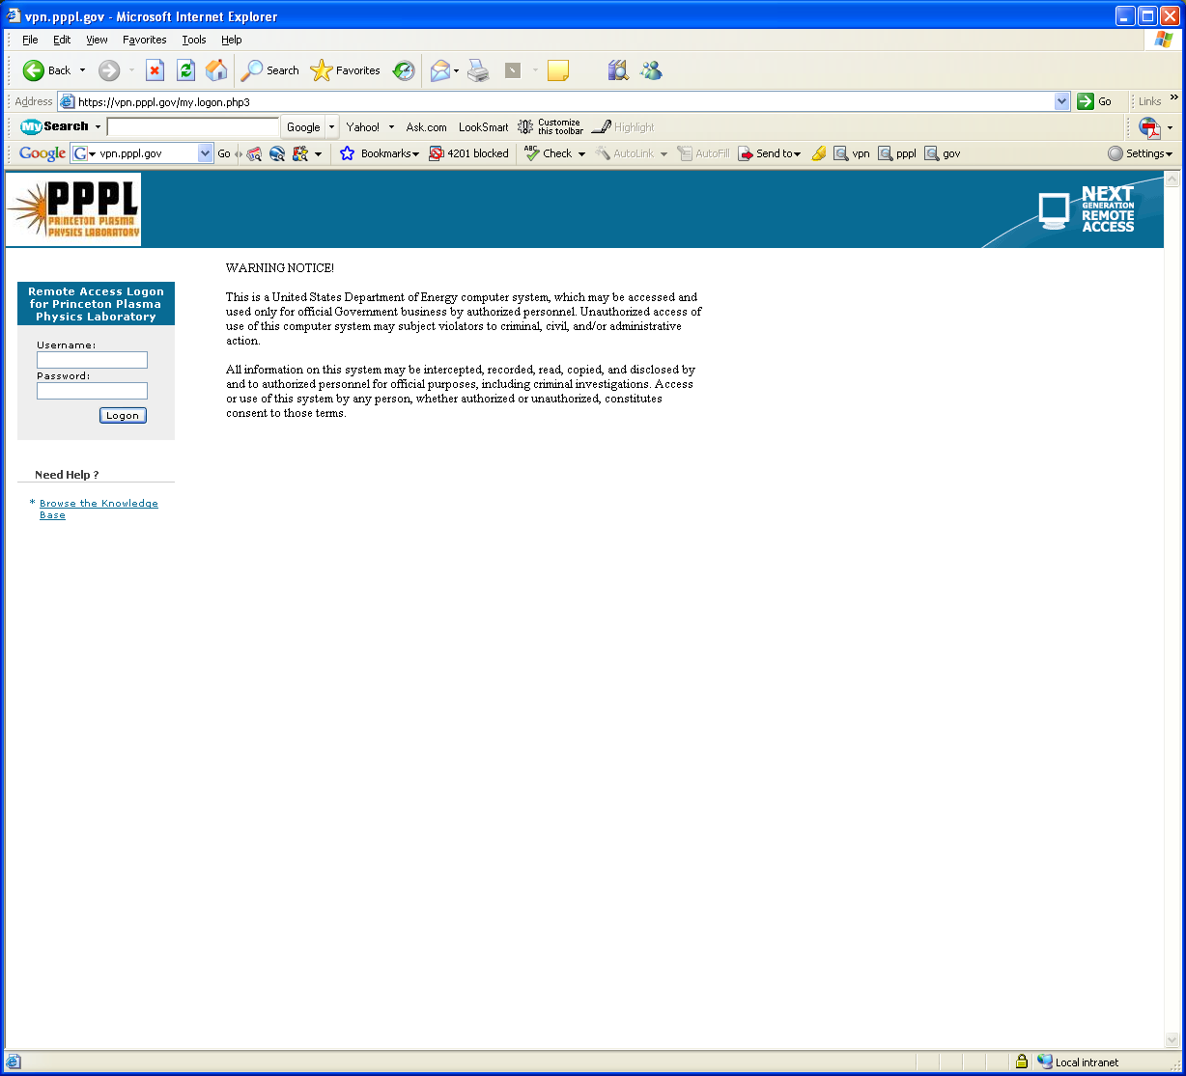
Authenticate through the PPPL Firewall using VPN (vpn.pppl.gov) by:
- Entering your PPPL User name and password (the one you were given once
- Click Logon
Step 2: Map Network Drive (Right Click on My Computer)

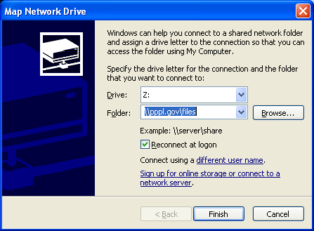
- Drive will likely show up as ‘Z’ or other drive.
- Enter \\pppl.gov\files
- Select “Connect using a different user name.”

Step 3: Logon to \\pppl.gov\files Using PPPL User name in format of XYYYYYY@pppl.gov , where X is typically the user’s first initial and YYYYYYY is the user’s last name (e.g., htowner@pppl.gov) and PPPL Domain password (the one set up when user established his/her PPPL User Account and Secure Key Fob.

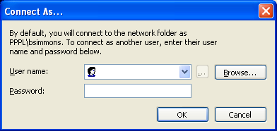

Step 4: Access PPPL Network ‘P’ Drive & Select “Web”

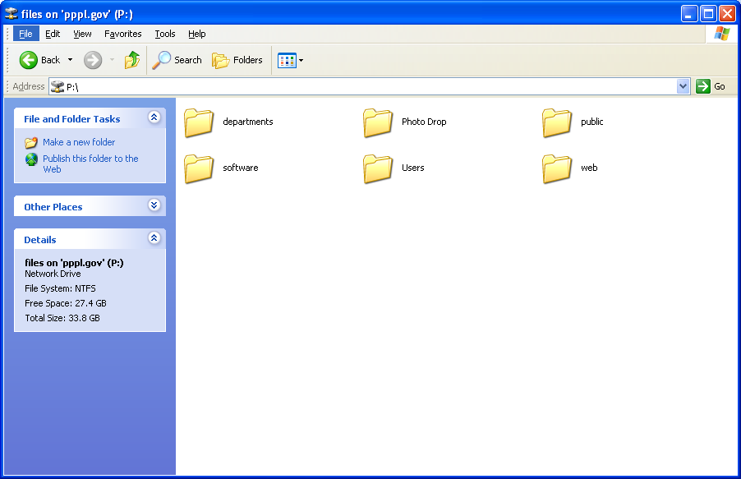
Select “Web”

Step 5: Select ‘ncsx.pppl.gov”, then ‘NCSX_Construction’

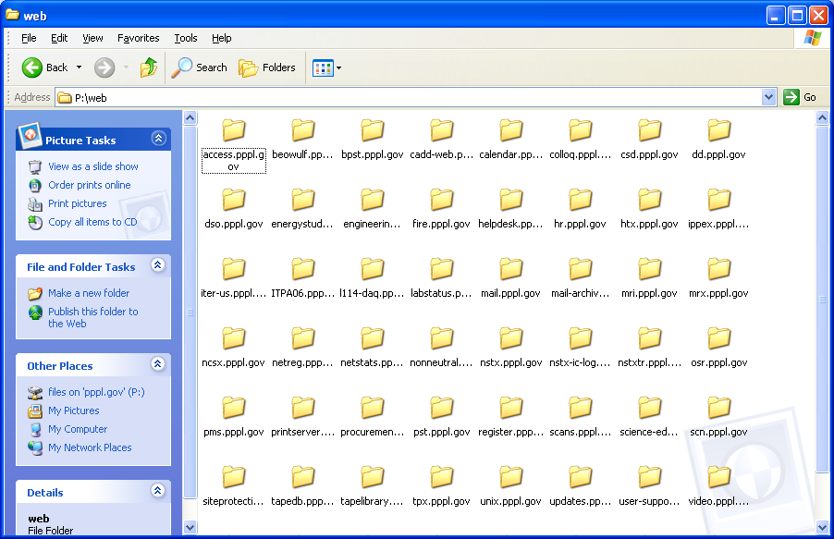
Select “ncsx.pppl.gov”

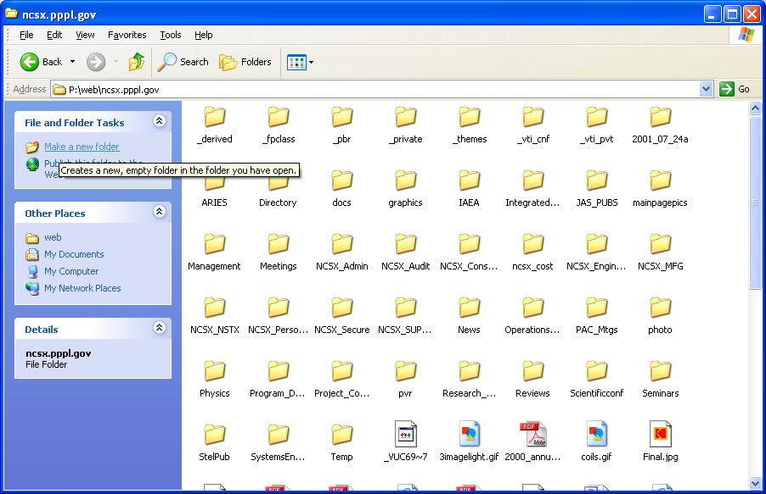
Select “NCSX_Construction”

Step 6: Project personnel with “write” access may drag and drop files/folders from their personal computers to the selected subfolder

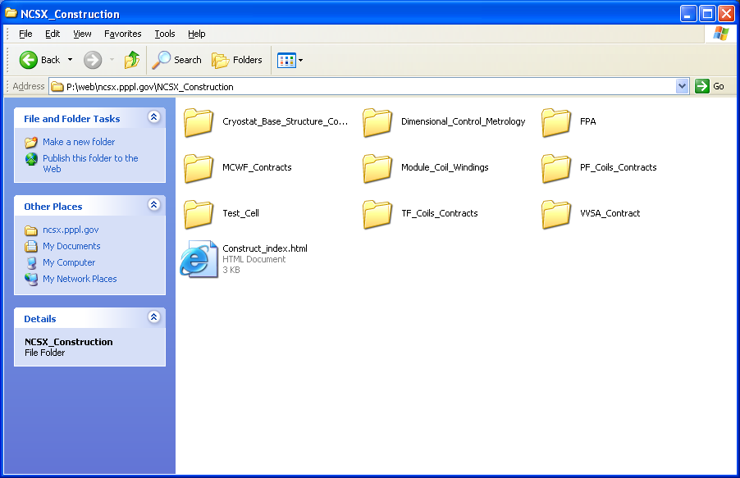
In order to access this site from off-site (outside the PPPL domain), the user must have a PPPL User Account and secure key fob.

Step 1: Authenticate Through PPPL Firewall Using the Same VPN Process Shown for the PC.

Authenticate through the PPPL Firewall using VPN (vpn.pppl.gov) by:
- Entering your PPPL User name and password (the one you were given once
- Click Logon
Step 2: Access the PPPL File Server

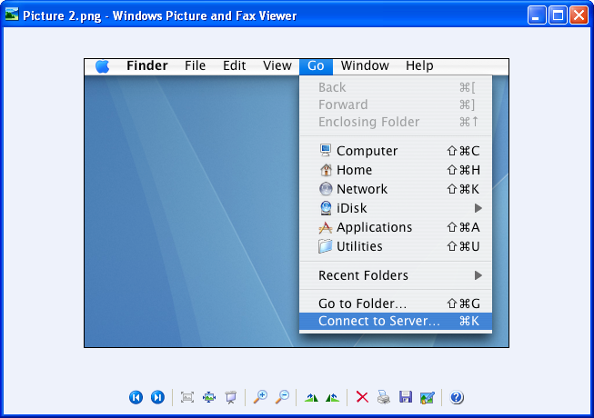
Select “Go” and then “Connect to Server”

Step 3: Insert Server Address: smb://samba1.pppl.gov/web to connect to the SMB/CIFS Files. Click “Connect”.

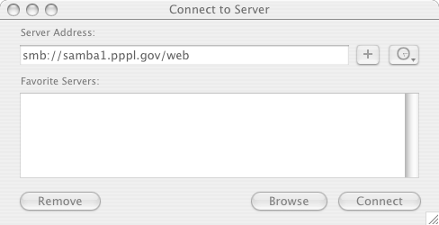
Step 4: SMB/CIFS File System Authentication

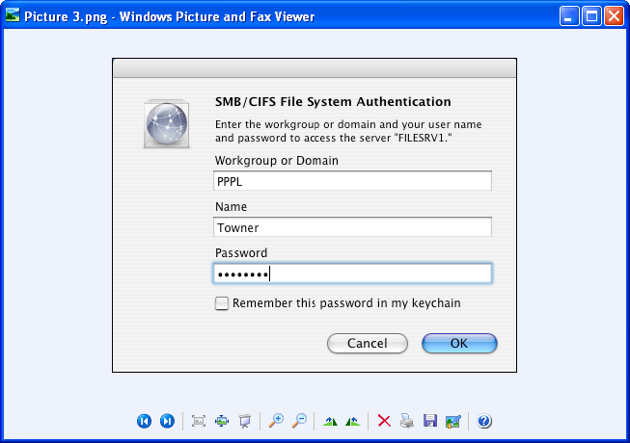
Enter PPPL User Name and Password and Select OK

Step 5: Select “ncsx.pppl.gov” and then “NCSX_Construction” Folder and Subfolders

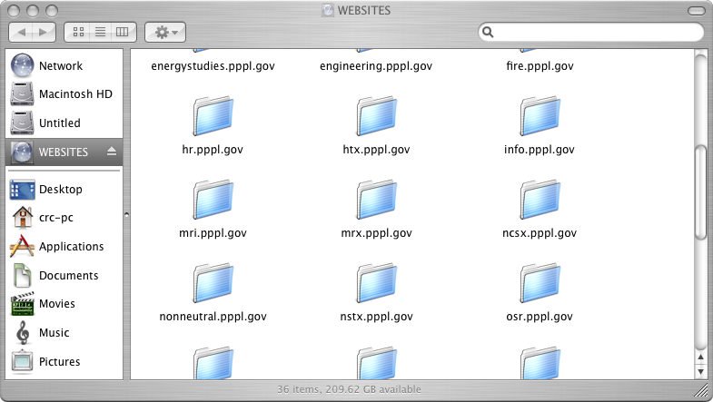

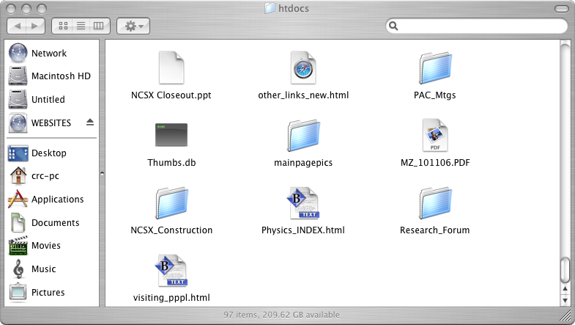

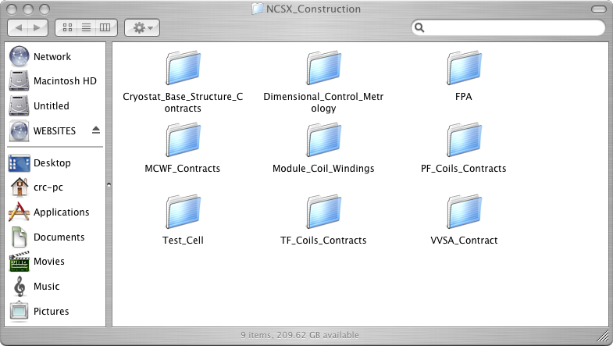
Attachments:

(1) Accessing NCSX Construction Information Web from Offsite

(2) Guidelines for Posting on the NCSX Construction Information Web

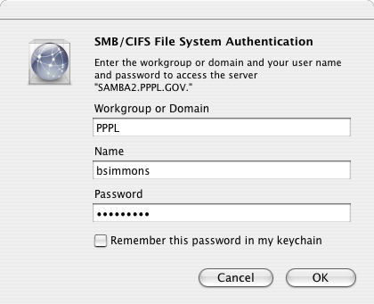

In order to access this site from off-site (outside the PPPL domain), the user must have a PPPL User Account and secure key fob.

Using a PC

Step 1: Authenticate Through PPPL Firewall Using VPN

Authenticate through the PPPL Firewall using VPN (vpn.pppl.gov) by:
- Entering your PPPL User name and password (the one you were given once
- Click Logon
Step 2: Map Network Drive (Right Click on My Computer)

- Drive will likely show up as ‘Z’ or other drive.
- Enter \\pppl.gov\files
- Select “Connect using a different user name.”

Step 3: Logon to \\pppl.gov\files Using PPPL User name in format of XYYYYYY@pppl.gov , where X is typically the user’s first initial and YYYYYYY is the user’s last name (e.g., htowner@pppl.gov) and PPPL Domain password (the one set up when user established his/her PPPL User Account and Secure Key Fob.

Step 4: Accesss PPPL Network ‘P’ Drive & Select “Web”

Select “Web”

Step 5: Select ‘ncsx.pppl.gov”, then ‘NCSX_Construction’

Select “ncsx.pppl.gov”

Select “NCSX_Construction”

Step 6: When prompted, insert the User ID and Password to Gain Access. Note: User ID and Password available from the NCSX Systems Engineering Support Manager.

Step 7: Select the Desired Folder

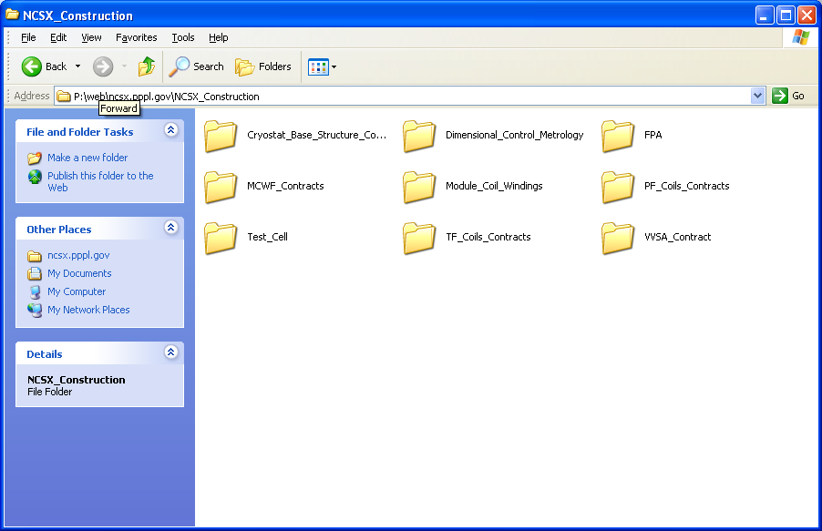
Select Desired Folder
For the MAC

Step 1: Authenticate Through PPPL Firewall Using the Same VPN Process Shown for the PC.

Authenticate through the PPPL Firewall using VPN (vpn.pppl.gov) by:
- Entering your PPPL User name and password (the one you were given once
- Click Logon
Step 2: Access the PPPL File Server

Select “Go” and then “Connect to Server”

Step 3: Insert Server Address: smb://filesrv.pppl.gov/web-ncsx$ to connect to the SMB/CIFS Files. click “Connect”.

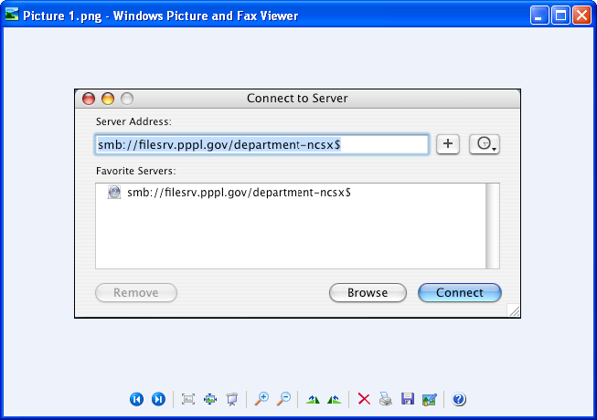

Step 4: SMB/CIFS File System Authentication

Enter PPPL User Name and Password and Select OK

Step 5: Access “Construction Info” Folder and Subfolders

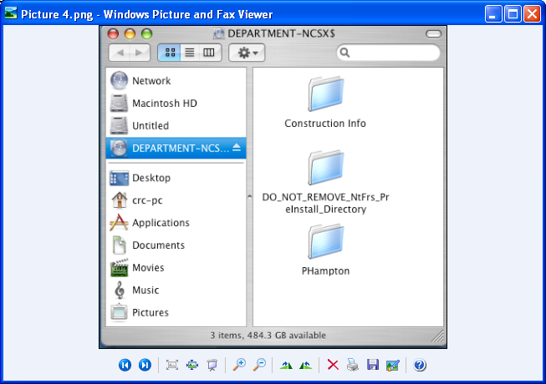
Access “Construction Info” folder and subfolders

