National Compact Stellarator Experiment (NCSX)

Product Specification

Prototype Vacuum Vessel Segment
NCSX-CSPEC-121-01-00
Draft C
13 October 2002

Prepared by:
_______________________________________
P. Heitzenroeder, Technical Representative for WBS 12 Procurements
Concurrences:
_______________________________________
P. Goranson, Vacuum Vessel (WBS 12) WBS Manager
_______________________________________
B. Nelson, Project Engineer for Stellarator Core Systems (WBS 1)
_______________________________________
F. Malinowski, PPPL Procurement QA Representative
Approved by:
_______________________________________
W. Reiersen, Engineering Manager
Controlled Document
This is an uncontrolled copy of a controlled document once printed. Check the PPPL Procurement Web Site (http://oorm-1.pppl.gov/public/procurement/) prior to use to assure that this document is current.

Record of Revisions

Revision | Date | Description of Changes
Rev. 0 | 11/14/02 | Initial release

Table of Contents

1 Introduction and Scope 1
1.1 Introduction 1
1.2 Scope 3
2 Applicable Documents 3
3 Requirements 4
3.1 Item Definition 4
3.2 Characteristics 4
3.2.1 Performance 4
3.2.1.1 Vacuum Performance 4
3.2.1.2 Surface Finish 5
3.2.1.2.1 Interior Surface Finish 5
3.2.1.2.2 External Surface Finish 5
3.2.1.3 Magnetic Permeability 5
3.3 Design and Construction 5
3.3.1 Fabrication Drawings 5
3.3.2 Materials, Processes, and Parts 6
3.3.2.1 Materials 6
3.3.2.1.1 Sheet, Strip, and Plate 6
3.3.2.1.2 Tubing and Pipe 7
3.3.2.1.3 Bar and Structural Shapes 7
3.3.2.1.4 Castings 7
3.3.2.1.5 Conflat Flanges 7
3.3.2.1.6 Weld Filler Metal 7
3.3.2.1.7 Bolts 7
3.3.2.1.8 Copper Seals 7
3.3.2.2 Welding 7
3.3.2.3 Cutting, Forming and Bending 8
3.3.2.4 Cleaning 8
4 Quality Assurance Provisions 8
4.1 General 8
4.1.1 Responsibility for Inspection 8
4.2 Quality Conformance Inspections 8
4.2.1 Verification of Vacuum Performance 8
4.2.2 Verification of Surface Finish 9
4.2.3 Verification of Magnetic Permeability 9
4.2.4 Verification of Dimensions and Tolerances 9
4.2.5 Materials 9
4.2.6 Weld Inspection and Examination 10
4.2.7 Verification of Cutting, Forming, and Bending 10
4.2.8 Verification of Cleaning Requirements 10
4.2.9 Inspection for Internal Defects 10
5 Preparation for delivery 10
5.1 Marking 10
5.2 Crating 11
5.3 Shipping 11

Introduction and Scope

Introduction
Stellarators are a class of magnetic fusion confinement devices characterized by three dimensional magnetic fields and plasma shapes and are the best-developed class of magnetic fusion devices after the tokamak. The stellarator concept has greatly advanced since its invention by Dr. Lyman Spitzer, the founding director of the Princeton Plasma Physics Laboratory (PPPL), during the 1950’s. A traditional stellarator uses only external magnetic fields to shape and confine the plasma. The differentiating feature of a compact stellarator is the use of plasma current in combination with external fields to accomplish shaping and confinement. This combination permits a more compact device. The NCSX project is managed by PPPL in partnership with the Oak Ridge National Laboratory. This Subcontract will be administered by PPPL. Operation of NCSX is scheduled to begin in July 2007.
The vacuum vessel is a key element in the stellarator core. The vacuum vessel is a contoured, three-period torus, which means that its geometry repeats every 120º toroidally. The geometry is also mirrored every 60º so that the first (0º to 60º) segment, if flipped over, is identical to the corresponding adjacent (60º to 120º) segment. The vacuum vessel assembly will be fabricated in three sub-assemblies that are bolted together and vacuum-sealed with double O-rings at flanges on the ends of each segment. Figure 1 shows the vessel segments during manufacture with the port reinforcements installed. The Subcontractor will need to supply temporary segment end covers so each segment can be individually tested.
With the exception of the large vertical ports and the neutral beam port located mid-segment, all port assembly extensions are required to be welded onto the three vessel sub-assemblies after installation of the modular coils and TF coils as part of the NCSX field period assembly operation. Assembly of the modular coils over a vacuum vessel sub-assembly is illustrated in Figure 2. Attachment of the port extensions is illustrated in Figure 3.
The vacuum vessel sub-assemblies will be supported from the modular coil shell structure via adjustable hangers. The interfacing fixed, structural brackets are part of the vacuum vessel assembly. ASME code stamping of the vacuum vessel sub-assemblies is NOT required.
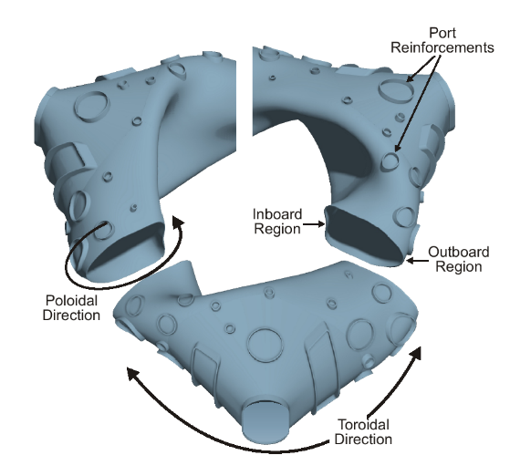
Figure 1 - NCSX vacuum vessel sub-assemblies (partially fabricated)

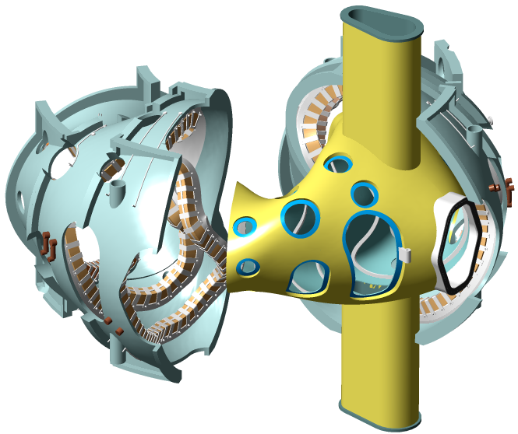
Figure 2 - Modular coils being assembled over vacuum vessel sub-assembly

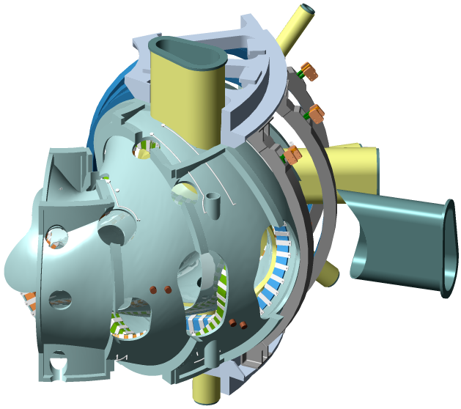
Figure 3 - Port extensions welded on after coils assembled

Scope
This specification establishes the manufacturing and acceptance requirements for the National Compact Stellarator Experiment (NCSX) Prototype Vacuum Vessel Segment (PVVS).

Applicable Documents
The versions of the United States Codes and Standards defined below are to be used in the performance of this work. Other equivalent foreign codes may be proposed:
- ASME B46.1
- ASME SFA specifications
- ASME SFA 5.14
- American Society of Mechanical Engineers (ASME), Boiler and Pressure Vessel Code, Sections V (Articles 6 and 9), VIII (Division 1), and IX, 1998 with 2000 Addendum.
- ASTM B 443
- ASTM B 444
- ASTM B 705
- ASTM B 446
- ASTM A 240
- ASTM A 193
- ASTM A 800
- ASTM Spec. A 494
- AWS D1.6, Paragraph 6.29.1
- MSS SP 54
- American Welding Society (AWS) QC1, Standard and Guide for Qualification and Certification of Welding Inspectors, 1996.
- American Society of Nondestructive Testing (ASNT) 2055, Recommended Practice SNT-TC-1A, 1996.

Requirements

Item Definition
The PVVS is a 20º segment of a full (120º) vacuum vessel sub-assembly. The PVVS extends from 10º to 30º, where 0º marks the center of a full sub-assembly. This section of a full sub-assembly features three ports. The PVVS will feature only one of the three ports. Finished port reinforcement and the associated port extension are to be included as a part of the PVVS. A view of the PVVS is provided in Figure 4.

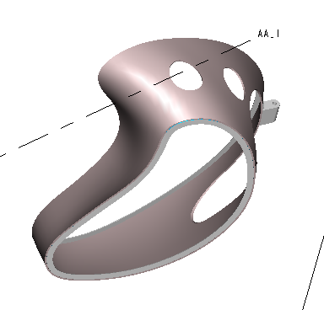
Figure 4 - View of PVVS

Characteristics

Performance

Vacuum Performance
The port extension included in the PVVS is to be leak checked. The port configuration during vacuum leak testing shall be:
- Prior to leak checking, the assembly shall be cleaned as defined in Sect. 3.3.2.4
- Vessel wall inside of reinforcement in place, as shown in Figure 4.
- Conflat flange, port cover, conflat seals and bolts in their operational configuration.
The port under test shall be evacuated using a turbo molecular pump to an internal pressure of <1 x 10⁻⁷ torr. The total helium leak rate for the port extension shall be <1.7 x 10⁻⁹ torr-l/s.

Surface Finish

Interior Surface Finish
Interior surface weld beads, scratches, tooling marks and other surface imperfections resulting from fabrication shall be ground to a 32 micro inch finish and shall be verified per ASME B46.1.

External Surface Finish
Mill finish on the exterior surfaces of the vessel is acceptable.

Magnetic Permeability
Overall relative magnetic permeability of all components fabricated of nickel chromium alloy shall not exceed 1.01.
Overall relative magnetic permeability of all components fabricated of 316 LN Stainless Steel shall not exceed 1.02.
Overall relative magnetic permeability in welds (and heat affected zones) joining 316 LN to nickel chromium shall not exceed 1.2.

Design and Construction

Fabrication Drawings
The Pro/Engineer CAD files listed in Table 1 shall be used to manufacture the PVVS. Tolerance requirements are provided in those drawings.
Table 1 - Fabrication drawings for the prototype vacuum vessel segment

The Pro/Engineer models and drawings of the PVVS are available through the PPPL anonymous FTP server. The following FTP commands can be used to access the files:
ftp> ftp.pppl.gov
User: anonymous <- login as anonymous
Password: <- enter your email address
ftp> cd pub/ncsx/manuf <- lowercase
ftp> bin <- binary transfer mode
ftp> mget * <- retrieve files
ftp> quit

The files may also be accessed through a web browser using the following URL address:
ftp://ftp.pppl.gov/pub/ncsx/manuf/

Materials, Processes, and Parts

Materials

Sheet, Strip, and Plate
All as-supplied sheet, strip, and plate shall be annealed Alloy (UNS N06625) and meet the requirements of ASTM B 443. If casting is proposed by the Subcontractor, samples of after-cast material will be required to be submitted for analysis and approval by the Laboratory with the Approval Data.

Tubing and Pipe
All tubing and pipe shall be seamless or welded Alloy (UNS N06625) and meet the requirements of ASTM B 444 or ASTM B 705.

Bar and Structural Shapes
All bar and structural shapes shall be annealed Alloy (UNS N06625) and meet the requirements of ASTM B 446.

Castings
If the Subcontractor proposes casting of the PVVS, the casting alloy shall be recommended such that properties are similar to Alloy (UNS N06625).

Conflat Flanges
The conflat flange shall be fabricated of 304 stainless steel and meet the requirements of ASTM A 240.

Weld Filler Metal
Weld filler metal shall meet the requirements of the applicable ASME SFA specifications. Welding of stainless steel conflat flanges to Alloy (UNS N06625) ports shall use ASME SFA 5.14 ERNiCr-3 or ERNiCrMo-3 filler metal.

Bolts
Conflat flange bolts shall be ASTM A 193, Grade B8; silver-plated, 12-point bolt kits provided with flanges from the flange manufacturer.

Copper Seals
Conflat flanges shall use standard copper seals provided from the flange manufacturer.

Welding
All welding shall be done in accordance with welding procedures that are written and qualified in accordance with the ASME Code, Section IX. Welds may be made by the GTAW or GMAW processes. Welds using SMAW process are not permitted.

Cutting, Forming and Bending
For the fabrication of the Vessel, all cutting, forming and bending shall be done in accordance with the ASME Boiler and Pressure Vessel Code, Section VIII, Division 1.

Cleaning
After completion of assembly and surface preparation, the PVVS interior shall be cleaned. All surfaces shall be degreased/cleaned using materials and procedures mutually agreed upon. As a minimum this procedure will include:
- Vapor degreasing to remove oils, greases, and die lubricant residues resulting from handling and fabrication of the Vessel.
- Solvent (e.g. ethanol) wipe down of the surfaces.
- Blow drying of surfaces with oil-free instrument air.
- Use of lint-free wipes.

Quality Assurance Provisions

General
Tests shall be conducted at the supplier’s facility or otherwise suitable location.

Responsibility for Inspection
The responsibility for performing all tests and verifications rests with the Subcontractor. PPPL reserves the right to witness or separately perform all tests specified or otherwise inspect any or all tests and inspections.

Quality Conformance Inspections

Verification of Vacuum Performance
Helium leak tests shall be performed to verify that the requirements stated in Sect. 3.2.1.1 are met.

Verification of Surface Finish
The interior surface finish shall be checked with a comparator to verify compliance with Section 3.2.1.2.1. The exterior surface finish shall be visually examined to verify compliance with Section 3.2.1.2.2.

Verification of Magnetic Permeability
Magnetic permeability shall be measured in accordance with the requirements of ASTM A 800, Supplementary Requirement S1 but the measurements shall be taken in relative permeability rather than ferrite content. All surfaces and features shall be checked with a calibrated Severn Permeability Indicator for compliance with Section 3.2.1.6. The surfaces of the PVVS shell and port extension shall be checked and documented in a 6" x 6" grid. The welds at the conflat flanges and at the junction between the port extension, reinforcement, and vessel shell shall be checked every 1/2" (both inside and outside surfaces wherever possible).

Verification of Dimensions and Tolerances
With the PVVS unrestrained on a surface measuring table and the port extension supported to compensate for gravity load, all surfaces and features shall be dimensionally checked on a grid no coarser than 1-inch centers using instruments having resolution at least ten times the tolerance. These measurements shall be compared to the tolerances indicated on the applicable drawings. Verification of dimension and tolerances shall be done both before and after attachment of the port extension.

Materials
Material certifications traceable to the materials used shall be provided as defined below. Subcontractor is to develop and utilize process controls to assure traceability of materials to their certifications.
- N06625: showing actual chemical and physical properties
- Bolts: Manufacturer statement
- Conflat flanges: Manufacturer statement
- Filler metal: showing actual chemical properties
If cast material is used, Subcontractor is to provide verification of properties from test coupons. Properties must meet those specified for Alloy (UNS N26625).

Weld Inspection and Examination
All welds are to be visually inspected using a written procedure prepared in accordance with Article 9 of Section V of the ASME Code. Welds designated with a "V" in the tail of the welds symbol shall also be visually examined with 8X magnification, in accordance with Article 6, Section V, of the ASME Code. The acceptance criteria for the visually inspected welds is given in AWS D1.6, Paragraph 6.29.1. All welds that do not meet the stated acceptance criteria shall be documented, repaired, and re-inspected.
Visual weld inspection shall be done by inspectors certified to perform visual inspection of welds in accordance with AWS QC1 or SNT-TC-1A, Level II or Level III.
Copies of welding heat treatment, NDE and special process procedures and qualification test records shall be available for review by PPPL. Welding procedures qualifications shall include evidence of compliance with special magnetic permeability criteria.

Verification of Cutting, Forming, and Bending
Copies of cutting, forming, and bending procedures shall be available for review by PPPL.

Verification of Cleaning Requirements
Visually inspect the PVVS and examine records for compliance with Section 3.3.2.4.

Inspection for Internal Defects
Castings shall be 100% examined for internal defects as defined in ASTM Spec. A 494 using radiographic inspection per Supplementary Requirement S2. Acceptance criteria for radiography shall be per MSS SP 54.

Preparation for delivery

Marking
The PVVS shall have its weight engraved or stamped at its outer horizontal centerline with characters 1/4” high.

Crating
A crate shall protect the items from shock and weather conditions, including precipitation. The crate shall be built for moving on rollers, handling with slings from overhead cranes, and transport by forklifts.

Shipping
Subcontractor is responsible arranging shipment, and for the safe arrival of the vessel components at PPPL in Princeton, New Jersey, USA. Subcontractor’s name, shipper, purchase order number, contents and gross weight shall be marked on the shipping container.

Available from Severn Engineering Co. Annapolis, Md.

