National Compact Stellarator Experiment (NCSX)

Product Specification

Vacuum Vessel Sub-Assembly
NCSX-CSPEC-121-02-00
Draft B
15 April 2003

Prepared by:
_______________________________________
P. Goranson, Vacuum Vessel (WBS 12) Manager
Concurrences:
_______________________________________
P. Heitzenroeder, Technical Representative for WBS 12 Procurements
_______________________________________
B. Nelson, Project Engineer for Stellarator Core Systems (WBS 1)
_______________________________________
F. Malinowski, PPPL Procurement QA Representative
Approved by:
_______________________________________
W. Reiersen, Engineering Manager
Controlled Document
This is an uncontrolled copy of a controlled document once printed.
Check the NCSX Engineering Web Web prior to use to assure that this document is current.

Record of Revisions

Revision | Date | Description of Changes
Rev. 0 |  | Initial release

TABLE OF CONTENTS

SECTION PAGE

1.01 INTRODUCTION AND SCOPE 1
1.1 INTRODUCTION 2
1.2 SCOPE 2

2 APPLICABLE DOCUMENTS 2

3 REQUIREMENTS 3
3.1 ITEM DEFINITION 3
3.2 CHARACTERISTICS 4
3.2.1 Performance 4
3.2.1.1 Vacuum Performance 4
3.2.1.2 Surface Finish 6
3.2.1.2.1 Interior Surface Finish 6
3.2.1.2.2 External Surface Finish 6
3.2.1.3 Magnetic Permeability 6
3.3 DESIGN AND CONSTRUCTION 6
3.3.1 Fabrication Drawings 7
3.3.2 Materials, Processes, and Parts 7
3.3.2.1 Materials 7
3.3.2.1.1 Sheet, Strip, and Plate 7
3.3.2.1.2 Tubing and Pipe 7
3.3.2.1.3 Bar and Structural Shapes 7
3.3.2.1.4 Castings 7
3.3.2.1.5 Conflat Flanges 7
3.3.2.1.6 Weld Filler Metal 7
3.3.2.1.7 Bolts 7
3.3.2.1.8 Seals 7
3.3.2.2 Welding 7
3.3.2.3 Cutting, Forming and Bending 8
3.3.2.4 Cleaning 8
3.3.2.5 Process 8
3.4 DIMENSIONS/TOLERANCES 8
3.5 SEGMENTATION 9
3.6 INSTALLATION 10
3.7 DELIVERABLES 10

4 QUALITY ASSURANCE PROVISIONS 10
4.1 GENERAL 10
4.1.1 Responsibility for Inspection 10
4.2 QUALITY CONFORMANCE INSPECTIONS 10
4.2.1 Verification of Vacuum Performance 10
4.2.2 Verification of Surface Finish 10
4.2.3 Verification of Magnetic Permeability 10
4.2.4 Verification of Dimensions and Tolerances 10
4.2.5 Materials 11
4.2.6 Weld Inspection and Examination 11
4.2.7 Verification of Cutting, Forming, and Bending 11
4.2.8 Verification of Cleaning Requirements 11
4.2.9 Inspection for Internal Defects 11
4.2.10 Responsibility for Inspection 11
4.2.11 Quality Assurance Plan 11
4.2.12 Manufacturing/Inspection/Test Plan 12
4.2.13 Inspection/Surveillance/Audit by NCSX Project 12
5 PREPARATION FOR DELIVERY 12
5.1 MARKING 12
5.2 CRATING 12
5.3 SHIPPING 12

1.0 INTODUCTION AND SCOPE

1.1 INTRODUCTION
The NCSX vacuum vessel is a contoured, three-period torus with a geometry that repeats every 120º toroidally. The geometry is also mirrored every 60º so that the top and bottom sections of the first (0º to 60º) segment, if flipped over, are identical to the corresponding sections of the adjacent (60º to 120º) segment. The vessel will be fabricated in three subassembly (VVSA) units that are bolted together and vacuum-sealed with double o-rings. A spacer is installed between the assembly flanges to provide diagnostic access at the assembly plane.
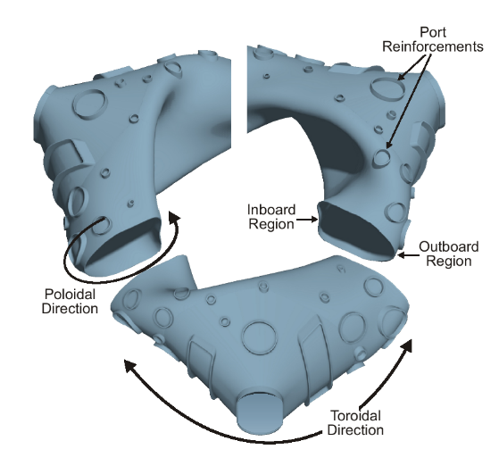
Figure 1 - NCSX vacuum vessel sub-assemblies (partially fabricated)

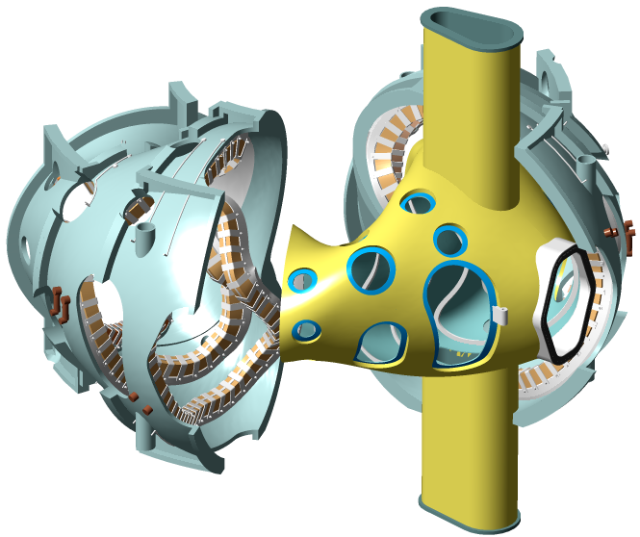
Figure 2 - Modular coils being assembled over vacuum vessel sub-assembly

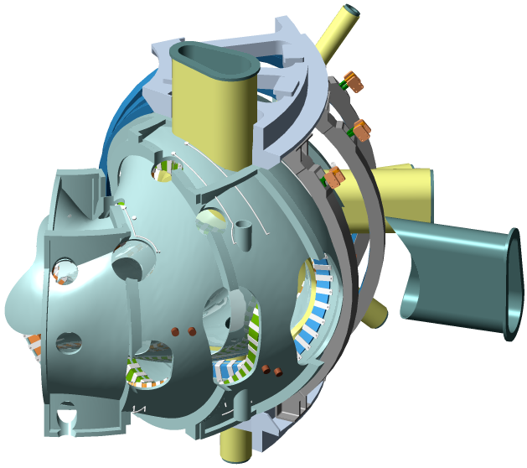
Figure 3 - Port extensions welded on after coils assembled

The assembly sequence will entail welding the port assemblies onto the VVSA shell and then cutting them off, leaving stubs which will serve as reinforcement and locating positions for subsequent reinstallation of the port extensions. With the exception of the large vertical ports and the neutral beam port located mid-segment, all port assembly extensions are required to be welded onto the three vessel sub-assemblies after installation of the modular coils and TF coils as part of the NCSX field period assembly operation. The stubs must be short enough to permit the Modular Coils to slip over the VVSA. Port assembly extensions will be welded onto the VVSA after installation of the Modular Coils and TF coils. Welding will be performed from the outside using automatic pipe welders inserted down into the port extensions. The VVSA configuration, port reinforcements (coils deleted for clarity) and definition of terminology used in this specification may be referenced in Figure 1. Figure 3 shows a completed NCSX VVSA.

Several sizes of radial and vertical ports are used. The large rectangular outboard ports are designed to permit personnel access into the interior during final assembly of the VVSA and for maintenance of internal equipment.

The VVSA will be supported from the modular coil shell structure via adjustable hangers. The interfacing fixed, structural brackets are a part of the VVSA and shall be supplied by the Seller.
The VVSA will be traced with tubes, which will be used for cooling during operation and bake out between operational cycles. The coolant tubes will be attached via clips welded to the VVSA. The tubes will be supplied and assembled onto each VVSA by Laboratory personnel.

1.2 SCOPE

This specification covers the fabrication of the Vacuum Vessel Sub-Assembly (VVSA) for the National Compact Stellarator Experiment (NCSX), including the supply of all required labor and materials, machining, fabrication, and factory acceptance inspections and tests. The Seller shall deliver the VVSA to the Princeton Plasma Physics Laboratory (Laboratory) site as a complete subassembly, a spacer assembly, and separate (unattached) port extension assemblies. All of the labor for the final installation and assembly of the VVSA will be supplied by the Laboratory.

2.0 APPLICABLE DOCUMENTS

The versions of the United States Codes and Standards defined below are to be used in the performance of this work. Other equivalent foreign codes may be proposed:
- ASME B46.1-1995 Surface texture (Surface Roughness, Waviness, And Lay)
- ASME SFA specifications
- ASME SFA 5.14 Nickel and Nickel Alloy Bare Welding Rods Electrodes
- American Society of Mechanical Engineers (ASME), Boiler and Pressure Vessel Code, Sections V (Articles 6 and 9), VIII (Division 1), and IX, 1998 with 2000 Addendum.
- ASTM B 443-00 Standard Specification for Nickel-Chromium-Molybdenum-Columbium Alloy (UNS N06625) and Nickel-Chromium-Molybdenum-Silicon Alloy (UNS N06219)* Plate, Sheet, and Strip
- ASTM B 444-00 Standard Specification for Nickel-Chromium-Molybdenum-Columbium Alloys (UNS N06625) and Nickel-Chromium-Molybdenum-Silicon Alloy (UNS N06219)* Pipe and Tube
- ASTM B 705-00 Standard Specification for Nickel-Alloy (UNS N06625, N06219 and N08825) Welded Pipe
- ASTM B 446-00 Standard Specification for Nickel-Chromium-Molybdenum-Columbium Alloy (UNS N06625) and Nickel-Chromium-Molybdenum-Silicon Alloy (UNS N06219)* Rod and Bar
- ASTM A 240-02 Standard Specification for Chromium and Chromium-Nickel Stainless Steel Plate, Sheet, and Strip for Pressure Vessels and for General Applications
- ASTM A193/A193M-01b Standard Specification for Alloy-Steel and Stainless Steel Bolting Materials for High-Temperature Service
- ASTM A 800/A 800M–01 Practice for Steel Casting, Austenitic Alloy, Estimating Ferrite Content Thereof
- ASTM Spec. A 494-01 Standard Specification for Castings, Nickel and Nickel Alloy
- AWS D1.6: 1999 Structural Welding Code - Stainless Steel, (Paragraph 6.29.1)
- MSS SP-54-1999, Quality Standard for Steel Castings for Valves, Flanges and Fittings and Other Piping Components -- Radiographic Examination Method
- American Welding Society (AWS) QC1, Standard and Guide for Qualification and Certification of Welding Inspectors, 1996.
- American Society of Nondestructive Testing (ASNT) 2055, Recommended Practice SNT-TC-1A, 1996.

The above Standards and Codes set forth the minimum requirements. They may be exceeded by Seller with written permission from the Laboratory if, in Seller’s judgment, superior or more economical designs or materials are available for successful and continuous operations, as required by the specification.

ASME Code stamping of the vacuum VVSA section is not required.

3.0 REQUIREMENTS

  - ITEM DEFINITION
The VVSA is a 120º segment of a full (360º) vacuum vessel assembly. The VVSA coordinate system is defined in the reference engineering drawings. The finished VVSA consists of port stubs with openings bored out, the associated port extension assemblies, and a spacer assembly. The port attachment concept is shown in Figure 4. A complete VVSA with Spacer, TF coils, Modular Coils, and Ports is shown in Figure 5.

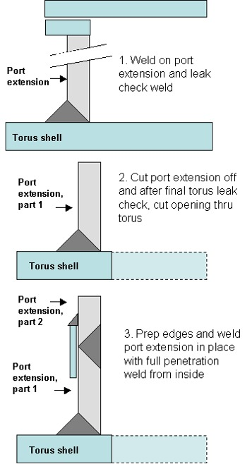

Figure 4 – Port attachment concept

  - CHARACTERISTICS

    - PERFORMANCE

3.2.1.1 Vacuum Performance
The port extensions included in the VVSA are to be leak checked. The port configuration during vacuum leak testing shall be:
- Prior to leak checking, the assembly shall be cleaned as defined in Sect. 3.3.2.4.
- Vessel wall inside of port extensions in place, as shown in Figure 4.
- Conflat flanges, o-ring flanges, port covers, seals, and bolts in their operational configuration.

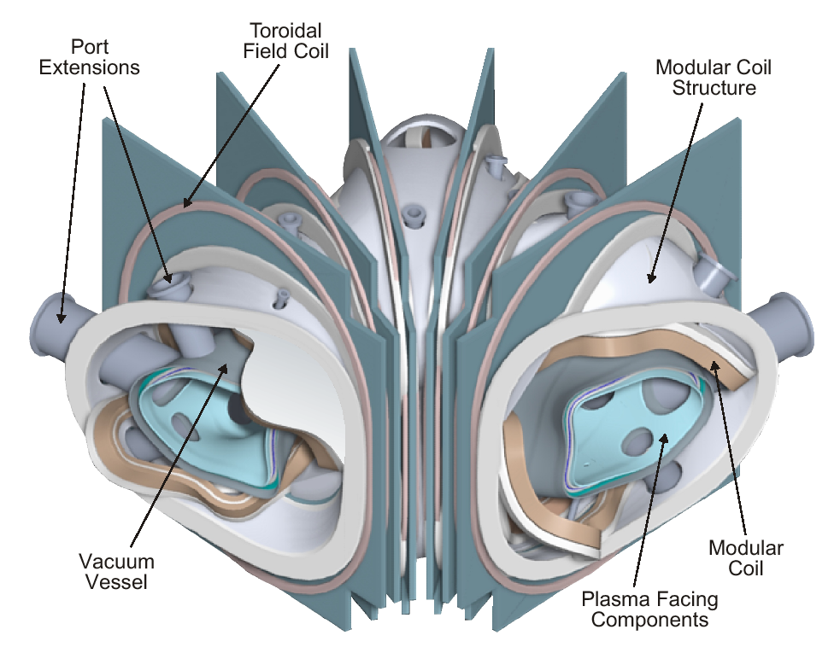
Figure 5 Field period subassembly (VVSA) with all port extensions and field joint spacer.

A helium leak test of the VVSA and port extensions shall be performed at Seller’s facility. VVSA testing shall be prior to final boring and machining of the port extension holes in the port reinforcements, in accordance with ASTME 498 and as delineated in the following paragraphs:

The VVSA shall be leak checked in its entirety by temporarily blanking off the subassembly with the appropriate flange seals. This test shall be performed a minimum of three times after cycling the temperature of the VVSA from room temperature to 200 C. The Seller shall furnish and install all temporary test fixtures, flanges, blanking off plates, and gaskets required to seal the VVSA for leak checking purposes. All such equipment shall be delivered to the Laboratory at the conclusion of testing.
A Turbomolecular Pump (TMP) and a mechanical vacuum pump shall be used to evacuate the assembly under test.
A mass spectrometer leak detector shall be connected to the TMP fore-line. A detection sensitivity of 10⁻¹⁰ scc/sec shall be provided.
All leaks found shall be documented on nonconformance reports, and repaired. Seller's leak repair procedures shall be submitted to the Laboratory for approval prior to use.

      - Surface Finish

        - Interior Surface Finish
Interior (vacuum) surfaces of Inconel sheet stock used for fabrication of the VVSA wall and port extensions shall be the identified and marked. The interior surfaces of the sheet stock shall be mechanically ground to a 32 micro-inch finish. Interior surfaces of pipe and tubing used for port extensions shall be mechanically ground or electro-polished to a 32 micro-inch finish. Interior surface weld beads, scratches, and tooling marks resulting from fabrication shall be ground to a 32 micro-inch finish. Scratches, pits, weld pin holes and other surface imperfections exceeding 0.015 inches in depth shall be repaired by welding before finish grinding.
Tools utilized in grinding and lapping operations on the VVSA and its components shall be nonferrous ceramics or nonmagnetic stainless steel, which have never been in contact with other than austenitic stainless material.

3.2.1.2.2 Exterior Surface Finish
Mill finish on the exterior surfaces of the VVSA is acceptable, but any gouges greater than .03 inches deep shall be weld repaired and ground smooth.

3.2.1.3 Magnetic Permeability
Overall relative magnetic permeability of all components fabricated of nickel chromium alloy shall not exceed 1.01.
Overall relative magnetic permeability of all components fabricated of 316 LN Stainless Steel shall not exceed 1.02.
Overall relative magnetic permeability in welds (and heat affected zones) joining 316 LN to nickel chromium shall not exceed 1.2.

  - DESIGN AND CONSTRUCTION

3.3.1 Fabrication Drawings
Figures provided in the text of this document are to provide clarity and are for information only; equipment shall be provided in conformance with the following drawings and electronic files:

SE120-001 REV O, Vacuum Vessel Assembly
SE121-002 REV O, Vacuum Vessel Period Assembly
SE121-019 REV O, Vacuum Vessel Spacer Detail

Vacuum Vessel Contour Pro-E® models are referenced on the fabrication drawings.

All the Drawings and CAD models are provided in Pro-E® format and it is the Seller’s responsibility to work with this format.
The Pro/Engineer models and drawings of the VVSA are available through the PPPL anonymous FTP server. The following FTP commands can be used to access the files:
ftp> ftp.pppl.gov
User: anonymous <- login as anonymous
Password: <- enter your email address
ftp> cd pub/ncsx/manuf <- lowercase
ftp> bin <- binary transfer mode
ftp> mget * <- retrieve files
ftp> quit

The files may also be accessed through a web browser using the following URL address:
ftp://ftp.pppl.gov/pub/ncsx/manuf/

    - Materials, Processes, and Parts

        - Materials

3.3.2.1.1 Sheet, Strip, and Plate
All as-supplied sheet, strip, and plate shall be annealed Alloy (UNS N06625) and meet the requirements of ASTM B 443. If the Subcontractor proposes casting, samples of after-cast material will be required to be submitted for analysis and approval by the Laboratory with the Approval Data.

3.3.2.1.2 Tubing and Piping
All tubing and pipe shall be seamless or welded Alloy (UNS N06625) and meet the requirements of ASTM B 444 or ASTM B 705.

3.3.2.1.3 Bar and Structural Shapes
All bar and structural shapes shall be annealed Alloy (UNS N06625) and meet the requirements of ASTM B 446.

3.3.2.1.4 Castings
If the Subcontractor proposes casting of VVSA components, the casting alloy shall be recommended such that properties are similar to Alloy (UNS N06625).

3.3.2.1.5 Conflat Flanges
The conflat flange shall be fabricated of 304 stainless steel and meet the requirements of ASTM A 240.

3.3.2.1.6 Weld Filler Metal
Weld filler metal shall meet the requirements of the applicable AWS A series specifications or ASME SFA specifications. Certified material test reports shall be supplied for all materials (see section 4.3).
Welding of stainless steel conflat flanges to Inconel 625 (UNS N06625) ports shall use ASME/AWS SFA/A 5.14 ERNiCr-3 or ERNiCrMo-3 filler metal

3.3.2.1.7 Bolts
Conflat flange bolts shall be ASTM A 193, Grade B8; silver-plated, 12-point bolt kits provided with flanges from the flange manufacturer.
Rectangular o-ring ports shall use ASME SA 453 Grade 660 bolts.(A286 or Inco 718)
VVSA Subassembly flanges shall use .(A286 or Inco 718)bolts

3.3.2.1.8 Seals
Metal Seals for Conflat flanges shall use standard copper seals provided from the flange manufacturer.

Custom racetrack-shaped and rectangular flanges will be sealed with Viton A o-rings on both the vacuum side and on the air side. During upgrade operation, metal o-rings may be substituted on the high vacuum side and Viton will be maintained on the air side. The metal o-rings will be supplied and installed by the Laboratory.
Dimensions and o-ring grooves shall conform to specifications listed in the Engineering Drawings.

3.3.2.2 Welding
All welding shall be done in accordance with welding procedures that are written and qualified in accordance with the ASME Code, Section IX. Welds may be made by the GTAW or GMAW processes. Welds using SMAW process are not permitted.

3.3.2.3 Cutting, Forming and Bending
For the fabrication of the Vessel, all cutting, forming and bending shall be done in accordance with the ASME Boiler and Pressure Vessel Code, Section VIII, Division 1.

3.3.2.4 Cleaning
After completion of assembly and surface preparation, the VVSA interior shall be cleaned. All surfaces shall be degreased/cleaned using materials and procedures mutually agreed upon. As a minimum this procedure will include:
- Vapor degreasing to remove oils, greases, and die lubricant residues resulting from handling and fabrication of the Vessel.
- Solvent (e.g. ethanol) wipe down of the surfaces.
- Blow drying of surfaces with oil-free instrument air.
- Use of lint-free wipes.

3.3.2.5 Process
The VVSA wall shall be fabricated by forming, pressing, or other related processes that result in a smooth contour, conforming to the ProE® model supplied by the Laboratory. If casting of components is proposed by the Seller, samples of after-cast material will be required to be submitted for analysis and approval by the Laboratory.

3.4 DIMENSIONS/TOLERANCES
The VVSA, shall be dimensionally checked for compliance with the dimensional requirements. This shall be done with the assembly completed, i.e. the port extensions cut off to form stubs, the holes bored, and vessel end flanges installed and after any required thermal cycling operations.

The VVSA wall inner and outer contour shall conform to the theoretical limiting surfaces in the Laboratory supplied ProE® models. One surface will define the vacuum side of the contour and the other
surface will define the “air” side of the contour. The VVSA wall will lie between these two theoretical surfaces. The highest tolerance region is on the inboard region of the VVSA (where the limiting contours are within + 0.15 inches) and the tolerance becomes more relaxed in the outboard region of the torus (where the limiting contours are within +0.5 inches). This is illustrated schematically in figure 6.

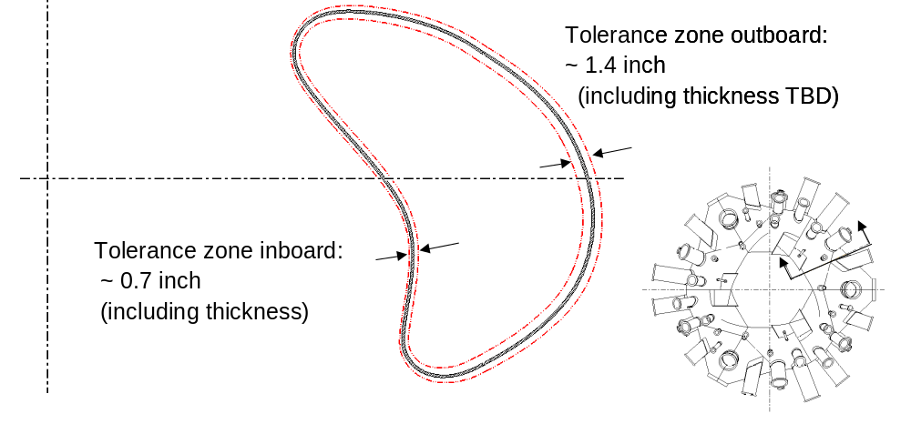
Figure 6 VVSA tolerance zone schematic

Overall dimensions and dimensional tolerances shall be in accordance with the referenced Engineering Drawings.

The VVSA wall thickness, after forming, shall be 0.375 ^{+0.01}/_{-0.12} inches.

The port reinforcements shall be machined to receive its associated port extension subassembly such that the location of the flange can be located within the prescribed tolerance (within 0.25 inches at both ends and perpendicular to the nominal port extension axis within 0.5 deg)

The Seller will be required to perform dimensional checks using full surface 3-D measurement equipment (eg laser tracker) to ensure that the surfaces are within the prescribed limits. The seller shall also perform VVSA wall thickness measurements using suitable method (e.g. ultrasonic).

Dimensional stability of the VVSA over an operating temperature range of room temperature to 175 C is a primary requirement. Fixturing and stress relieving for the purpose of dimensional stability after welding will be necessary to maintain the VVSA tolerances and to avoid subsequent distortion. . All fixturing equipment shall become the property of the Laboratory and shall be delivered to the Laboratory at conclusion of testing.

3.5 SEGMENTATION
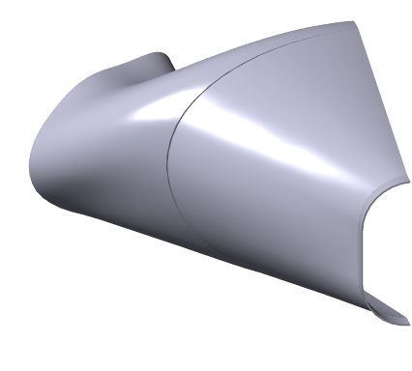
The VVSA is made up of contoured plate segments, welded together and mated to end flanges. A possible fabrication segmentation of a half (60degree) VVSA is shown in Figure 7, which uses 6 shapes and 12 total pieces to form a VVSA. This configuration incorporates shapes that can be freely removed from a forming die without interference (entrapment) and minimizes the amount of plate deformation required during the forming process. The Seller may propose other segmentation schemes with the bid proposal for review and approval by the Laboratory. Schemes minimizing the number of segments (and subsequent welding) are preferred to schemes using more segments.
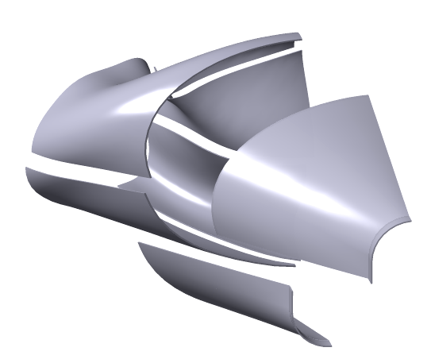
Figure 7 Fabrication segmentation scheme for a half period section of the VVSA.

3.6 INSTALLATION
The Seller shall furnish the Laboratory with the VVSA all special purpose handling fixtures and rigging used during fabrication as well as documentation describing their use. Upon award of contract, the Seller shall provide the Laboratory a list of equipment necessary to perform final check out and alignments. All tools, i.e., electronic indicators, levels, etc. necessary to perform the installation and on site tests will be supplied by the Laboratory. The Seller shall provide this list of tools at least 8 weeks in advance of delivery.

3.7 DELIVERABLES
The Seller is responsible for delivering to the laboratory the following:

3.7.1 All documentation listed in Section 4.2.

3.7.2 A completed VVSA, spacer, and all port assemblies, which have successfully passed all acceptance tests and criteria.

4.0 QUALITY ASSURANCE REQUIREMENTS

4.1 GENERAL
Tests and inspections shall be conducted at the supplier’s facility or otherwise suitable location. Actual data and accept/reject status for each inspection and test shall be documented. The reports shall contain sufficient information to accurately locate the area involved and to reproduce the inspection or test performed. This can be accomplished by reference to other Subcontractor-provided documents such as procedures and radiographs.

4.1.1 Responsibility for Inspection
The responsibility for performing all tests and verifications rests with the Subcontractor. PPPL reserves the right to witness or separately perform all tests specified or otherwise inspect any or all tests and inspections.

4..2 QUALITY CONFORMANCE INSPECTIONS

4.2.1 Verification of Vacuum Performance
Helium leak tests shall be performed to verify that the requirements stated in Section 3.2.1.1 are met.

4.2.2 Verification of Surface Finish
The interior surface finish shall be checked with a comparator to verify compliance with Section 3.2.1.2.1. The exterior surface finish shall be visually examined to verify compliance with Section 3.2.1.2.2.

4.2.3 Verification of Magnetic Permeability
Magnetic permeability shall be measured in accordance with the requirements of ASTM A 800, Supplementary Requirement S1 but the measurements shall be taken in relative permeability rather than ferrite content. All surfaces and features shall be checked with a calibrated Severn Permeability Indicator for compliance with Section 3.2.1.6. The surfaces of the PVVS shell and port extension shall be checked and documented in a 6" x 6" grid. The welds at the conflat flanges and at the junction between the port extension, reinforcement, and vessel shell shall be checked every 1/2" (both inside and outside surfaces wherever possible).

4.2.4 Verification of Dimensions and Tolerances
With the PVVS unrestrained on a surface measuring table and the port extension supported to compensate for gravity load, all surfaces and features shall be dimensionally checked on a grid no coarser than 1-inch centers using instruments having resolution at least ten times the tolerance. These measurements shall be compared to the tolerances indicated on the applicable drawings. Verification of dimension and tolerances shall be done both before and after attachment of the port extension.

4.2.5 Materials
Material certifications traceable to the materials used shall be provided as defined below. Subcontractor is to develop and utilize process controls to assure traceability of materials to their certifications.
- N06625: showing actual chemical and physical properties
- Bolts: Manufacturer’s certification of grade
- Conflat flanges: Manufacturer’s statement
- Filler metal: showing actual chemical properties
If cast material is used, Subcontractor is to provide verification of properties from test coupons. Properties must meet those specified in Section 3.3.2.1.

4.2.6 Weld Inspection and Examination
All welds are to be visually inspected using a written procedure prepared in accordance with Article 9 of Section V of the ASME Code. Welds designated with a "V" in the tail of the welds symbol shall also be visually examined with 8X magnification, in accordance with Article 6, Section V, of the ASME Code. The acceptance criteria for the visually inspected welds is given in AWS D1.6, Paragraph 6.29.1. All welds that do not meet the stated acceptance criteria shall be documented, repaired, and re-inspected.
Visual weld inspection shall be done by inspectors certified to perform visual inspection of welds in accordance with AWS QC1 or SNT-TC-1A, Level II or Level III.
Copies of welding heat treatment, NDE and special process procedures and qualification test records shall be available for review by PPPL. Welding procedures qualifications shall include evidence of compliance with special magnetic permeability criteria.

4.2.7 Verification of Cutting, Forming, and Bending
Copies of cutting, forming, and bending procedures shall be available for review by PPPL.

4.2.8 Verification of Cleaning Requirements
Visually inspect the PVVS and examine records for compliance with Section 3.3.2.4.

4.2.9 Inspection for Internal Defects
Castings shall be 100% examined for internal defects as defined in ASTM Spec. A 494 using radiographic inspection per Supplementary Requirement S2. Acceptance criteria for radiography shall be per MSS SP 54.

    - Responsibility for Inspection
The responsibility for performing all tests and verifications rests with the Subcontractor. PPPL reserves the right to witness or separately perform all tests specified or otherwise inspect any or all tests and inspections.

4.2.11 Quality Assurance Plan
The Seller shall submit with the offer a copy of their general quality assurance plan with documented evidence showing how the Seller intends to comply with all requirements of this specification.
After award of the subcontract and prior to fabrication, a final Quality Assurance Plan specific for this equipment shall be submitted to the Laboratory for approval. This Quality Assurance Plan shall be of sufficient detail and scope to allow the Laboratory to determine the quality control that can be expected from the Seller. This plan shall describe the Quality Assurance policies and practices that will be used to ensure the product meets specified requirements and will perform its intended function.

4.2.12 Manufacturing/Inspection/Test Plan
Seller shall prepare and submit for Laboratory review and approval a Manufacturing/Inspection/Test Plan, which identifies parts, sub-assemblies, etc.; shows their integrated flow into end items; and identifies critical manufacturing operations as well as inspections and tests. Preparing the Plan may include developing a flow chart and generating Process Sheets/Shop Travelers, etc. The Laboratory may designate selected manufacturing, inspection and/or test operations as mandatory “witness” points based on the MIT plan. Seller shall provide Laboratory with five (5) working days notice in advance of such witness points.

4.2.13 Inspection/ Surveillance/Audit by NCSX Project
Authorized representatives of the Laboratory shall have the right at all reasonable times to visit the Seller's premises and those of Seller's suppliers during the performance of the procurement for the purposes of inspection, surveillance, audit and/or obtaining any required information as may be necessary to assure that items or services are being furnished in accordance with specified requirements. Such visits shall be coordinated with the Seller's personnel to minimize interference with the normal operations of said premises. The Seller shall make available records and documentation necessary for this function and shall provide all reasonable facilities and assistance for the safety and convenience of Laboratory representatives in the performance of their duties. The Laboratory recognizes the Seller's right to withhold information concerning proprietary processes. The Seller agrees to insert the paragraph above in each lower tier procurement issued hereunder.

5.0 PREPARATION FOR DELIVERY

5.1 LABELING
A corrosion-resistant, non-magnetic, metal name plate shall be attached to each major component. This name plate shall be plainly and permanently marked with the following information:
Seller’s name
Machine model number
Machine serial number
Date of manufacture (month and year)
Contract number

VVSA Subassemblies and components shall be marked to provide positive identification to a machine. When such markings impairs proper functioning of the equipment, a metal tag shall be used.

5.2 PACKING AND SKIDDING
All the components shall be sealed, packaged, and skidded to provide protection against contamination, deterioration and damage during shipment.
The plan shall include a description of methods to be used to preserve, package, skid, and identify equipment. The Seller shall contact the Laboratory ten days prior to shipment of the machine to confirm shipping method and route.

5.3 MARKING
Each shipping skid shall be marked with the name of the Seller, Laboratory Purchase Order Number, the component, Seller’s Model Number, and gross weight. Boxes containing loose parts, attachments, and accessories shall be marked identifying the machine to which they belong, and where possible, boxes are to be secured to the skid of the unit.

Available from Severn Engineering Co. Annapolis, Md.

