NCSX

Product Specification

TF Coil Wedge Castings

NCSX-CSPEC-131-03-00
DRAFT C

June 17, 2005

Prepared By: __________________________________________________________
M. Kalish, WBS Manager for TF Coils (WBS 13)

Concurred By: __________________________________________________________
B. Nelson, Project Engineer for Stellarator Core Systems (WBS 1)

Concurred By: __________________________________________________________
QA Representative

Approved by: __________________________________________________________
W. Reiersen, NCSX Engineering Manager

Controlled Document
This is a controlled document. Check the NCSX Engineering Web prior to use to assure that this document is current.
Record of Revisions

Revision | Date | Description of Changes
0 |  | Initial issue

Table of Contents
1 Scope 1
2 Applicable Documents 1
2.1 PPPL Drawing 1
2.1.1 TF Coil Nose Casting Machining Detail Drawing # SE131-007 Sheets 1 and 2 1
2.2 Codes and Standards 1
2.2.1 American Society for Testing and Materials (ASTM) Documents 1
2.2.2 Manufacturers Standardization Society (MSS) of the Valve and Fittings Industry Documents 2
3 Requirements 2
3.1 Item Definition 2
3.2 Characteristics 2
3.2.1 Performance 2
3.2.1.1 Chemical Composition 2
3.2.1.1.1 Casting Alloy 2
3.2.1.1.2 Weld Wire 3
3.2.1.2 Mechanical Properties 3
3.2.1.3 Surface Finish 3
3.2.1.4 Relative Magnetic Permeability 4
3.2.1.5 External Defects 4
3.2.1.5.1 Visual Examination 4
3.2.1.5.2 Liquid Penetrant Inspection 4
3.2.1.6 Internal Defects 4
3.3 Design and Construction 4
3.3.1 Production Drawings 4
3.3.2 Dimensions and Tolerances 4
3.3.3 Standards of Manufacture 4
3.3.3.1 Heat Treatment and Stress Relieving 4
3.3.3.2 Repairs 5
3.3.3.2.1 Non-Weld Repairs 5
Weld Repairs 5
3.2.3.2.2.1 Minor Weld Repairs 5
3.2.3.2.2.2 Major Weld Repairs 5
3.2.3.2.2.3 PPPL Approval of Weld Repairs 5
4 Quality Assurance Provisions 5
4.1 General 5
4.1.1 Responsibility for Inspection 5
4.2 Quality Conformance Inspections 6
4.2.1 Verification of Chemical Composition 6
4.2.1.1 Casting Alloy 6
4.2.1.2 Weld Wire 6
4.2.2 Verification of Mechanical Properties 6
4.2.2.1 Verification of Yield Strength and Elastic Modulus 6
4.2.2.2 Verification of Ultimate Tensile Strength and Elongation 6
4.2.2.3 Verification of Charpy V-Notch Energy 6
4.2.2.4 Additional Test Material 6
4.2.2.5 Weld Wire 6
4.2.3 Verification of Surface Finish 7
4.2.4 Verification of Relative Magnetic Permeability 7
4.2.5 Verification of Dimensions and Tolerances 7
4.2.6 Inspection for External Defects 7
4.2.6.1 Visual Inspection 7
4.2.6.2 Liquid Penetrant Inspections 7
4.2.6.2.1 General Liquid Penetrant Inspection 7
4.2.6.2.2 Post Machining Liquid Penetrant Inspection 7
4.2.7 Inspection for Internal Defects 7
4.2.7.1 Pre-machining Inspection for Internal Defects 7
5 Preparation for delivery 8
5.1 Marking 8
5.2 Cleaning 8
5.3 Crating 8
5.4 Shipping 8

List of Tables
Table 3-1 Weight % of Chemical Constituents in Casting Alloy 2
Table 3-2 Weight % of Chemical Constituents in Casting Alloy (Alternate) 2
Table 3-3 Weight % of Chemical Constituents in Weld Wire 3
Table 3-4 Minimum Mechanical Properties 3

Scope
This specification defines the Toroidal Field (TF) Coil Wedge Castings (Wedge Castings) and requirements for its manufacture. There are two (2) identical Wedge Castings per TF coil and thirty-six (36) altogether. An illustration of the Wedge Castings with a TF coil is shown in Figure 1 - TF Coil With Wedge Castings
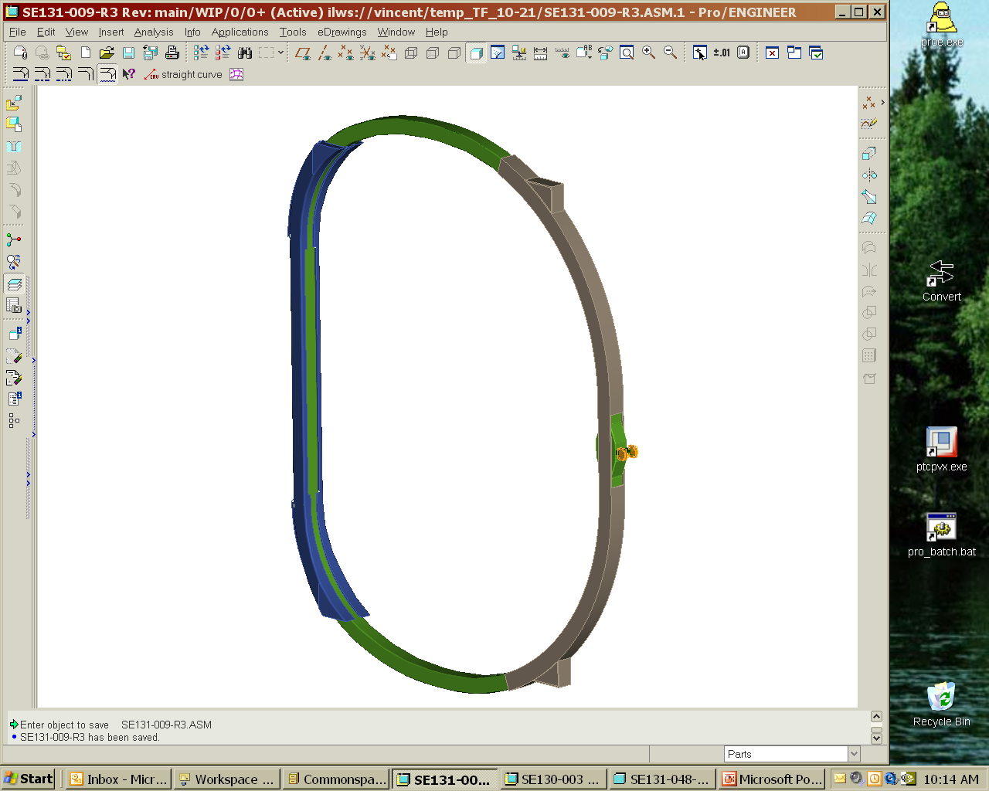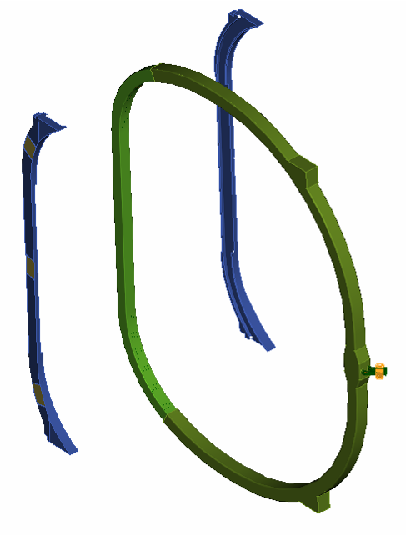
Wedge
Castings
Figure 1 - TF Coil With Wedge Castings

Applicable Documents

PPPL Drawing

TF Coil Nose Casting Machining Detail Drawing # SE131-007 Sheets 1 and 2

Codes and Standards

American Society for Testing and Materials (ASTM) Documents
A703/A703M-03 “Standard Specification for Steel Castings, General Requirements for Pressure Containing Parts”.
A800/A800M-01 “Standard Practice for Steel Casting, Austenitic Alloy, Estimating Ferrite Content Thereof”.
A802/A802M–95 “Standard Practice for Steel Castings, Surface Acceptance Standards, Visual Examination”.
A903/A903/M–99 “Standard Specification for Steel Castings, Surface Acceptance Standards, Magnetic Particle, and Liquid Penetrant Inspection”.

Manufacturers Standardization Society (MSS) of the Valve and Fittings Industry Documents
MSS SP-54-2001: “Quality Standard for Steel Castings for Valves, Flanges, Fittings, and Other Piping Components; Radiographic Inspection Method”.

Requirements

Item Definition
The item covered in this specification is the TF wedge casting. This specification defines the TF wedge casting and requirements for its fabrication.

Characteristics

Performance

Chemical Composition
Background
The chemical composition for two acceptable casting alloys is provided below. The vendor may select from these alloys based on their compatibility with the manufacturing process. The vendor may propose alternate casting alloys and weld wire if they meet the requirements of this specification. All alternate alloys shall be subject to review and approval by PPPL.

Casting Alloy
The chemical composition shall be in accordance with Table 3-1 or Table 3-2.

Table 3-1 Weight % of Chemical Constituents in Casting Alloy
 | C | Mn | Si | Cr | NI | Mo | P | S | N
Min. % | .040 | 2.3 | -- | 18.0 | 13.0 | 2.1 | -- | -- | .24
Max.% | .070 | 2.8 | 0.7 | 18.5 | 13.5 | 2.5 | .015 | .015 | .28

Table 3-2 Weight % of Chemical Constituents in Casting Alloy (Alternate)
 | C | Mn | Si | Cr | NI | Mo | P | S | N
Min. % | 0 | .5 | 0 | 17.0 | 14.0 | 2.0 | -- | -- | --
Max.% | .080 | 1.5 | 1.0 | 18.5 | 18.0 | 3.0 | .015 | .015 | --

Weld Wire
The chemical composition of the weld wire shall comply with the range of chemistry specified in Table 3-3.

Table 3-3 Weight % of Chemical Constituents in Weld Wire
 | C | Mn | Si | Cr | Ni | Mo | P | S | Cu | N
Min. % | - | 6.0 | 0.3 | 19.0 | 15.0 | 2.5 | -- | -- | - | .12
Max. % | .025 | 8.0 | 0.65 | 21.0 | 18.0 | 3.5 | .03 | .02 | 0.3 | .20

Mechanical Properties
The properties of the casting alloy shall meet or exceed the mechanical properties requirements stated in Table 3-4.
Table 3-4 Minimum Mechanical Properties
Temperature | 77K | 293K
Elastic Modulus | 21 Msi (144.8 GPa) | 20 Msi (137.9 GPa)
0.2% Yield Strength | 72 ksi (496.4 MPa) | 30 ksi (206.8 MPa)
Tensile Strength | 95 ksi (655 MPa) | 78 ksi (537.8 MPa)
Elongation | 32% | 36%
Charpy V – notch Energy | 35 ft-lbs (47.4 J) | 50 ft-lbs (67.8 J)

Surface Finish
All machined surfaces must have a RMS (root mean square) surface finish <125 μ-inches. Uniform “scallops” which exceed 125 μ-inches, which may result from some machining processes, may be acceptable, subject to PPPL approval of the non-conformance that would be generated in this case. The finished part shall be free of sharp edges and burrs.

Relative Magnetic Permeability
The local relative magnetic permeability shall not exceed 1.02.

External Defects

Visual Examination
- Cast surfaces shall be free of visual external defects as defined in ASTM A802/A802M (using graded reference comparators available from Castings Technology International) Level III.
- Machined surfaces shall be free of visual external defects as defined in ASTM A802/A802M (using graded reference comparators available from Castings Technology International) Level II.
- Discontinuities not meeting the evaluation criteria shall be repaired per Section 3.3.3.2.

Liquid Penetrant Inspection
- Each casting ,shall be free of external defects as defined in ASTM A903/A903M Level I when checked by liquid penetrant inspection.
- Discontinuities not meeting the evaluation criteria shall be repaired per Section 3.3.3.2.

Internal Defects
- Each casting shall be free of internal defects as defined in MSS SP 54 for radiography.
- Discontinuities not meeting the evaluation criteria shall be repaired per Section 3.3.3.2.

Design and Construction

Production Drawings
The castings shall be fabricated in accordance with the TF Coil Nose Casting Machining Detail Drawing SE131-007.

Dimensions and Tolerances
The Wedge Castings shall conform to the dimensions and tolerances defined in the production drawings referenced in Section 3.3.1. All dimensions are for 20 C; actual measurements shall be temperature compensated for 20 C.

Standards of Manufacture

Heat Treatment and Stress Relieving
The castings shall be heat treated prior to final measurements of mechanical properties and relative magnetic permeability. In addition, stress relieving shall be performed after all upgrading is completed at the foundry. The temperature and duration of the stress relieving process shall be reviewed and approved by PPPL. Heat treatment records shall be prepared and maintained as defined in S21 of ASTM Spec. A703/A703M, and supplied to PPPL.

Repairs

Non-Weld Repairs
When defects are removed by grinding without violating minimum wall thickness requirements, the ground area shall be re-inspected by the original inspection method to verify complete defect removal. Discontinuities will be completely removed during machining operations do not need to be weld repaired.

Weld Repairs
Weld repairs may be necessitated to (1) repair casting defects when defect removal involves excavation beyond wall thickness limitations or (2) to repair gouges or other machining errors. Welding procedure qualification tests shall include evidence of compliance with the magnetic permeability requirements of Section 3.2.1.4, as well as compliance with the mechanical properties listed in Error: Reference source not found and Error: Reference source not found. Weld preparation shall be per Section S10 of ASTM A703/A703M. Weld repairs must meet the inspection criteria of Sections 3.2.1.5 and 3.2.1.6.

Minor Weld Repairs
Weld repairs smaller than those defined in Section 3.2.3.2.2.2, as Major Weld Repairs shall be welded in accordance with this section. Rejectable surface defects which are less than 0.125” in depth shall be eliminated by grinding. Rejectable surface defects which exceed this depth, as well as any rejectable subsurface defects shall be reported in a non-conformance report for evaluation by PPPL. When the non-conformance report disposition requires weld repair, it must be repaired per Section 3.3.3.2.2.

Major Weld Repairs
Repairs shall be considered major when the depth of the cavity prepared for welding exceeds 20 % of the actual wall thickness or when the extent of the cavity exceeds approximately 1 in². Weld Maps (showing size and location as required by ASTM A703/A703M S20) shall be prepared for each major weld repair cycle. The weld map shall be delivered to PPPL no later than 24 hours after the start of welding. Major weld repairs during machining operations shall necessitate the issuance of a Non-Conformance Report to address the conditions that led to the need for welding. The weld repairs may proceed while the NCR is being dispositioned.

PPPL Approval of Weld Repairs
ASTM A703/A703M S12, which necessitates a hold point pending PPPL review of the submitted weld map and may necessitate additional post-weld testing and/or stress relief of the casting, is invoked when:
- Repair requires more than 2 weld repair cycles for the same location, or
- When the depth of the cavity prepared for welding exceeds 25 % of the actual wall thickness, or when the extent of the cavity exceeds approximately 1 in2

Quality Assurance Provisions

General

Responsibility for Inspection
The responsibility for performing all tests and verifications rests with the supplier. PPPL reserves the right to witness or separately perform all tests specified or otherwise inspect any or all tests and inspections.

Quality Conformance Inspections

Verification of Chemical Composition

Casting Alloy
The material chemical composition shall be measured for compliance with the requirements stated in Section 3.2.1.1.1 and shall be provided for each ladle used in each casting.

Weld Wire
The chemistry shall be reported for each lot of weld wire for compliance with the requirements in Section 3.2.1.1.2.

Verification of Mechanical Properties
The mechanical properties of the casting alloy for each Wedge Casting must be verified for compliance with Section 3.2.1.2 by testing of specimens made from sections taken from each casting (or from a substitute approved in writing by PPPL). The specimen material shall be heat treated simultaneously with the Wedge Casting. During the heat treatment this material shall be located adjacent to the area from which it was derived in order to represent as closely as possible the properties of that material. Each specimen shall be engraved to permit traceability. All test data must be referenced to the test specimen identifiers. It is requested that this data be supplied to PPPL within 30 days of the casting date

Verification of Yield Strength and Elastic Modulus
The yield strength at 0.2% offset elongation and the elastic (Young’s) modulus shall be verified for the casting alloy in the as heat-treated condition at room temperature and 77K for each Wedge Casting. Test specimen coupons shall be tested in accordance with ASTM A703/A703M-03, Paragraphs 6 and 7.

Verification of Ultimate Tensile Strength and Elongation
The ultimate tensile strength and elongation for the cast stainless steel in the as heat-treated condition at room temperature and 77K shall be verified for each casting. Tensile test specimen coupons shall be tested in accordance with ASTM A703/A703M-03, Paragraphs 6 and 7.

Verification of Charpy V-Notch Energy
The Charpy V-Notch energy of the casting alloy at room temperature and 77K shall be measured for each casting. Specimen coupons shall be cast and heat treated with each wedge casting and tested in accordance with ASTM A703/A703M-03, Paragraph 6.

Additional Test Material
Sufficient additional heat treated material shall be provided from every fourth wedge casting to allow NCSX to fabricate (3) specimens sized 3” x 3” x 3/4” thick. All supplied material shall have its identification information engraved in it as described in Section 4.2.2.

Weld Wire
Vendor to supply manufacturers material certifications showing the chemistry of the weld wire meets the requirements of Secton 3.2.1.1.2

Verification of Surface Finish
All machined surfaces shall be inspected for compliance with surface finish requirements specified in Section 3.2.1.3. Either a surface profilometer or comparator can be used.

Verification of Relative Magnetic Permeability
All cast surfaces and features shall be checked with a calibrated Severn Permeability Indicator for compliance with Section 3.2.1.4. Relative magnetic permeability that exceeds 1.02 must be documented on a Nonconformance Report and will require approval on a case-by-case basis. Accessible weld repairs shall be checked at a minimum of 1 point per every 2 sq. in. of surface area. Relative magnetic permeability measurements shall be made on all surfaces of the final casting at locations approximately 6 inches apart (to approximate a 6 inch x 6 inch grid). Final machined surfaces shall be inspected on a 2 x 2” grid. Permeability measurements shall be per Supplementary Requirements S24 of ASTM Spec. A703/A703M and S1 of ASTM A800/A800M, except that the results shall be expressed as relative permeability, μ, Mu, rather than ferrite content (FN)

Verification of Dimensions and Tolerances
All cast surfaces, machined surfaces, and features shall be dimensionally checked to assure compliance with Section 3.3.2. per standard machine shop practices.

Inspection for External Defects

Visual Inspection
All of the casting features shall be visually inspected to assure compliance with Section 3.2.1.5.1.

Liquid Penetrant Inspections

General Liquid Penetrant Inspection
All surfaces of the casting shall be liquid penetrant inspected to assure compliance with Section 3.2.1.5.2 (Liquid Penetrant Examination of Casting). Certified test reports shall be per ASTM A903, Supplementary Requirement S1. Surfaces shall be prepared by abrasive blast per standard foundry procedures.

Post Machining Liquid Penetrant Inspection
All machined surfaces shall be liquid Penetrant inspected to assure to assure compliance with Section 3.2.1.5.2 (Liquid Penetrant Examination of Casting). Certified test reports shall be per ASTM A903, Supplementary Requirement S1.

Inspection for Internal Defects

Pre-machining Inspection for Internal Defects
Each casting shall be examined for internal defects as defined in ASTM Spec. A703/A703M using radiographic inspection per Supplementary Requirement S5 Acceptance criteria shall be as defined in Section 3.2.1.6.

Preparation for delivery

Marking
Each casting shall have the supplier's name, a serial number (drawing number and a unique identifier), marked or stamped with characters ¼ inches high. The marking shall be located as shown in the part drawing.

Cleaning
The casting shall be degreased/cleaned using a solvent which must be able to dissolve grease, oils and other soils, and leave the casting residue free. No chips, burrs, oil, etc. shall remain in any of the tapped holes.

Crating
The crate shall protect the casting from shock and weather conditions, including precipitation. The crate shall be constructed to protect the casting from being bent or warped and so that the straightness of the part is maintained. The crate shall be built for moving on rollers, handling with slings from overhead cranes, and transport by forklifts. The part shall be totally wrapped with a plastic protective film.

Shipping
Supplier is responsible for arranging shipment, and for the safe arrival of the casting at PPPL in Princeton, New Jersey, USA. Subcontractor’s name, shipper, purchase order number, contents and gross weight shall be marked on the shipping container.

Publications are available from http://www.astm.org/cgi-bin/SoftCart.exe/index.shtml?E+mystore.
Publications are available from Manufacturers Standardization Society of the Valve and Fittings Industry, Inc., 127 Park Street, NE , Vienna, Virginia 22180p, Tel. (703)-281-6613.

