NCSX

Product Specification

TF Coil Wedge Structure Weldment

NCSX-CSPEC-131-04-00

January 31, 2006

Prepared By: __________________________________________________________
M. Kalish, WBS Manager for TF Coils (WBS 13)

Concurred By: __________________________________Signed per email from Keilbach 2/2/06, 6:00pm
Bob Keilbach, Weld Engineer

Concurred By: __________________________________________________________
Irving Zatz, QA Representative

Approved by: __________________________________________________________
B. Nelson, Project Engineer for Stellarator Core Systems (WBS 1)

Controlled Document
This is a controlled document. Check the NCSX Engineering Web prior to use to assure that this document is current.
Record of Revisions

Revision | Date | Description of Changes
0 |  | Initial issue

Table of Contents
1 Scope 1
2 Applicable Documents 1
2.1 PPPL Drawing 1
2.1.1 TF Coil Nose Structure Machining Detail Drawing # SE131-007-00 Sheets 1 and 2 1
2.2 Codes and Standards 1
2.2.1 American Society for Testing and Materials (ASTM) Documents 2
2.2.1.1 ASTM A 240/A 240M – 05a, Standard Specification for Chromium and Chromium-Nickel Stainless Steel Plate, Sheet, and Strip for Pressure Vessels and for General Applications 2
2.2.1.2 ASTM A 276 – 05a, Standard Specification for Stainless Steel Bars and Shapes 2
2.2.1.3 ASTM A 479/A 479M – 05, Standard Specification for Stainless Steel Bars and Shapes for Use in Boilers and Other Pressure Vessels 2
2.2.2 American Welding Society 2
2.2.3 American Society of Mechanical Engineers 2
3 Requirements 2
3.1 Item Definition 2
3.2 Characteristics 2
3.2.1 Performance 2
3.2.1.1 Materials 2
3.2.1.1.1 Stainless Steel 2
3.2.1.1.2 Weld Wire 2
3.2.1.2 Mechanical Properties 2
3.2.1.3 Surface Finish 3
3.2.1.4 Relative Magnetic Permeability 3
3.2.1.5 Weld Examination Requirements 3
3.3 Design and Construction 3
3.3.1 Production Drawings 3
3.3.2 Dimensions and Tolerances 3
3.3.3 Stress Relieving 3
3.3.4 Method of Construction 3
3.3.5 Welding 4
4 Quality Assurance Provisions 4
4.1 General 4
4.1.1 Responsibility for Inspection 4
4.2 Quality Conformance Inspections 4
4.2.1 Verification of Materials 4
4.2.1.1 Stainless Steel 4
4.2.1.2 Weld Wire 4
4.2.2 Verification of Mechanical Properties of Welds 4
4.2.3 Verification of Surface Finish 4
4.2.4 Verification of Relative Magnetic Permeability 4
4.2.5 Verification of Dimensions and Tolerances 4
4.2.6 Inspection for External Defects 5
5 Preparation for delivery 5
5.1 Marking 5
5.2 Cleaning 5

List of Tables
Table 3-1 Minimum Mechanical Properties 3

Scope
This specification defines the Toroidal Field (TF) Coil Wedge Structures and requirements for its manufacture. There are two (2) identical Wedge Structures per TF coil and thirty-six (36) altogether. An illustration of the Wedge Structures with a TF coil is shown in Figure 1 - TF Coil With Wedge Structures
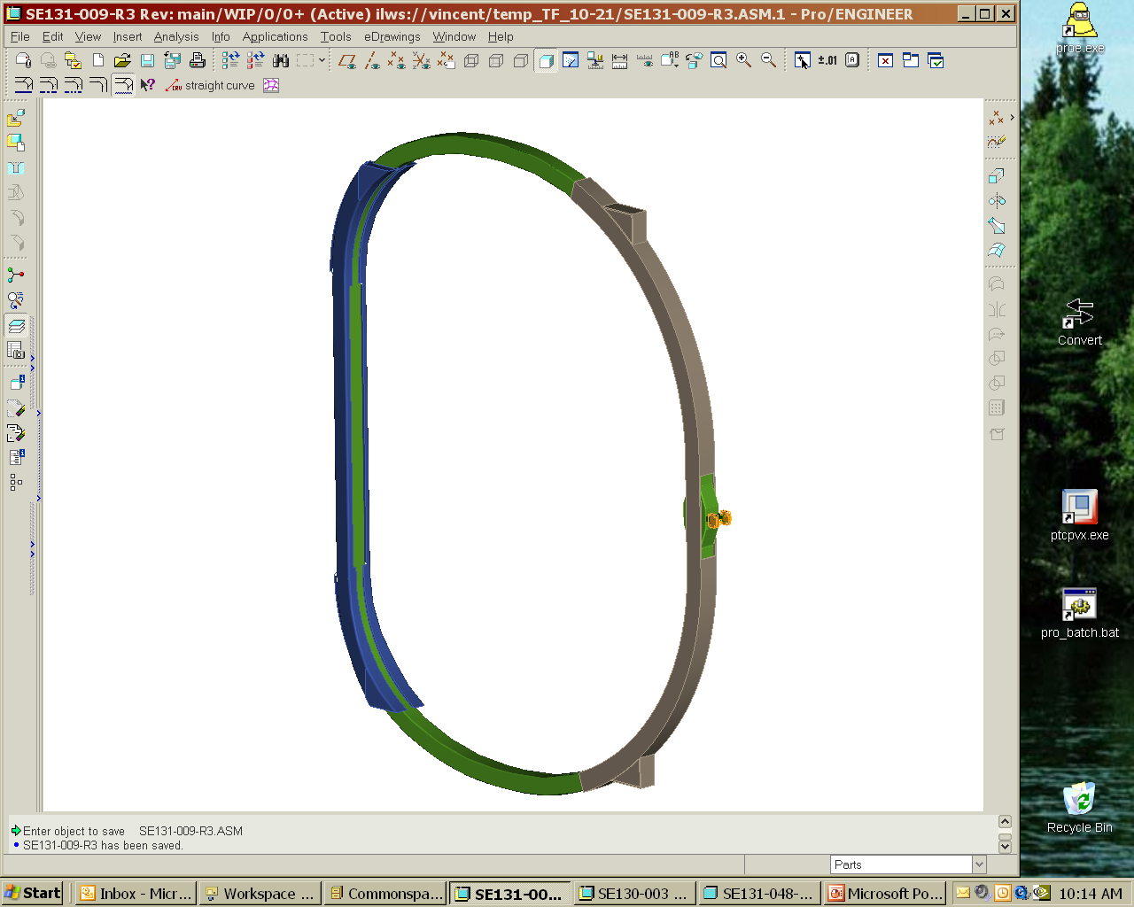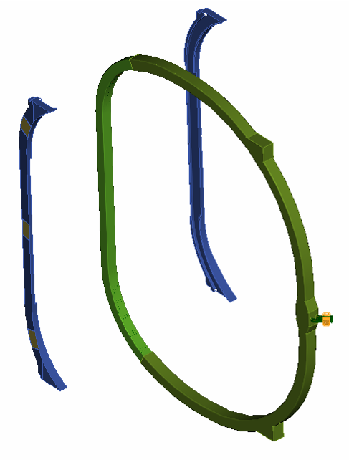
Wedge
Structures
Figure 1 - TF Coil With Wedge Structures

Applicable Documents

PPPL Drawing

TF Coil Nose Structure Machining Detail Drawing # SE131-007-00 Sheets 1 and 2

Codes and Standards
The version of the code or standard in effect at the date of the subcontract award shall be applicable to this specification.

American Society for Testing and Materials (ASTM) Documents

ASTM A 240/A 240M – 05a, Standard Specification for Chromium and Chromium-Nickel Stainless Steel Plate, Sheet, and Strip for Pressure Vessels and for General Applications

ASTM A 276 – 05a, Standard Specification for Stainless Steel Bars and Shapes

ASTM A 479/A 479M – 05, Standard Specification for Stainless Steel Bars and Shapes for Use in Boilers and Other Pressure Vessels

American Welding Society
AWS D1.6 “Structural Welding Code – Stainless Steel”

American Society of Mechanical Engineers
ASME Boiler and Pressure Vessel Code, Section V, Nondestructive Examination

Requirements

Item Definition
The item covered in this specification is the TF wedge structure. This specification defines the TF wedge structure and requirements for its fabrication.

Characteristics

Performance

Materials

Stainless Steel
The wedge structure shall be constructed of UNS S31600 stainless steel per ASTM A240, A276, and/or A479. Stainless steel alloys other than UNS S31600 can be proposed if it can be demonstrated that they meet NCSX strength, toughness, ductility, and magnetic permeability requirements. Use of alloys other than Grade 316 will require prior approval by the NCSX project.

Weld Wire
Weld filler metal shall meet the requirements of the applicable AWS A series specifications or ASME SFA specifications. Certified Material Test Reports shall be supplied for all materials. Weld wire must produce welds with relative magnetic permeability not to exceed 1.02 mu

Mechanical Properties
The properties of the stainless steel and welds shall meet or exceed the mechanical properties requirements stated in Table 3-1.
Table 3-1 Minimum Mechanical Properties
Temperature | 77K | 293K
Elastic Modulus | 21 Msi (144.8 GPa) | 20 Msi (137.9 GPa)
0.2% Yield Strength | 72 ksi (496.4 MPa) | 30 ksi (206.8 MPa)
Tensile Strength | 95 ksi (655 MPa) | 78 ksi (537.8 MPa)
Elongation | 32% | 36%

Surface Finish
Surface finishes are specified on the drawing(s) referenced in 2.1.1. The finished part shall be free of sharp edges and burrs.

Relative Magnetic Permeability
The relative magnetic permeability of the completed weldment shall not exceed 1.02 mu

Weld Examination Requirements
Welds shall be visually inspected in accordance with the acceptance criteria of AWS D1.6, Section 6.29.1

Design and Construction

Production Drawings
The structures shall be fabricated in accordance with the TF Coil Nose Structure Machining Detail Drawing SE131-007-00.

Dimensions and Tolerances
The Wedge Structures shall conform to the dimensions and tolerances defined in the production drawings referenced in Section 3.3.1. All dimensions are for 20 C; actual measurements shall be temperature compensated for 20 C. If the Vendor proposes to machine the final wedge profile after the wedge is assembled to the coil the wedge structure may have excess material added to that surface. If the Vendor proposes to locate the wedge geometry within the final coil assembly tolerances by means of a VPI mold fixture then the wedge structure must be machined accurately within its final tolerances prior to assembly to the TF coil.

Stress Relieving
If stress relieving is necessary it shall be performed after all welding is completed. The temperature and duration of the stress relieving process shall be reviewed and approved by PPPL.

Method of Construction
The final part may be constructed by joining a number of smaller parts using full penetration welds provided that the final part meets all of the criteria established in this specification. The full penetration welds are to meet the requirements for cyclically loaded structures of AWS D1.6 Structural Welding Code – Stainless Steel PPPL shall approve the manufacturing drawings, weld details , and seam locations, prior to fabrication.

Welding
All welding shall be performed by qualified personnel using written and qualified welding procedures in accordance with the AWS D1.6. Welding procedure qualifications shall include evidence of compliance with magnetic permeability criteria

Quality Assurance Provisions

General

Responsibility for Inspection
The responsibility for performing all tests and verifications rests with the supplier. PPPL reserves the right to witness or separately perform all tests and inspections.

Quality Conformance Inspections

Verification of Materials

Stainless Steel
Certified Material Test Reports, traceable to the material used and showing actual chemical and physical test results shall be provided for the stainless steel.

Weld Wire
Vendor to supply manufacturer’s material certifications showing that the chemistry of the weld wire meets the requirements of Section 3.2.1.1.2

Verification of Mechanical Properties of Welds
In addition to the AWS requirements, the welding procedure qualification shall demonstrate by testing that the mechanical properties comply with Section 3.2.1.2 .

Verification of Surface Finish
All machined surfaces shall be inspected for compliance with surface finish requirements specified in Section 3.2.1.3. Either a surface profilometer or comparator can be used.

Verification of Relative Magnetic Permeability
Relative magnetic permeability shall be checked with a calibrated Severn Permeability Indicator for compliance with Section 3.2.1.4. Relative magnetic permeability that exceeds 1.02 Mu must be documented on a nonconformance report and will require approval on a case-by-case basis. Permeability checks shall, at minimum, be taken on either side of the wedge structure every 4 inches along its length and at a minimum of 4 representative locations on each weld.

Verification of Dimensions and Tolerances
All surfaces, and features shall be dimensionally checked to assure compliance with Section 3.3.2.

Inspection for External Defects
All welds shall be visually inspected using a written procedure prepared in accordance with Article 9 of Section V of the ASME Code. The acceptance criteria for the visually inspected welds are given in AWS D1.6, Paragraph 6.29.1. All welds that do not meet the stated acceptance criteria shall be documented repaired and re-inspected. Visual weld inspection shall be done by inspectors certified to perform visual inspection of welds in accordance with AWS QC1 or ASNT SNT-TC-1A, Level II or Level III, or PPPL approved equivalent requirements.

Preparation for delivery

Marking
Each structure shall have the supplier's name, a serial number (drawing number and a unique identifier), marked or stamped with characters ¼ inches high. The marking shall be located as shown in the part drawing.

Cleaning
The structure shall be degreased/cleaned using a PPPL approved solvent which must be able to dissolve grease, oils and other soils, and leave the structure residue free. No chips, burrs, oil, etc. shall remain in any of the tapped holes.

Publications are available from http://www.astm.org/cgi-bin/SoftCart.exe/index.shtml?E+mystore.

