NCSX
Specification

System Requirements Document (SRD)
For the
Toroidal Field Coils (WBS 131)

NCSX-BSPEC-131-00

Draft A

05 November 2004

Prepared by: __________________________________________________________________________
M. Kalish (WBS 13) Manager

Concur: ______________________________________________________________________________
B. Nelson, Project Engineer for Stellarator Core Systems (WBS 1)

Concur: ______________________________________________________________________________
M. Zarnstorff, Head, Project Physics

Concur: ______________________________________________________________________________
R. Simmons, Systems Engineering Support Manager

Concur: ______________________________________________________________________________
W. Reiersen, Engineering Manager

Concur: ______________________________________________________________________________
J. Levine, ES&H

Concur: ______________________________________________________________________________
J. Malsbury, Quality Assurance

Approved by: _________________________________________________________________________
G. H. Neilson, NCSX Project Manager
Controlled Document
This is a controlled document. Check the NCSX Engineering Web prior to use to assure that this document is current.
Record of Revisions

Revision | Date | ECP | Description of Change
Rev. 0 |  | - | Initial issue
TABLE OF CONTENTS
1 Scope 1
1.1 Document Overview 1
1.2 Incomplete and Tentative Requirements 1
2 Applicable Documents 2
2.1 NCSX Documents 2
3 Subsystem Requirements 3
3.1 Subsystem Definition 3
3.1.1 Subsystem Diagrams 3
3.1.1.1 Functional Relationships 3
3.1.1.2 Functional Flow Block Diagram 4
3.1.2 Interface Definition 4
3.1.2.1 Conventional Coils (WBS 13) 4
3.1.2.2 Modular Coils (WBS 14) 4
3.1.2.3 Coil Support Structures (WBS 15) 5
3.1.2.4 LN2 Distribution System (WBS 161) 5
3.1.2.5 Electrical Leads (WBS 162) 5
3.1.2.6 Coil Protection System (WBS 163) 5
3.1.2.7 Cryostat (WBS 171) 5
3.1.2.8 Field Period Assembly (WBS 18) 5
3.1.2.9 Magnetic Diagnostics (WBS 31) 5
3.1.2.10 Electrical Power Systems (WBS 4) 5
3.1.2.11 Central I&C (WBS 5) 6
3.1.2.12 Central I&C (WBS 5) 6
3.1.2.13 Cryogenic Systems (WBS 62) 6
3.1.2.14 Test Cell Preparations and Machine Assembly (WBS 7) 6
3.1.3 Major Component List 6
3.2 Characteristics 6
3.2.1 Performance 6
3.2.1.1 Perform Initial and Pre-run Verification 6
3.2.1.1.1 Initial Facility Startup 6
3.2.1.1.1.1 Initial Verification of Operability 6
3.2.1.1.1.2 Field Line Mapping 7
3.2.1.1.1.3 Design Verification 7
3.2.1.1.2 Pre-Run Facility Startup 7
3.2.1.2 Prepare for and Support Experimental Operations 7
3.2.1.2.1 Subsystem Verification and Monitoring 7
3.2.1.2.2 Coil Cooldown 7
3.2.1.2.2.1 Timeline for Coil Cool-down to Cryogenic Temperature 8
3.2.1.2.3 Bakeout 8
3.2.1.2.3.1 Coil Temperatures during Bakeout 8
3.2.1.2.3.2 Bakeout Cycles 8
3.2.1.2.4 Pre-Pulse Temperature 8
3.2.1.2.5 Field Error Requirements 8
3.2.1.2.5.1 Eddy Current Time Constants 8
3.2.1.2.5.2 Winding Tolerance 8
3.2.1.2.5.3 Deflections under Load 9
3.2.1.2.6 Plasma Magnetic Field Requirements 9
3.2.1.2.6.1 Magnetic Field Polarity 9
3.2.1.2.6.2 Reference Scenario Requirements 10
3.2.1.2.6.3 Flexibility Requirements 10
3.2.1.2.7 Disruption Handling 10
3.2.1.2.8 Pulse Repetition Rate 10
3.2.1.2.9 Discharge Termination 10
3.2.1.2.9.1 Normal Termination 10
3.2.1.2.9.2 Abnormal Termination 11
3.2.1.3 Shut Down Facility 11
3.2.1.3.1 Coil Warm-up Timeline 11
3.2.2 Physical Characteristics 11
3.2.2.1 Configuration Requirements and Essential Features 11
3.2.2.1.1 TF Coils (WBS 131) 11
3.2.3 System Quality Factors 12
3.2.3.1 Reliability, Availability, and Maintainability 12
3.2.3.2 Design Life 12
3.2.3.3 Seismic Criteria 12
3.2.4 Transportability 13
3.3 Design and Construction 13
3.3.1 Materials, Processes, and Parts 13
3.3.1.1 Magnetic Permeability 13
3.3.1.2 Structural and Cryogenic Criteria 13
3.3.1.3 Corrosion Prevention and Control 13
3.3.1.4 Metrology 13
3.3.2 Electrical Grounding 13
3.3.3 Nameplates and Product Marking 13
3.3.3.1 Labels 13
3.3.4 Workmanship 14
3.3.5 Interchangeability 14
3.3.6 Environmental, Safety, and Health (ES&H) Requirements 14
3.3.6.1 General Safety 14
3.3.6.2 Personnel Safety 14
3.3.6.3 Flammability 14
3.4 Documentation 14
3.4.1 Specifications 14
3.5 Logistics 15
3.5.1 Maintenance 15
4 Quality Assurance Provisions 16
4.1 General 16
4.2 Verification Methods 16
4.3 Quality Conformance 16
Appendix A – Quality Conformance Matrix 17
Appendix B – Technical Data 18

Table of Figures
Figure 3-1 Modular coil system functional relationships 3
Figure 3-2 Functional flow block diagram 4
Figure 3-3 NCSX coordinate system 9

Table of Tables
Table 3-1 TF coil specifications 14

Scope
The National Compact Stellarator Experiment (NCSX) is an experimental research facility that is to be constructed at the Department of Energy’s Princeton Plasma Physics Laboratory (PPPL). Its mission is to acquire the physics knowledge needed to evaluate compact stellarators as a fusion concept, and to advance the understanding of 3D plasma physics for fusion and basic science.
A primary component of the facility is the stellarator core, an assembly of four coil systems that surround a highly shaped plasma and vacuum chamber. The four coil systems include the modular coils, the poloidal field (PF) coils, the toroidal field (TF) coils, and the external trim coils. These coils provide the magnetic field required for plasma shaping and position control, inductive current drive, and error field correction. This specification addresses the requirements for the Torroidal Field Coils

Document Overview
This document, the System Requirements Document (SRD) for the TF Coils (WBS 13), is the complete development specification for this subsystem. Performance requirements allocated to this subsystem in the system specification, the General Requirements Document (NCSX-GRD-01), have been incorporated in this document. In this document, the term “the system” refers to the overall device and facility and the terms “the subsystem” and “TF Coils” refer to the Torroidal Field Coils (WBS 13).
The specification approach being used on NCSX provides for a clear distinction between performance requirements and design constraints. Performance requirements state what functions a system has to perform and how well that function has to be performed. Design constraints, on the other hand, are a set of limiting or boundary requirements that must be adhered to while allocating requirements or designing the system. They are drawn from externally imposed sources (e.g., statutory regulations, DOE Orders, and PPPL ES&H Directives) as well as from internally imposed sources as a result of prior decisions, which limit subsequent design alternatives.

Incomplete and Tentative Requirements
Within this document, the term “TBD” (to be determined) indicates that additional effort (analysis, trade studies, etc) is required to define the particular requirement. The term “TBR” (to be revised) indicates that the value given is subject to change.

Applicable Documents
The following documents form a part of this specification to the extent specified herein. In the event of a conflict, the contents of this specification shall be considered a superseding requirement.

NCSX Documents
- Project Execution Plan (NCSX-PLAN-PEP-XX)
- General Requirements Document (NCSX-ASPEC-GRD-XX)
- Stellarator Core Systems (WBS 1) WBS Dictionary (NCSX-WBS1-XX)
- Structural and Cryogenic Design Criteria (NCSX-CRIT-CRYO-XX)
- Seismic Design Criteria (NCSX-CRIT-SEIS-XX)
- Reliability, Availability, and Maintainability Plan (NCSX-PLAN-RAM-XX)
Note: In the document names above, XX denotes the latest issue.

Subsystem Requirements

Subsystem Definition
The TF coil system consists of 18 identical, equally spaced TF coils providing a 1/R field at the plasma. The coils operate within the cryostat and are cooled by liquid nitrogen.

Subsystem Diagrams

Functional Relationships
A block diagram of the TF Coils and their environment is depicted in Figure 3-1.
TBD
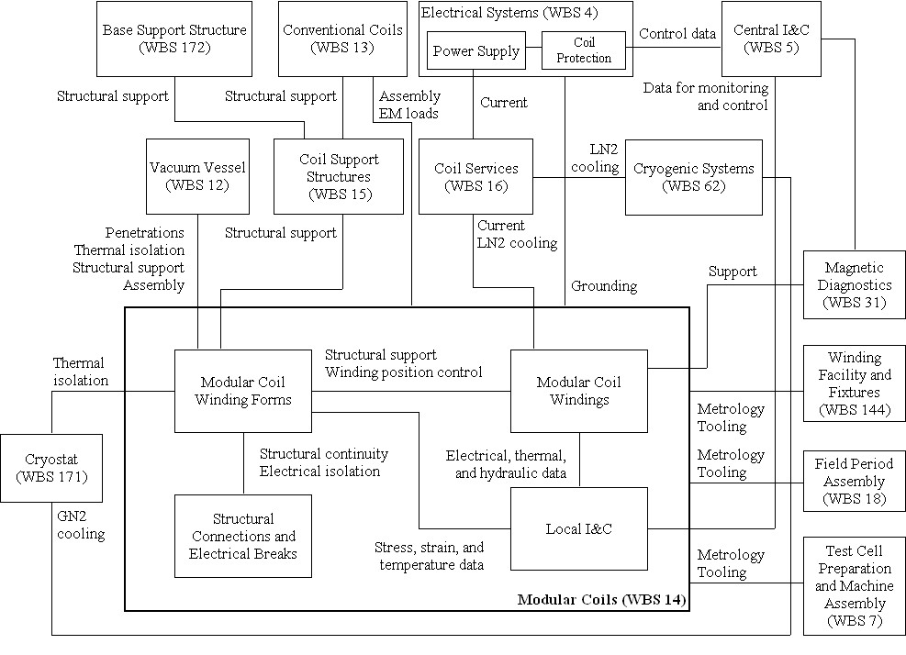

Figure 3-1 Modular coil system functional relationships

Functional Flow Block Diagram
A functional flow block diagram (FFBD) is provided in Figure 3-2.
?????
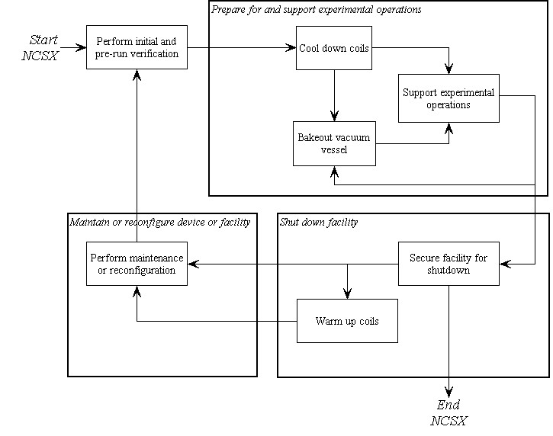
Figure 3-2 Functional flow block diagram

Interface Definition

Conventional Coils (WBS 13)
Conventional Coils (WBS 13) includes in addition to the toroidal field (TF) coils, the poloidal field (PF), and external trim coils. Although there is no physical contact between these coils and the TF Coils, they are all inside the cryostat and clearances must be maintained under all operating conditions. Also Modeling of the operating scenarios includes parameters for the PF coils that will effect the TF coil stress and deflections.

Modular Coils (WBS 14)
Operation of the Modular coils as defined by the references scenarios in the GRD has a direct effect on the stresses and deflections induced in the TF Coils.

Coil Support Structures (WBS 15)
The Coil Support Structures (WBS 15) include a group of elements that form structural plates above and below the TF Coils coils. These elements attach the TF coils to the modular coil winding forms. The upper and lower supports provide both vertical and out of plane support to the TF Coils. Supports also exist outboard to apply inward radial loading to the TF Coils. These loads are transmitted through the modular coil shell to the lower plate along with gravity loads from the modular coils, vacuum vessel, and in-vessel components. Gravity loads from the stellarator core are transmitted through the lower plate to the Base Support Structure (WBS 172).

LN2 Distribution System (WBS 161)
Liquid nitrogen for coil cooling is supplied from the Cryogenic Systems (WBS 62) to the LN2 Distribution System (WBS 161), which in turn supplies the liquid nitrogen to the individual TF coils.

Electrical Leads (WBS 162)
The current and voltage required to drive the TF coils is supplied from the Electrical Power Systems (WBS 4) to the Electrical Leads (WBS 162), which in turn supplies the direct current (DC) power to the individual TF coils.

Coil Protection System (WBS 163)
The Coil Protection System (WBS 163) includes all the activities required to develop the coil protection logic and specification of coil protection parameters, including TF coils. The Coil Protection System (WBS 163) does not include any hardware or software.

Cryostat (WBS 171)
Although there is no physical contact between the Cryostat (WBS 171) and the TF Coils, the cryostat does provide thermal isolation from the environment outside the cryostat and containment for the cold, dry nitrogen environment inside the cryostat. The TF Coil is both cooled by the internal LN2 cooling and the external cooling provided by the cryostat. The nitrogen environment inside the cryostat is maintained by the Cryogenic Systems (WBS 62).

Field Period Assembly (WBS 18)
The TF coils will have interfaces with the tooling and metrology equipment required for field period assembly, including lifting points and monuments to facilitate position measurements.

Magnetic Diagnostics (WBS 31)
Diagnostic magnetic field sensor loops will be incorporated into TF coils The loop will be on the side of the coil facing the plasma.

Electrical Power Systems (WBS 4)
- The current and voltage required to drive the TF coils is supplied from the Electrical Power Systems (WBS 4) to the Electrical Leads (WBS 162), which in turn supplies the direct current (DC) power to the individual TF coils.
- Electrical Power Systems (WBS 4) provide coil protection via parameters measured in the power supply circuitry based on parameters provided by Coil Protection System (WBS 163) activities. Electrical Power Systems (WBS 4) also provides coil protection via permissives and trip signals provided by Central I&C (WBS 5) in response to the output from sensors included in the local I&C within the TF Coil System (WBS 13).

Central I&C (WBS 5)
Central I&C (WBS 5) is responsible for taking the output from the sensors (e.g. strain gauges, resistance temperature detectors, and thermocouples) provided in the local I&C in the TF Coil System (WBS 13), processing those signals, displaying and storing the data, and providing permissives and trip signals for coil protection to Electrical Power Systems (WBS 4) in accordance with the coil protection logic and parameters specified by the Coil Protection Systems (WBS 163).

Central I&C (WBS 5)
Central I&C (WBS 5) is responsible for taking the output from the sensors provided in the local I&C in the Vacuum Vessel System (WBS 12), processing those signals and displaying and storing the data.

Cryogenic Systems (WBS 62)
- Cryogenic Systems (WBS 62) are responsible for providing liquid nitrogen cooling for the TF coils via the LN2 Distribution System (WBS 161).
- Cryogenic Systems (WBS 62) are responsible for providing the gaseous nitrogen cooling within the cryostat required to cool and maintain the external temperature of the TF coil.

Test Cell Preparations and Machine Assembly (WBS 7)
The TF coils will have interfaces with the tooling and metrology equipment required for field period assembly.

Major Component List
There are no major components for which additional development specifications are planned.

Characteristics

Performance

Perform Initial and Pre-run Verification

Initial Facility Startup
Background
Initial facility startup includes all activities required to verify safe operation of NCSX systems after their initial assembly and installation, or after a major facility reconfiguration, and before plasma operations. Initial facility startup activities would be performed prior to First Plasma and will include subsystem pre-operational test procedures (PTPs) and an Integrated System Test Program (ISTP) to verify that the system operates safely and as expected prior to plasma operation. For example, the ISTP will include verification of proper coil polarities and power supply connections. The ISTP will also include verification that, at First Plasma, the system demonstrates a level of system performance sufficient for the start of research operations, as specified in the Project Execution Plan (NCSX-PLAN-PEP-01). A subset of the ISTP will be conducted before the start of a run.

Initial Verification of Operability
The subsystem shall provide the capability to perform subsystem PTPs and support a comprehensive ISTP, to verify, prior to plasma operation that the system is properly configured, functioning correctly, and can be operated safely. [Ref. GRD Section 3.2.1.1]

Field Line Mapping
- The subsystem shall perform the capability to perform field line mapping with current waveforms as specified in the Field Line Mapping Scenario (Appendix B, Section A.3.2) with the modular coils starting at room temperature prior to completely installing the cryostat.
- The subsystem shall perform the capability to perform field line mapping with current waveforms as specified in the Field Line Mapping Scenario (Appendix B, Section A.3.2) with the modular coils starting at cryogenic temperature (nominally 80K) after completely installing the cryostat. [Ref. GRD Section 3.1.2a]

Design Verification
The subsystem shall be instrumented such that key vacuum vessel performance parameters (stresses, deflections, temperatures, etc.) can be measured and compared to calculated values to assure that the subsystem is performing consistent with the design intent prior to First Plasma.

Pre-Run Facility Startup
Background
Pre-run facility startup includes all activities required to verify safe operation of the NCSX subsystems after a major maintenance outage or a minor facility reconfiguration (one affecting a small number of subsystems). Pre-run facility startup activities would typically be performed prior to the start of a run period and would include a subset of the full PTP and ISTP activities referred to in Section 3.2.1.1.1.
Requirement
The subsystem shall support the capability to perform a controlled startup of the facility, and verify that the subsystem is properly configured, functioning correctly, and can be operated safely. [Ref. GRD Section 3.2.1.2]

Prepare for and Support Experimental Operations

Subsystem Verification and Monitoring
Background
Pre-operational initialization and verification activities would generally cover those activities required prior to the start of an operating day following an overnight or weekend shutdown. Pre-pulse initialization and verification activities cover those activities required prior to the start of each pulse (plasma discharge). The TF Coils (WBS 13) should be monitored to verify that the subsystem is functioning correctly and configured properly at the start of an operating day and prior to the start of each pulse.
Requirement
The subsystem shall provide the capability to verify that the subsystem is properly configured, functioning correctly, and can be operated safely prior to the start of an operating day and prior to the start of each pulse (plasma discharge). [Ref. GRD 3.2.1.3 and GRD 3.2.1.4]

Coil Cooldown
Background
The Integrated System Test Program (ISTP) will include coil testing and initial field line mapping with the coils around room temperature to facilitate engineering shakedown and testing with portions of the cryostat removed. The coils will be cooled to cryogenic temperatures for First Plasma. (In this context, cryogenic temperatures are around 80K (the saturation temperature of liquid nitrogen at slightly above 1 atmosphere).
Prior to experimental operations, the cryo-resistive coils must be cooled down from room temperature to a pre-pulse operating temperature of about 80K. The coils are located in a dry nitrogen environment that is provided by the cryostat, which surrounds the coils. In order to gain access to the interior of cryostat, the coils must be warmed up from operating temperature to room temperature. The anticipated operational plans are expected to result in up to less than 150 cool-down and warm-up cycles between room temperature and operating temperature over the lifetime of the machine.

Timeline for Coil Cool-down to Cryogenic Temperature
The TF Coils shall be capable of being cooled down from room temperature (293K) to their pre-pulse operating temperature within 96 hours with the vacuum vessel at room temperature (20°C). [Ref. GRD Sections 3.2.1.2.1.1 and 3.2.1.2.1.3]

Bakeout
Background
The temperature of the vacuum vessel shell will be capable of being elevated to a nominal temperature of 150ºC for vacuum vessel bakeout operations and to a nominal temperature of 350ºC to support bakeout of an in-vessel carbon-based liner (to be installed as an upgrade) at that temperature. Initially, there will not be any limiters installed in the vacuum vessel for first plasma or field line mapping. However, later in the program, the liner will be installed inside the vacuum vessel with a surface area that is a substantial part of the vacuum vessel surface area to absorb the high heat loads and to protect the vacuum vessel and internal components. The capability to bake the vessel with the cryo-resistive coils at cryogenic temperature is required.

Coil Temperatures during Bakeout
The capability to bakeout the vacuum vessel with the TF coils below 90K shall be provided. The TF coils shall return to their pre-pulse operating temperatures within the 24 hours following completion of bakeout. [Ref. GRD Section 3.2.1.2.3.3]

Bakeout Cycles
The device shall be designed for at least 1000 bakeout cycles over the life of the machine. [Ref. GRD Section 3.2.1.2.3.6]

Pre-Pulse Temperature
The modular coils shall return to a pre-pulse temperature of about 80K, so as to prevent overheating during repeated operation, with a vacuum vessel shell temperature in the range of 40ºC to 250 C. [Ref. GRD Section 3.2.1.4.2]

Field Error Requirements
Background
Field errors are a major concern in the design of NCSX. The fundamental global requirement is that the toroidal flux in island regions due to fabrication errors, magnetic materials, and eddy currents shall not exceed 10% of the total toroidal flux in the plasma (including compensation). To implement this requirement, external trim coils have been provided for field error correction. The TF coils will be fabricated and assembled to tight tolerances which are calculated to introduce acceptably low field errors after deflections due to EM loads are taken into account.

Eddy Current Time Constants
The time constant of the longest-lived eddy current eigenmode shall be less than 20 ms. [Ref. GRD Section 3.1.5.2c]????

Winding Tolerance
The local current centroid of each modular coil shall be located within TBD of the nominal location defined in Section A.1.1 Coil Centroids with the TF coils at the pre-pulse operating temperature with zero current.

Deflections under Load
- TF coils shall be designed such that deflections due to thermal growth and due to electromagnetic loads preserve stellarator symmetry.
Deflections due to electromagnetic loads shall not exceed TBD

Plasma Magnetic Field Requirements

Magnetic Field Polarity
Background
Figure 3-3 illustrates the right-handed coordinate system used for the stellarator and test cell on NCSX. The Z-axis of the coordinate system is vertical. The major axis of the stellarator is coincident with the Z-axis. The following conventions are followed:
- A positive toroidal (plasma) current or a positive toroidal magnetic field point in the φ-direction (counter-clockwise viewed from above).
- A positive vertical magnetic field points in the Z-direction (upward).
- A positive poloidal current (TF or modular coil current in the inner leg) flows in the Z-direction and provides a positive toroidal magnetic field.
- Positive radial magnetic fields and currents are in the R-direction, radially outward from the Z-axis, the major axis of the stellarator.
[Ref. GRD Section 3.2.1.5.3.1]
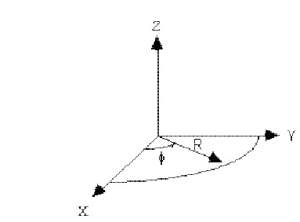
Figure 3-3 NCSX coordinate system

Requirements
- The TF coils shall be configured for the standard magnetic field polarity to have its toroidal field in the negative direction.
- The TF coils shall have the capability to be reconfigured to operate with the magnetic field polarity reversed from its standard direction.
[Ref. GRD Section 3.2.1.5.3.2]

Reference Scenario Requirements
Background
NCSX is designed to be a flexible, experimental test bed. To ensure adequate dynamic flexibility, a series of reference scenarios has been established. TF, PF, and modular coil systems and the vacuum vessel will be designed for a plasma with a nominal major radius of 1.4 m and capability to meet the requirements of all the reference scenarios. Electrical power systems shall be designed and initially configured to meet the requirements of the First Plasma and Field Line Mapping Scenarios and shall be capable of being upgraded to meet the requirements of all other reference scenarios.
Reference scenario definitions are provided in Section 3.2.1.5.3.3.1 of the General Requirements Document. Reference waveforms of engineering parameters such as coil currents, voltages, power dissipation, etc. are derived from the scenario specifications and are documented in Appendix B.
Requirement
The TF coils will be designed to meet the requirements of all the reference scenarios. [Ref. GRD Section 3.2.1.5.3.3.2]

Flexibility Requirements
Background
NCSX is designed to be a flexible, experimental test bed. To ensure that changes in equilibria can be accommodated, several dimensions have been identified over which changes in equilibria must be accommodated.
Flexibility requirements have been established for a toroidal magnetic field of 1.7T. Greater flexibility exists at lower field levels.
The NCSX Project has determined that the required flexibility can be achieved with the TF coil capabilities developed in response to the reference scenarios. Therefore, no additional requirements are placed on the TF coils to satisfy flexibility requirements for the overall device and facility.
Requirements
None

Disruption Handling
The TF Coils shall be designed to withstand electromagnetic forces due to major disruptions characterized by instantaneous disappearance of the plasma at the maximum plasma current of 320 kA [Ref. GRD Section 3.2.1.5.5]

Pulse Repetition Rate
The TF coils shall be designed for pulses to be initiated at intervals not exceeding 15 minutes when constrained by cool-down and 5 minutes otherwise. [Ref. GRD Section 3.2.1.5.10]

Discharge Termination

Normal Termination
Background
Normal termination includes all system actions necessary to shutdown the plasma and associated subsystems at the conclusion of a pulse in preparation for the next pulse.
Requirement
During a controlled shutdown, the TF coil currents will be driven to zero by the power supplies according to the pre-programmed current waveform. [Ref. GRD Section 3.2.1.5.11.1]

Abnormal Termination
Background
Abnormal termination consists of all system responses necessary to remove conditions that occur during experimental operations that could cause significant damage to the NCSX system or cause injury to personnel.
Requirement
??? During an abnormal termination, the TF coil power supplies will be bypassed and the TF coil currents will go to zero on the natural decay times of the coil circuits. [Ref. GRD Section 3.2.1.5.11.2]

Shut Down Facility
Background
Facility shutdown involves the shutdown of NCSX equipment following the termination of a discharge (per Section 3.2.1.2.9) in preparation for a brief (overnight or weekend) or extended (between run periods) shutdown.
Requirement
The NCSX system shall provide the capability to perform a controlled shutdown of the TF Coils. [Ref. GRD Section 3.2.1.6]

Coil Warm-up Timeline
The cryo-resistive coils (TF, PF, and modular coils) shall be capable of being warmed up from operating temperature (80K) to room temperature (293K) within a period of 96 hours. [Ref. GRD Section 3.2.1.6.1]

Physical Characteristics

Configuration Requirements and Essential Features

TF Coils (WBS 131)
Background
There are 18 identical, equally spaced TF coils providing 1/R field at the plasma. The D shaped coils are wound from hollow copper conductor and vacuum impregnated with glass-epoxy. They operate within the cryostat and are cooled by LN2 nominally to 80K. The inboard face of the coils is machined so that inward radial loads are reacted by wedging against the adjacent TF Coil. Other loads are reacted by structural elements attached to the Modular Coil Winding Forms.
Requirements
- The wedged shape inboard surfaces of the coil must be held to exacting tolerances so that centering EM loads are evenly distributed amongst the adjacent TF Coils
- Provisions must exist to apply adequate centering forces for the TF Coils adequate to react outward EM loads if analysis of the reference scenarios reveal such loads exist
- The geometric tolerances for the TF Coil must be held in the manufacture of the coil as well as maintained during shipping adequate to meet the requirements spelled out in Field Error Requirements 3.2.1.2.5 .

System Quality Factors

Reliability, Availability, and Maintainability
Background
The overall objective is to provide a device with high operational availability, meaning that the number of plasma discharges achieved in a run period is a large percentage (greater than 75%) of the number planned after the initial shakedown and commissioning phases of the facility. Bottoms-up reliability predictions are difficult to perform and have large uncertainties for first-of-a-kind experimental devices such as NCSX. Therefore, quantitative RAM requirements on NCSX will be few. Rather, NCSX will rather rely on sound engineering practice to assure high availability in NCSX, which has been the tried-and-true approach on similar scale fusion devices. Sound engineering practices include:
- Applying design principles that promote reliability (e.g., employing an adequate factor of safety on mechanical and electrical stresses, avoiding unnecessary complexity, using proven design approaches and well characterized materials, etc.)
- Optimizing designs for reliability and maintainability through systematic evaluation of design options,
- Performing failure modes, effects and criticality analysis (FMECAs) for RAM design improvement and verification, and
- Employing peer reviews as a mechanism to enhance the design process.
The NCSX RAM Plan defines the processes that will be used by the Project to achieve a device with high availability.
Requirements
- The TF Coils shall incorporate reliability and maintainability features in the design that are consistent with achieving a high (greater than 95%) operational availability.
- Provisions for recovery shall be made for every credible failure mode.
- The TF Coils shall be capable of being disassembled and reassembled to permit replacement of any part or machine reconfiguration that would require disassembly.
- Provisions for lifting, e.g. lifting eyes, other sling attachment provisions, or equivalent provisions, shall be made in the design of the TF Coils.
[Ref. GRD Section 3.2.4.1]

Design Life
- The TF Coils shall have a design life of >10 years.
- The TF Coils shall be designed for the following maximum number of pulses based on the factors for fatigue life specified in the NCSX Structural and Cryogenic Design Criteria Document:
- 100 per day;
- 13,000 per year; and
- 130,000 lifetime.
[Ref. GRD Section 3.2.4.2]

Seismic Criteria
Background
NCSX systems shall be designed in accordance with seismic design and evaluation criteria for Performance Category 1 (PC1) facilities, per DOE-STD-1020-2002, “Natural Phenomena Hazards Design and Evaluation Criteria for Department of Energy Facilities.” The NCSX Seismic Design Criteria provides an NCSX-specific interpretation of those requirements
Requirement
The TF Coils shall be design in accordance with the NCSX Seismic Design Criteria. [Ref. GRD Section 3.3.1.5]

Transportability
The TF Coils and components shall be transportable by commercial carrier via highway, air, sea, or railway. [Ref. GRD Section 3.2.5]

Design and Construction

Materials, Processes, and Parts

Magnetic Permeability
All materials (including weld materials) used in the TF Coils must have a relative magnetic permeability less than 1.02 unless otherwise authorized by the Project. [Ref. GRD Section 3.3.1.1]

Structural and Cryogenic Criteria
The TF Coils shall be designed in accordance with the NCSX Structural and Cryogenic Design Criteria. [Ref. GRD Section 3.3.1.3]

Corrosion Prevention and Control
Materials, processes, and protective surface treatments or finishes shall be provided to ensure that equipment capability during its service life is not degraded due to corrosion. Where possible, contact between dissimilar metals shall be avoided. [Ref. GRD Section 3.3.1.4]

Metrology
The TF Coils shall provide features (e.g., fiducial markers) to facilitate accurately measuring and locating components relative to the magnetic field for the life of the machine. [Ref. GRD Section 3.3.1.6]

Electrical Grounding
??? The TF Coil winding electrical circuits are connected to a single point ground by the Electrical Power Systems (WBS 4). [Ref. GRD Section 3.3.2]

Nameplates and Product Marking

Labels
Equipment and any parts of that equipment to be used by personnel shall be identified with appropriate labels. Labels shall indicate clearly and concisely the function and purpose of the item being labeled. Hierarchical labeling shall be used to facilitate component location on control panels. The terminology used for equipment, procedures, and training materials shall be the same for each case. Label design shall be consistent to promote simplicity and avoid clutter. The use of abbreviations and acronyms shall be minimized. Permanent labels shall be attached to the specific component or equipment in such a manner that environmental conditions or usage by personnel will not remove or destroy the label. Temporary labels shall be used only when necessary and shall not obscure other information or equipment. If a temporary label is to designate a device that is out of service, the label shall be applied so that it prevents the use of that device. Labeling shall be legible and conform to human visual capabilities and limitations in regard to physical characteristics. [Ref. GRD Section 3.3.3.1]

Workmanship
During TF Coil fabrication and finishing, particular attention shall be given to freedom from blemishes, defects, burrs, and sharp edges; accuracy of dimensioning radii of weld fillets; making of parts; thoroughness of cleaning; quality of brazing, welding, riveting, painting, and wiring; alignment of parts; and tightness and torquing of fasteners. [Ref. GRD Section 3.3.4]

Interchangeability
Design tolerances shall permit parts and assemblies of the same part number to be used as replacement parts without degrading the specified performance of the parent item. [Ref. GRD Section 3.3.5]

Environmental, Safety, and Health (ES&H) Requirements

General Safety
- When utilized within its intended use and within specified environments, the safe operation, test, handling, maintenance and storage of the TF Coils shall be provided.
- The TF Coils shall not present any uncontrolled safety or health hazard to user personnel.
[Ref. GRD Section 3.3.6.1]

Personnel Safety
The TF Coils shall meet all applicable OSHA requirements in accordance with 29CFR1910. The system shall limit personnel exposure to hazardous materials to below their OSHA permissible exposure limit (PEL). [Ref. GRD Section 3.3.6.3]

Flammability
The use of flammable materials shall be minimized. [Ref. GRD Section 3.3.6.4]

Documentation

Specifications
Specifications shall be developed for each configuration item as shown in Table 3-1.

Table 3-1 TF coil specifications
Configuration Item | Specification Identifier | Specification Type
TF Coil | NCSX-CSPEC-131-XX-XX | Product specification – forms the basis of the TF Coil procurement

Logistics

Maintenance
The TF Coils shall be maintained using, to the extent possible, standard/common tools and existing multi-purpose test equipment. Use of new/special tools and the number of standard/common tools shall be minimized through maximum commonality of fasteners, clamps, adapters, and connectors.

Quality Assurance Provisions

General
This section identifies the methods to be used for verification of requirements in Section Error: Reference source not found of this specification. General definitions of basic verification methods are outlined in Section 4.2 Verification of subsystem requirements will require additional testing in operational or near-operational environments.

Verification Methods
Verification of qualification shall be by analysis, demonstration, inspection, or test. Definition of analysis, demonstration, inspection, and test is as follows:
Analysis: Verification of conformance with required characteristics by calculation or simulation, including computer modeling based on established material or component characteristics.
Demonstration: Verification of conformance with required characteristics by un-instrumented test, performed at ambient, where success is evident by observation; or review of design drawings and specifications; or review of data for similar components and applications
Inspection: Verification of conformance by measuring, examining, testing, and gauging one or more characteristics of a product or service and comparing the results with specified requirements.
Test: Verification by physically exercising a component or system under appropriate loads or simulated operating conditions, including measurement and analysis of performance data.

Quality Conformance
Background
This section establishes the specific evaluation criteria for verification of the subsystem performance requirements in Section 3. In general, all requirements shall be verified under operational or near-operational conditions as possible given test constraints.
Requirements
Test methods for each of the performance characteristics in Section 3 are identified in the Quality Conformance Matrix in Appendix A – Quality Conformance Matrix.

Appendix A – Quality Conformance Matrix

Section | Characteristic | Analysis | Demonstration | Inspection | Test | Comments
3.2 | Characteristics
3.2.1 | Performance
3.2.1.1 | Perform Initial and Pre-run Verification
3.2.1.1.1 | Initial Facility Startup
3.2.1.1.1.1 | Initial Verification of Operability |  | X
3.2.1.1.1.2 | Field Line Mapping |  | X
3.2.1.1.1.3 | Design Verification |  | X
3.2.1.1.2 | Pre-Run Facility Startup |  | X
3.2.1.2 | Prepare for and Support Experimental Operations
3.2.1.2.1 | Subsystem Verification and Monitoring |  | X
3.2.1.2.2 | Coil Cool-down
3.2.1.2.2.1 | Timeline for Coil Cool-down to Cryogenic Temperature |  | X
3.2.1.2.2.2 | Cool-down and Warm-up Cycles | X
3.2.1.2.3 | Bakeout
3.2.1.2.3.1 | Coil Temperatures during Bakeout | X | X
3.2.1.2.3.2 | Bakeout Cycles | X
3.2.1.2.4 | Pre-Pulse Temperature | X | X
3.2.1.2.5 | Field Error Requirements
3.2.1.2.5.2 | Winding Tolerance |  |  | X
3.2.1.2.5.3 | Deflections under Load | X |  |  | X
3.2.1.2.6 | Plasma Magnetic Field Requirements
3.2.1.2.6.1 | Magnetic Field Polarity |  | X
3.2.1.2.6.2 | Reference Scenario Requirements | X |  |  | X
3.2.1.2.6.3 | Flexibility Requirements
3.2.1.2.8 | Pulse Repetition Rate | X | X
3.2.1.2.9 | Discharge Termination
3.2.1.2.9.1 | Normal Termination |  | X
3.2.1.2.9.2 | Abnormal Termination |  | X
3.2.1.3 | Shut Down Facility |  | X
3.2.1.3.1 | Coil Warm-up Timeline | X | X
3.2.3 | System Quality Factors
3.2.3.1 | Reliability, Availability, and Maintainability | X | X
3.2.3.2 | Design Life | X | X
3.2.3.3 | Seismic Criteria | X
3.2.4 | Transportability |  | X

Appendix B – Technical Data
Need Word File For Technical Data !

