NCSX

Product Specification
For the
Poloidal Field Ring Coils
[PF-4 thru 6]

NCSX-CSPEC-132-02-00

27 February 2008

Prepared by: _____________________________________________________
J. Chrzanowski, Responsible NCSX Engineer for PF Coils

Concur: _________________________________________________________
M. Kalish, Technical Coil Expert

Concur: ________________________________________________________________
Frank Malinowski, Procurement Quality Assurance Representative

Approved by: ______________________________________________
Phil Heitzenroeder, RLM for Stellarator Core Systems (WBS 1) Design and Procurement
Controlled Document
This is a controlled document. Check the NCSX Engineering Web prior to use to assure that this document is current.
Record of Revisions

Revision | Date | ECP | Description of Change
0 | 2/27/2008 |  | Initial Issue

Table of Contents
1 Scope 1
2 Applicable Documents 1
3 Requirements 1
3.1 Item Definition 1
3.2 Characteristics 2
3.2.1 Performance 2
3.2.2 Physical Characteristics 4
3.3 Design and Construction 7
3.3.1 Materials, Processes, and Parts 7
3.3.2 Labels 7
3.3.3 Workmanship 7
4 Quality Assurance Provisions 8
4.1 General 8
4.2 Verification 8
4.2.1 Performance Verification 8
4.2.2 Verification of Physical Characteristics 9
5 Appendices 11
5.1 Assembly Models and Drawings 11

Table of Figures
Figure 3-1 PF Coils 4, 5 and 6 1
Figure 3-2 PF4 Joint Lead Area Isometric View 2

Scope
The PF Coils are a primary component of the NCSX Device. There are three types of Poloidal coils that are addressed in this specification- PF4, PF5, and PF6. There are a quantity of two of each type of PF Coil, one upper and one lower for a total of six Poloidal coils. The coils will be cooled with liquid nitrogen and operate in the temperature range of 77 K – 95 K. The coils have a solid copper conductor with coolant hole and are vacuum impregnated with glass insulation. This specification defines the PF Coils and the requirements for their fabrication.

Applicable Documents
NCSX-CSPEC-132-04, Product Specification for the PF Coil Conductor
Assembly Drawings as listed in Section 5

Requirements

Item Definition
PF Ring Coils consist of [3] sets of coils [PF4, PF5 and PF6] manufactured with insulated, extruded copper conductor. Once wound the coils shall be epoxy VPI’d. Figure 3-1 PF Coils 4, 5 and 6 show the coils in their final installed configuration

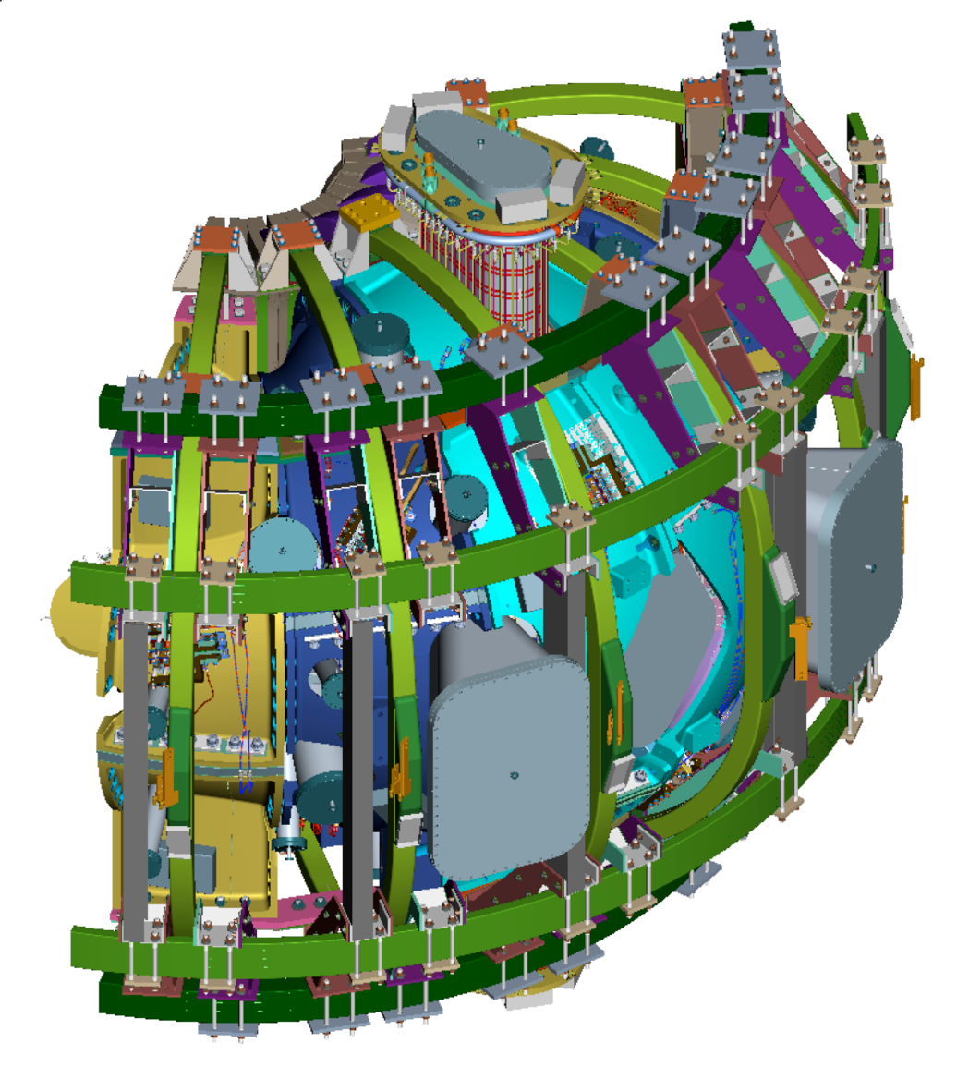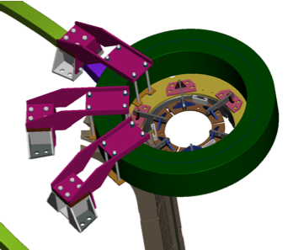
PF-6
PF-5
PF-4
Figure 3-1 PF Coils 4, 5 and 6
- Conductor: The conductor is a continuous length of extruded copper conductor with a center hole. The Product Specification NCSX-CSPEC-132-04 defines the PF Coil Conductor.

- Ground Insulation: The ground insulation consists of multiple layers of fiberglass tape surrounding the winding pack.
- Layer to Layer Insulation: The layer to layer insulation consists of one (1) half-lapped layer of Kapton tape followed by two (2) half-lapped layers of fiberglass tape wound around each turn.
- Coil Leads: The coil leads are machined copper blocks brazed to the ends of the copper conductor to provide lead connections for the PF Coil.
- Insulating/ Support Lead Blocks: G-10 FR-4 or G-11CR lead blocks surround the coil leads to provide mechanical support and electrical isolation to the PF lead area.
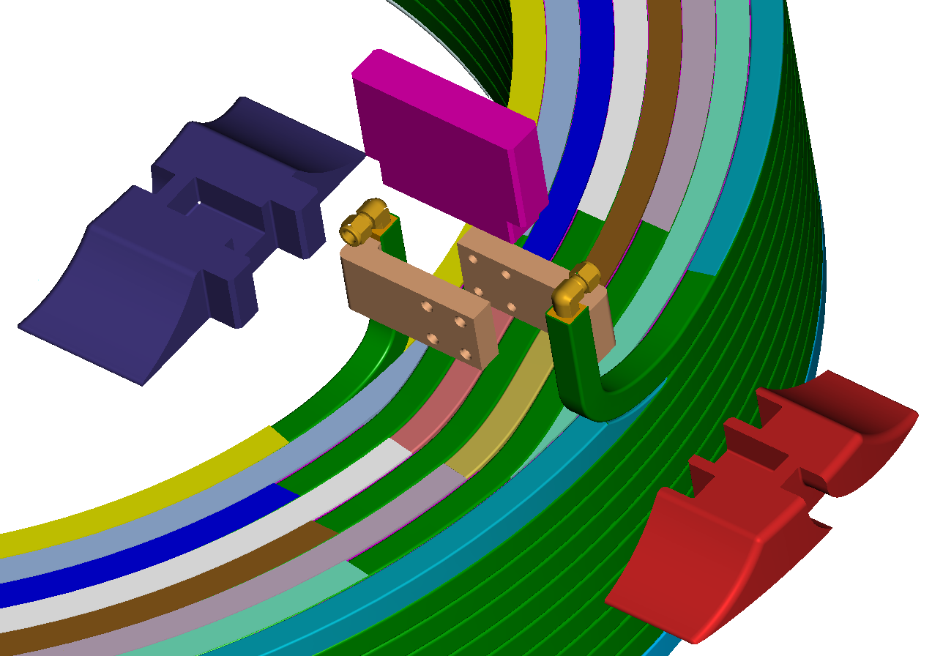
Figure 3-2 PF4 Joint Lead Area Isometric View
- Co-wound Diagnostic Loops: Co-wound diagnostic loops are placed on the plasma facing side [inside diameter] of each coil assembly. The coil leads are brought out in the vicinity of the lead area where mounting provisions are provided for strain relief.

Characteristics

Performance

Electrical Requirements [Based on GRD]

DC Resistance
The total coil resistance measured at room temperature (20ºC) shall be within +/-2% of the calculated resistance given in Table 1:
Table 1- Coil Resistance
Coil Identification | Calculated Coil Resistance micro-Ohms
PF-4 | 13466
PF-5 | 17207
PF-6 | 12287

Voltage Standoff, Terminal- to-ground
The Assembly shall provide a standoff capability between the electrical circuit (conductor) and ground or any other component of 7.5 kV with resistance not to exceed 1000 MΩ. [Design voltage is 11.25 kV] The maximum test voltage must be held for 1 full minute during testing to allow reading to stabilize.

Voltage Standoff, Turn-to-turn
The Assembly shall provide a voltage standoff capability between adjacent conductors or leads adequate to withstand a peak terminal-to-terminal voltage of 2.25 kV [PF-4] and 4.5 kV for coils PF-5 and PF-6 with a maximum of 10 µA of current leakage.

Electrical Isolation of Co-Wound Diagnostic Loops
The co-wound diagnostic loops shall be electrically isolated from all other components by being placed within the ground wrap and by a Teflon sleeve. During the coil to ground electrical tests they shall be shorted and grounded [3.2.1.1.2]. The Teflon sleeved co-wound diagnostic loops shall have a minimum of 1kV dielectric strength to other components. [PPPL shall provide loops and is responsible for verification of dielectric strength]

Cooling Requirements

Leak Tightness
Completed coil assemblies shall be free of leaks when tested with compressed air at a pressure of 200 psi. [Do not use water for pressure test]

Flow Characteristics
Completed coil assemblies shall be free of obstructions in the coolant channels when tested with compressed air. The pneumatic minimum flow rate values are identified in table 2: The measured values shall be within +/- 5% [Do not use water for flow test]
Table 2- Pressure vs. Flow in CFM at Coil Exit
PF ID | 20 psi | 40 psi | 60 psi | 80 psi
PF-4 | 2.52 | 4.37 | 6.17 | 7.96
PF-5 | 2.21 | 3.84 | 5.43 | 7.01
PF-6 | 2.65 | 4.58 | 6.47 | 8.35
* All pressures at coil inlet are at 20 degrees C

Physical Characteristics

Component Characteristics

Conductor
The Product Specification NCSX-CSPEC-132-04 defines the PF Coil Conductor.

Brazed Joints
- Braze material: Sil-Fos braze material, a product of Handy & Harmon shall be used for all braze joints. No flux shall be used with the Sil-Fos material.
- Composition: 15% Ag, 80% Cu, 5% P
- Melting Point: 1185° F (640° C)
- Brazing Temperature Range: 1300F-1500F (704° C-816° C)
- Braze technique: Induction brazing is required for all joints (except coolant fittings).
- Hardness: Brazed Joints are to maintain a Rockwell hardness F of greater than 55.
- Braze material certification: Certification of the Sil-Fos braze material shall be in accordance with AWS A5.8-2004, Classification BCuP-5.
- Brazes are to be placed not less than 12 inches from adjacent brazes and equally spaced on either side of the lead area. The location of the braze joints are to be measured and recorded and kept consistent with each similar coil.

Turn-to-turn Insulation
Turn-to-turn insulation is composed of one [half-lapped] layer of adhesive backed Kapton tape applied with the adhesive layer face down directly against the conductor. The Kapton tape is one inch wide with a total thickness of 0.0035 inches (0.002 inches Kapton and 0.0015 inches adhesive) x 2 = a nominal build of 0.007 inches for the Kapton tape.
Three half lap layers of S2 glass are applied directly over the Kapton layer. The S-2 glass tape is one inch wide by 0.007 inch thick. The nominal build of the S2 glass layers is 0.042 inches bringing the total build of the turn-to-turn insulation to 0.049 inches.
The glass and tape thicknesses and width may be adjusted to reach the required overall thickness and to facilitate manufacturing requirements with the written approval of PPPL. Any changes in the turn-to-turn insulation build up must still meet the PF electrical standoff requirements in Sections 3.2.1.1.2 and 3.2.1.1.3.

Ground Insulation
The ground insulation is applied over the completed coil and is composed of 0.015 inch thick and 0.012 inch thick by two inch wide S2 glass. The S2 glass is applied in half lap layers using 0.015 and 0.011 inch thick to bring the total build of the turn-to-turn insulation to 0.375- 0.380 inches (Ref Drawings SE132-040, 050 and 060). The number of layers of the ground wrap insulation shall be determined by measurement and adjusted to achieve a sum total of 10% compression for both the ground wrap and turn to turn glass insulation. The number of layers of glass used shall be approved by PPPL prior to fabrication.
The completed ground wrapped assembly is to be vacuum impregnated using CTD 101K epoxy. The number of layers of ground insulation is to be optimized so that the compression of the coil in the VPI mold sufficient to minimize resin rich areas. To eliminate resin rich areas, voids in the corners of the VPI mold are to be eliminated with the use of radiused fillers.

Insulation for Lead Area
The Lead Area insulation is custom wound Kapton and S2 glass. Where the lead area is flush with the winding pack the lead insulation as a minimum must have the same build up as the turn-to-turn insulation including one half lap layer of Kapton (Ref. 3.2.2.1.3) and a minimum of 0.125 inch build up of S2 glass ground insulation. Where the lead exits the winding pack the exposed copper must have a minimum of two uninterrupted layers of 3.5 mil Kapton tape (achieved for example by two half lap layers) with a minimum of an additional 0.125 inch of S2 glass. The glass and tape thicknesses may be adjusted to reach the required overall thickness and to facilitate manufacturing requirements with the written approval of the PPPL. Any changes in lead insulation build up must meet the PF electrical standoff requirements in Sections 3.2.1.1.2 and 3.2.1.1.3.

Insulating Lead Blocks
- Material: The insulating lead blocks shall be constructed of NEMA grade G-10 FR-4 or [G-11 CR] epoxy laminate.
- Workmanship: The lead blocks shall be free of burrs and sharp edges that can damage the conductor. Any voids in the lead area must be filled with supplied glass material to facilitate complete impregnation.
- Surface preparation: All surfaces unless machined shall be sanded to remove any high gloss surface, to promote bonding of the epoxy to the lead blocks.

Co-wound Diagnostic Loops
- Loop location: Magnetic loops will be incorporated into the Assembly. There shall be one loop per coil located under the last layer of ground wrap on the inner diameter of the PF coil. It shall be positioned at the center height [+/- 0.125 inch] of the inner wall of the coil. The location of the installed loops shall be measured prior to vacuum pressure impregnation.
- Loop material: The loops shall be composed of 0.032-in diameter mineral insulated wire with a Teflon sleeve to provide electrical isolation. The overall diameter with the insulated shrink sleeving shall be 0.047 inch.
- Loop termination: From where the two ends of each loop leave the inner diameter of the winding pack, they shall be twisted together and routed to the top surface of the PF coil (still beneath one layer of glass) and exit the insulation. There, post VPI, a plastic [PPPL provided] box will be secured to the coil via Tie-wraps to protect the diagnostic leads during handling.

Vacuum-Pressure-Impregnation [VPI]
Each finished poloidal field coil shall be vacuum pressure impregnated [VPI] using the pre-selected epoxy resin system identified below.
  - Epoxy Description: CTD-101K: a modified 3-part anhydride cured epoxy system with excellent performance at cryogenic temperatures.
  - Manufacturer: Composite Technology Development Inc.
1505 Coal Creek Drive
Lafayette, Colorado 80026
Phone: (303) 664-0394
  - Epoxy Working and Cure Temperatures
- Mixing Temperature: 40-60 degrees C
- Cure Cycle: 5 hours @ 110 degrees C
- Post Cure: 16 hours @ 125 degrees C

Final Inspection and Tests
The inspections and tests identified in Section 4.0 shall be performed when the coil is in a deliverable state.

Design and Construction

Materials, Processes, and Parts

Production Drawings
The Assembly shall be fabricated in accordance with the models and drawings listed in Section 5.1.

Metrology
Inspection reports shall be provided to verify dimensions are within tolerance as specified in coil drawings identified in Section 5.1. The inner and outer diameter shall be reported as a minimum every 12 inches along the perimeter of each coil.

Labels
The Assembly shall have a permanent label with the following minimum information – NCSX PF Coil Assembly, P/N [coil drawing number], the serial number of the item, the manufacturer of the item, the date of manufacture (month and year) and the weight of the item (in lbs). The label shall be located within 12 inches of the leads on the outer edge (same side as the leads).

Workmanship
During Assembly fabrication and finishing, particular attention shall be given to freedom from blemishes, defects, burrs, and sharp edges; thoroughness of cleaning; quality of brazing and alignment of parts.

Each spool of copper conductor shall be flushed with a degreasing agent to be approved by PPPL before brazing.

The conductor shall be wiped down with degreasing solvent to remove excess oil, lubricant and grease prior to being wound into the assembly. Cleaned copper, whether bare or insulated, shall be stored and processed in an environment free from metallic dust or other contaminants. After cleaning, the copper surface and insulating materials shall be protected from skin oil, etc., by requiring shop personnel to handle conductors only while wearing clean, lint free, white cotton or latex gloves.

Quality Assurance Provisions

General
The vendor has sole responsibility for inspection and testing of all PF coil assemblies.

Verification

Performance Verification

Electrical Requirement Verification
The time at test voltage for all electrical verifications shall be a minimum of one minute

Verification of DC Resistance
The total coil resistance shall be measured at room temperature (20ºC) in order to verify compliance with Section 3.2.1.1.1. This test shall be performed:
- Prior to ground wrapping the coil
- After Coil VPI

Verification of Terminal-to-ground Voltage Standoff
Each PF coil assembly shall be Megger tested at room temperature (20ºC) during acceptance testing to verify compliance with Section 3.2.1.1.2. This test shall be performed prior to and after VPI operations. The values are identified below:
- Prior to ground wrapping the coil at 1kV
- After Coil VPI at 7.5 kV

Verification of Turn-to-turn Voltage Standoff
Each PF coil assembly shall be tested for turn to turn dielectric strength. The vendor shall propose a testing plan for achieving this turn to turn test. Compliance with the values identified in 3.2.1.1.3 is required. In addition the inductance of each coil is to be measured and recorded after VPI. The turn to turn test shall be performed:
- Prior to ground wrapping the coil
- After Coil VPI

Verification of Electrical Isolation of Other Components
Electrical isolation of the co-wound diagnostic loops shall be tested to verify compliance with Section 3.2.1.1.4. This test shall be performed after Coil VPI.

Verification of Pneumatic Requirements

Verification of Leak Tightness
Completed coil assemblies shall be pressure tested at 200 psi, using compressed air in order to verify compliance with Section 3.2.1.2.1. The pressure shall be 200 psi for 10 minutes with no drop in pressure after the system has been isolated from the pressure supply. The pressure vs. time data is to be recorded periodically during the test. Accuracy shall be within 2 psi, with a range for the pressure gauge sufficient so that 200 psi is in the center. The test is then to be repeated with the pressure held for a minimum of one hour with a loss in pressure of not more than 10 psi.

Verification of Flow Characteristics
Completed coil assemblies shall be tested for flow vs. pressure, using one of the Press vs. Flow values in [Table 2- Pressure vs. Flow in CFM at Coil Exit] to verify that the cooling channel is clear and complies with Section 3.2.1.2.2. The pressure is to be measured directly at the inlet to the coil as well as at the coil outlet [@ room pressure with no obstructions] using calibrated pressure gauges. The flow rate measurement may be made with a flow meter. This test shall be performed using compressed air. Record inlet pressure, outlet pressure, and flow for each coil.

Verification of Physical Characteristics

Verification of Component Characteristics

Verification of Conductor
Rockwell hardness measurements shall be taken to verify compliance with paragraph 3.2.2.1.1 immediately prior to winding coil. Measurements shall be made 2 feet from each end and the middle of the conductor spool.

Verification of Brazed Joints
        - Brazing Alloy material certifications shall be submitted as part of the documentation package. The supplier shall develop process details, helium leak test and pull test techniques, as well as a technician qualification program to be approved by PPPL. Rockwell hardness measurements shall be taken to verify compliance with paragraph 3.2.2.1.2 after brazing.
        - Each braze joint must be inspected and tested prior to proceeding with winding operations.

        - After the brazed joint is complete it shall be tested for leaks. First the braze area must be cleaned to remove excess braze material and allow for adequate inspection. Then with the conductor placed in tension at 14,000 psi (8,500 lb) the brazed joint shall be tested by pressurizing with helium at 50 psi. A mass spectrometer "sniffer" capable of detecting leaks <10 -5 cc/sec is to be used to detect leakage. Bad joints must be cut out beyond the heat affected zone and re-brazed.
        - Each conductor joint shall be visually inspected for full flow and whetting of the braze material and no cracks. The inspection shall be documented. Photographs of each braze are required for the inspection reports.

Verification Turn to Turn Insulation
Verification of T/T insulation build thickness shall be made via periodic measurements that are to be recorded in the winding procedure for each coil to verify compliance with paragraph 3.2.2.1.3. Measurements shall be made and verified every 3 turns of the coil.

Verification of Ground Insulation Parameters
Measurements of insulation build and the number of layers are to be recorded in the winding procedure for each coil to verify compliance with paragraph 3.2.2.1.4

Verification of Insulation for Leads
Measurements and parameters such as insulation thickness are to be recorded in the fabrication procedure for each coil to verify compliance with paragraph 3.2.2.1.5

Verification of Lead Block Properties
Lead blocks are to be inspected for sharp edges. The lead area is to be inspected to verify no resin rich areas. Lead blocks are to be inspected to verify roughened surfaces prior to installation. The inspector shall indicate satisfactory inspection, with signature and date, in the fabrication procedure.

Verification of Diagnostic Loop Installation
The location of the installed loops shall be measured prior to vacuum pressure impregnation. The routing of the wire shall be verified per the requirements of 3.2.2.1.7. The measurements shall be documented and approved PPPL. The Teflon sleaving of the loop shall be inspected for cracks or tears. The ends of the wire are to be inspected, with a procedure signoff, to be certain they are properly protected prior to vacuum impregnation.

Geometry
Each completed PF Coil assembly is to be measured with all dimensions documented. Inspection reports are to note nominal dimensions and deviations from those dimensions along with allowable tolerances.

Appendices

Assembly Models and Drawings
Drawing Number | No. of Sheets | Description
SE132-040 | 4 | PF-4 Coil Winding Assembly and Details
SE132-050 | 4 | PF-5 Coil Winding Assembly and Details
SE132-060 | 4 | PF-6 Coil Winding Assembly and Details
SE132-039 | 1 | Braze Joint Conductor Details- PF-4, PF-5 and PF-6

