NCSX

System Requirements Document (SRD)

for the

Trim Coils (WBS 133)

NCSX-BSPEC-133-00

12 March 2008

Concur: __________________________________________________________________________
M. Kalish, WBS Manager for Trim Coils (WBS 133)

Concur: __________________________________________________________________________
G.H. Neilson, NCSX Physics Requirement Reviewer/ Program Integration Manager

Approved By: ______________________________________________________________________________
P.J. Heitzenroeder, NCSX Project Engineer for Project Design and Procurement

Record of Revisions

Revision | Date | ECP | Description of Change
Rev. 0 |  | - | Initial issue
TABLE OF CONTENTS
1.1 Document Overview 5
1.2 Incomplete and Tentative Requirements 5
2 Applicable Documents 5
3 Requirements 5
3.1 Subsystem Definition 5
3.1.1 Subsystem Diagrams 6
3.1.1.1 Functional Flow Block Diagram 6
3.1.2 Interface Definition 6
3.1.2.1 Vacuum Vessel (WBS 12) 6
3.1.2.2 TF Coils (WBS 131) 6
3.1.2.3 PF Coils (WBS 133) 6
3.1.2.4 Modular Coils (WBS 14) 6
3.1.2.5 Coil Support Structures (WBS 15) 7
3.1.2.6 LN2 Distribution System (WBS 161) 7
3.1.2.7 Electrical Leads (WBS 162) 7
3.1.2.8 Coil Protection System (WBS 163) 7
3.1.2.9 Cryostat (WBS 171) 7
3.1.2.10 Magnetic Diagnostics (WBS 31) 7
3.1.2.11 Electrical Power Systems (WBS 4) 7
3.1.2.12 Central I&C (WBS 5) 7
3.1.2.13 Cryogenic Systems (WBS 62) 8
3.1.2.14 Test Cell Preparations and Machine Assembly (WBS 7) 8
3.1.3 Major Component List 8
3.2 Characteristics 8
3.2.1 Performance 8
3.2.1.1 Perform Initial and Pre-run Verification 8
3.2.1.2 Prepare for and Support Experimental Operations 9
3.2.1.3 Shut Down Facility 11
3.2.2 Physical Characteristics 11
3.2.2.1 Configuration Requirements and Essential Features 11
3.2.3 System Quality Factors 12
3.2.3.1 Reliability, Availability, and Maintainability 12
3.2.3.2 Design Life 12
3.2.3.3 Seismic Criteria 12
3.2.4 Transportability 12
3.3 Design and Construction 12
3.3.1 Materials, Processes, and Parts 12
3.3.1.1 Magnetic Permeability 12
3.3.1.2 Structural and Cryogenic Criteria 12
3.3.1.3 Corrosion Prevention and Control 12
3.3.1.4 Metrology 12
3.3.2 Electrical Grounding 12
3.3.3 Nameplates and Product Marking 12
3.3.3.1 Labels 12
3.3.4 Workmanship 12
3.3.5 Interchangeability 12
3.3.6 Environmental, Safety, and Health (ES&H) Requirements 12
3.3.6.1 General Safety 12
3.3.6.2 Personnel Safety 12
3.3.6.3 Flammability 12
3.4 Documentation 12
3.4.1 Specifications 12
3.5 Logistics 12
3.5.1 Maintenance 12
3.5.2 Standardized Parts 12
4 Quality Assurance Provisions 12
4.1 General 12
4.2 Verification Methods 12
4.3 Quality Conformance 12
4.3.1 Performance 12
4.3.1.1 Perform Initial and Pre-run Verification 12
4.3.1.2 Prepare for and Support Experimental Operations 12
4.3.1.3 Shut Down Facility 12

Table of Figures
Figure ‎3-1 Functional flow block diagram 6
Figure ‎3-2 Trim coil geometry for One Field Period 12

The National Compact Stellarator Experiment (NCSX) is an experimental research facility that is to be constructed at the Department of Energy’s Princeton Plasma Physics Laboratory (PPPL). Its mission is to acquire the physics knowledge needed to evaluate compact stellarators as a fusion concept, and to advance the understanding of 3D plasma physics for fusion and basic science.
A primary component of the facility is the stellarator core, an assembly of four coil systems that surround a highly shaped plasma and vacuum chamber. The four coil systems include the modular coils, the poloidal field (Trim) coils, the toroidal field (TF) coils, and the external trim coils. These coils provide the magnetic field required for plasma shaping and position control, inductive current drive, and error field correction.
This specification addresses the design requirements for the Trim Coils (WBS 133).

Document Overview
This document, the System Requirements Document (SRD) for the Trim Coils (WBS 133), is the complete development specification for this subsystem. Performance requirements allocated to this subsystem in the system specification, the General Requirements Document (NCSX-GRD-XX), have been incorporated in this document. In this document, the term “the system” refers to the overall device and facility and the terms “the subsystem” and refers to the Trim coils.” (WBS 133).
The specification approach being used on NCSX provides for a clear distinction between performance requirements and design constraints. Performance requirements state what functions a system has to perform and how well that function has to be performed. Design constraints, on the other hand, are a set of limiting or boundary requirements that must be adhered to while allocating requirements or designing the system. They are drawn from externally imposed sources (e.g., statutory regulations, DOE Orders, and PPPL ES&H Directives) as well as from internally imposed sources as a result of prior decisions, which limit subsequent design alternatives.

Incomplete and Tentative Requirements
Within this document, the term “TBD” (to be determined) indicates that additional effort (analysis, trade studies, etc) is required to define the particular requirement. The term “TBR” (to be revised) indicates that the value given is subject to change.

Applicable Documents
NCS X-ASPEC-GRD NCSX General Requirements Document
NCSX-CRIT-CRYO NCSX Structural and Cryogenic Design Criteria Document
NCSX-CRIT-SEIS NCSX Seismic Design Criteria Document

Requirements

Subsystem Definition
The Trim coil system consists of a set of 48 coils mounted outside the modular coil to suppress field errors. Field errors are a major concern in the design of NCSX. The fundamental global requirement is that the toroidal flux in island regions due to fabrication errors, magnetic materials, and eddy currents shall not exceed 10% of the total toroidal flux in the plasma (including compensation). The 48 Trim Coil geometry is the result of an analysis which demonstrates compliance with this requirement. The Trim coils are designed for operation throughout the life of NCSX. All of the Trim coils operate within the cryostat and are cooled passively through convection.

Subsystem Diagrams

Functional Flow Block Diagram
A functional flow block diagram (FFBD) is provided in Figure 3-1.
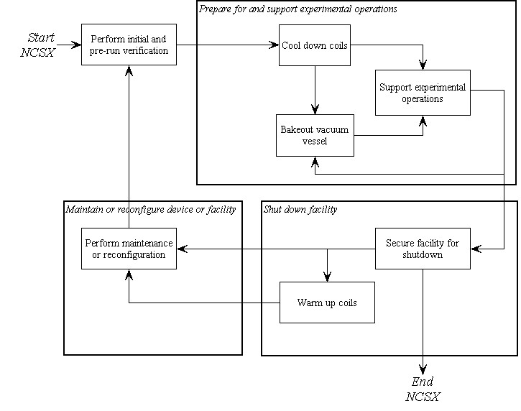
Figure 3-1 Functional flow block diagram

Interface Definition

Vacuum Vessel (WBS 12)
  - Proximity. The vacuum vessel port extensions pass close to the Trim coils. Although there is no physical contact between the Trim coils and VV port extensions, they are all inside the cryostat and clearances must be maintained under all operating conditions.
  - Heat leakage. The Trim coils operate at cryogenic temperature whereas the VV port extensions operate at temperatures up to 150C. The port extensions are thermally insulated to reduce heat leakage to the Trim coils to tolerable levels.

TF Coils (WBS 131)
TF coils impose EM loads on the Trim coils and vice versa.

PF Coils (WBS 133)
PF coils impose EM loads on the Trim coils and vice versa.

Modular Coils (WBS 14)
The modular coils impose EM loads on the Trim coils and vice versa.

Coil Support Structures (WBS 15)
The coil support structures provide mechanical support to the Trim coils.

LN2 Distribution System (WBS 161)
Liquid nitrogen for coil cooling is supplied from the Cryogenic Systems (WBS 62) to the LN2 Distribution System (WBS 161), which in turn is available to supply the liquid nitrogen to the Trim coils if required.

Electrical Leads (WBS 162)
The current and voltage required to drive the Trim coils is supplied from the Electrical Power Systems (WBS 4) to the Electrical Leads (WBS 162), which in turn supplies the direct current (DC) power to the Trim coils.

Coil Protection System (WBS 163)
The Coil Protection System (WBS 163) includes all the activities required to develop the coil protection logic and specification of coil protection parameters, including Trim coils. The Coil Protection System (WBS 163) does not include any hardware or software.

Cryostat (WBS 171)
Although there is no physical contact between the Cryostat (WBS 171) and the Trim Coils, the cryostat does provide thermal isolation from the environment outside the cryostat and containment for the cold, dry nitrogen environment inside the cryostat. Trim coils are cooled convection cooling to the nitrogen atmosphere. The nitrogen environment inside the cryostat is maintained by the Cryogenic Systems (WBS 62).

Magnetic Diagnostics (WBS 31)
There is no requirement for magnetic diagnostic loops on the Trim coils.

Electrical Power Systems (WBS 4)
- DC power. The current and voltage required to drive the Trim coils is supplied from the Electrical Power Systems (WBS 4) to the Electrical Leads (WBS 162), which in turn supplies the direct current (DC) power to the Trim coils.
- Coil protection. Electrical Power Systems (WBS 4) provide coil protection via parameters measured in the power supply circuitry based on parameters provided by Coil Protection System (WBS 163) activities. Electrical Power Systems (WBS 4) also provides coil protection via permissives and trip signals provided by Central I&C (WBS 5) in response to the output from sensors included in the local I&C within the PF Coil System (WBS 132).
- Grounding. Electrical Power Systems (WBS 4) are responsible for providing single point grounds for the Trim coils.
- I&C sensor leads – The connecting cables between the Trim coil I&C sensors and the Central I&C system (WBS 5) will be supplied by Electrical Power Systems (WBS 4).

Central I&C (WBS 5)
Central I&C (WBS 5) is responsible for taking the output from the sensors (e.g. strain gauges, resistance temperature detectors, and thermocouples) provided in the local I&C in the Trim Coil System (WBS 133), processing those signals, displaying and storing the data, and providing permissives and trip signals for coil protection to Electrical Power Systems (WBS 4) in accordance with the coil protection logic and parameters specified by the Coil Protection Systems (WBS 163).

Cryogenic Systems (WBS 62)
- Liquid nitrogen cooling. There is no requirement for liquid nitrogen cooling from the Cryogenic Systems (WBS 62) for the Trim coils.
- Gaseous nitrogen cooling. Cryogenic Systems (WBS 62) are responsible for providing the gaseous nitrogen cooling within the cryostat required to cool and maintain the external temperature of the Trim coils.

Test Cell Preparations and Machine Assembly (WBS 7)
The Trim coils will have interfaces with the tooling and metrology equipment required for final machine assembly.

Major Component List
There are no major components for which additional development specifications are planned.

Characteristics

Performance

Perform Initial and Pre-run Verification

Initial Facility Startup
Background
Initial facility startup includes all activities required to verify safe operation of NCSX systems after their initial assembly and installation, or after a major facility reconfiguration, and before plasma operations. Initial facility startup activities would be performed prior to First Plasma and will include subsystem pre-operational test procedures (PTPs) and an Integrated System Test Program (ISTP) to verify that the system operates safely and as expected prior to plasma operation. For example, the ISTP will include verification of proper coil polarities and power supply connections. The ISTP will also include verification that, at First Plasma, the system demonstrates a level of system performance sufficient for the start of research operations, as specified in the Project Execution Plan (NCSX-PLAN-PEP-01). A subset of the ISTP will be conducted before the start of a run.

Initial Verification of Operability
The subsystem shall provide the capability to perform subsystem PTPs and support a comprehensive ISTP, to verify, prior to plasma operation that the system is properly configured, functioning correctly, and can be operated safely. [Ref. GRD Section 3.2.1.1]

Design Verification
The subsystem shall be instrumented such that key performance parameters (stresses, deflections, temperatures, etc.) can be measured and compared to calculated values to assure that the subsystem is performing consistent with the design intent prior to First Plasma.

Pre-Run Facility Startup
Background
Pre-run facility startup includes all activities required to verify safe operation of the NCSX subsystems after a major maintenance outage or a minor facility reconfiguration (one affecting a small number of subsystems). Pre-run facility startup activities would typically be performed prior to the start of a run period and would include a subset of the full PTP and ISTP activities referred to in Section 3.2.1.1.1.1.
Requirement
The subsystem shall support the capability to perform a controlled startup of the facility, and verify that the subsystem is properly configured, functioning correctly, and can be operated safely. [Ref. GRD Section 3.2.1.2]

Prepare for and Support Experimental Operations

Subsystem Verification and Monitoring
Background
Pre-operational initialization and verification activities would generally cover those activities required prior to the start of an operating day following an overnight or weekend shutdown. Pre-pulse initialization and verification activities cover those activities required prior to the start of each pulse (plasma discharge). The Trim Coils (WBS 133) should be monitored to verify that the subsystem is functioning correctly and configured properly at the start of an operating day and prior to the start of each pulse.
Requirement
The subsystem shall provide the capability to verify that the subsystem is properly configured, functioning correctly, and can be operated safely prior to the start of an operating day and prior to the start of each pulse (plasma discharge). [Ref. GRD 3.2.1.3 and GRD 3.2.1.4]

Coil Cool-down
Background
Prior to experimental operations, the cryo-resistive coils must be cooled down from room temperature to a pre-pulse operating temperature of about 80K. The coils are located in a dry nitrogen environment that is provided by the cryostat, which surrounds the coils. In order to gain access to the interior of cryostat, the coils must be warmed up from operating temperature to room temperature. The anticipated operational plans are expected to result in no more than 150 cool-down and warm-up cycles between room temperature and operating temperature over the lifetime of the machine.

Coil Cooling
With convection cooling these coils are not restricted to 92K as the coils with LN2 flow are. Peak coil temperatures shall be governed by the induced thermal stresses with an assumed pre-pulse starting temperature of 85K. The possibility of uneven thermal loading in the cryostat from excessive Trim Coil temperatures must also be considered.

Timeline for Coil Cool-down to Cryogenic Temperature
The Trim Coils shall be capable of being cooled down from room temperature (293K) to their pre-pulse operating temperature (<85K) within 96 hours with the vacuum vessel at room temperature (20°C). [Ref. GRD Sections 3.2.1.2.1.1 and 3.2.1.2.1.3]

Bakeout
Background
The temperature of the vacuum vessel shell will be capable of being elevated to a nominal temperature of 150ºC for vacuum vessel bakeout operations and to a nominal temperature of 350ºC to support bakeout of an in-vessel carbon-based liner (to be installed as an upgrade) at that temperature. Initially, there will not be any limiters installed in the vacuum vessel for first plasma or field line mapping. However, later in the program, the liner will be installed inside the vacuum vessel with a surface area that is a substantial part of the vacuum vessel surface area to absorb the high heat loads and to protect the vacuum vessel and internal components. The capability to bake the vessel with the cryo-resistive coils at cryogenic temperature is required.

Coil Temperatures during Bakeout
The capability to bakeout the vacuum vessel with the Trim Coils below 90K shall be provided. The Trim Coils shall return to their pre-pulse operating temperatures (<95K) within the 24 hours following completion of bakeout. [Ref. GRD Section 3.2.1.2.3.3]

Bakeout Cycles
The device shall be designed for at least 1000 bakeout cycles over the life of the machine. [Ref. GRD Section 3.2.1.2.3.6]

Pre-Pulse Temperature
The Trim Coils shall return to a pre-pulse temperature of less than 95K, so as to prevent overheating during repeated operation, with a vacuum vessel shell temperature in the range of 40ºC to 210 C. [Ref. GRD Section 3.2.1.4.2]

Plasma Magnetic Field Requirements

Reference Scenario Requirements
Background
NCSX is designed to be a flexible, experimental test bed. To ensure adequate dynamic flexibility, a series of reference scenarios has been established. TF, PF and modular coil systems and the vacuum vessel will be designed for a plasma with a nominal major radius of 1.4 m and capability to meet the requirements of all the reference scenarios. The Trim ring coils will also be designed to meet the requirements of all the reference scenarios. Electrical power systems shall be designed and initially configured to meet the requirements of the First Plasma and Field Line Mapping Scenarios and shall be capable of being upgraded to meet the requirements of all other reference scenarios.
Reference scenario definitions are provided in Section 3.2.1.5.3.3.1 of the GRD. Reference waveforms of engineering parameters such as coil currents, voltages, power dissipation, etc. are derived from the scenario specifications and are documented in Appendix A of the GRD.
Requirement
- The Trim ring coils will be designed to meet the requirements of all the reference scenarios. [Ref. GRD Section 3.2.1.5.3.3.2]

Disruption Handling
The Trim Coils shall be designed to withstand electromagnetic forces due to major disruptions characterized by instantaneous disappearance of the plasma at the maximum plasma current of 320 kA [Ref. GRD Section 3.2.1.5.5]

Pulse Repetition Rate
The Trim Coils shall be designed for 2 second pulses to be initiated at intervals not exceeding 15 minutes when constrained by cool-down and 5 minutes otherwise. [Ref. GRD Section 3.2.1.5.10]

Voltage Stand-off Requirements
Background
Voltage standoff requirements are based on an assumed Maximum Operating Voltage (MOV). A Maintenance Field Test Voltage (MFTV) is derived by multiplying the MOV by two and adding 1 kV. A Manufacturing Test Voltage (MTV) is derived by multiplying the MFTV by 1.5. A Design Voltage Standoff (DVS) is derived by multiplying the MTV by 1.5. To guarantee the capability of achieving a response time of less than 20 ms the MOV for the coil is 1kV. With an MOV of 1kV the turn to turn maximum voltage differentials are 100 volts. The coil will be designed to withstand 10 times that voltage. There is no direct testing of the turn to turn voltage.
Requirements
Trim coils shall be designed to a DVS of 6.75kV and subjected to a MFTV of 4.5kV.
Turn to turn insulation shall be designed to withstand a minimum of 1kV.

Discharge Termination

Normal Termination
Background
Normal termination includes all system actions necessary to shutdown the plasma and associated subsystems at the conclusion of a pulse in preparation for the next pulse.
Requirement
During a controlled shutdown, the Trim coil currents will be driven to zero by the power supplies according to the pre-programmed current waveform. [Ref. GRD Section 3.2.1.5.11.1]

Abnormal Termination
Background
Abnormal termination consists of all system responses necessary to remove conditions that occur during experimental operations that could cause significant damage to the NCSX system or cause injury to personnel.
Requirement
During an abnormal termination, the Trim coil power supplies will be bypassed and the Trim coil currents will go to zero on the natural decay times of the coil circuits. [Ref. GRD Section 3.2.1.5.11.2]

Shut Down Facility
Background
Facility shutdown involves the shutdown of NCSX equipment following the termination of a discharge (per Section 3.2.1.2.9) in preparation for a brief (overnight or weekend) or extended (between run periods) shutdown.
Requirement
The NCSX system shall provide the capability to perform a controlled shutdown of the Trim Coils. [Ref. GRD Section 3.2.1.6]

Coil Warm-up Timeline
The Trim Coils shall be capable of being warmed up from operating temperature (80K) to room temperature (293K) within a period of 96 hours. [Ref. GRD Section 3.2.1.6.1]

Physical Characteristics

Configuration Requirements and Essential Features

Number and Location

Configuration
Trim Coils shall be mounted to the modular coils by way of the PF and TF Coil support structure. There are a total of 48 Coils. depicts the geometry for one field period of trim coils. This pattern is repeated symmetrically three times.

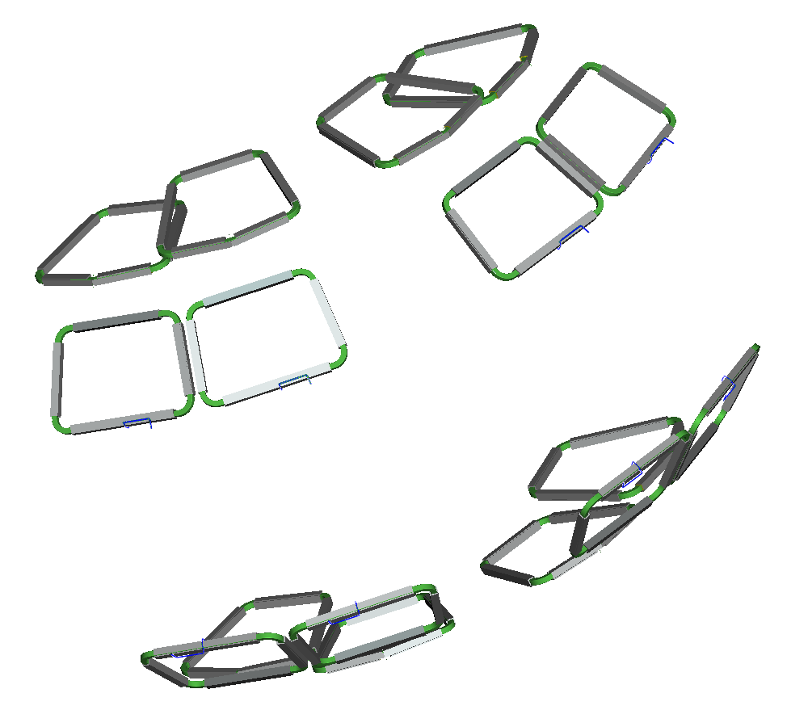

Figure 3-2 Trim coil geometry for One Field Period

Symmetry and Alignment
Trim coils shall be up-down symmetric with respect to the horizontal mid-plane of the modular coils and aligned with the major axis of the modular coil assembly in the installed condition. Individual coil fabrication tolerances shall be +/- 6mm. Installed positioning tolerances shall be +/- 12mm. The final installed location of the Trim coils shall be documented by measuring four points on the coil to within +/- 2mm. These are the system performance requirements. Mounting interface requirements may dictate that coil tolerances be lower than stated.

Coil Supports
The trim coils will have custom designed brackets which will be mounted to the Coil Support Structures (WBS 15).

Electrical Requirements

Turns per Coil
The trim coils shall have a 20 KA-Turn capability. The Trim coils shall be designed with 120 turns requiring a maximum current of 167 amps to match the planned power supply capabilities.

Circuit Configuration

Circuit Configuration
- Individual leads will be provided at the center of each Trim coil capable of handling an equivalent RMS current of 8 amps (167 amps for 2 seconds every 15 minutes).

System Quality Factors

Reliability, Availability, and Maintainability
Background
The overall objective is to provide a device with high operational availability, meaning that the number of plasma discharges achieved in a run period is a large percentage (greater than 75%) of the number planned after the initial shakedown and commissioning phases of the facility. Bottoms-up reliability predictions are difficult to perform and have large uncertainties for first-of-a-kind experimental devices such as NCSX. Therefore, quantitative RAM requirements on NCSX will be few. Rather, NCSX will rather rely on sound engineering practice to assure high availability in NCSX, which has been the tried-and-true approach on similar scale fusion devices. Sound engineering practices include:
- Applying design principles that promote reliability (e.g., employing an adequate factor of safety on mechanical and electrical stresses, avoiding unnecessary complexity, using proven design approaches and well characterized materials, etc.)
- Optimizing designs for reliability and maintainability through systematic evaluation of design options,
- Performing failure modes, effects and criticality analysis (FMECAs) for RAM design improvement and verification, and
- Employing peer reviews as a mechanism to enhance the design process.

The NCSX RAM Plan defines the processes that will be used by the Project to achieve a device with high availability.
Requirements
- The Trim Coils shall incorporate reliability and maintainability features in the design that are consistent with achieving a high (greater than 95%) operational availability.
- Provisions for recovery shall be made for every credible failure mode.
- The Trim Coils shall be capable of being disassembled and reassembled to permit replacement of any part or machine reconfiguration that would require disassembly.
[Ref. GRD Section 3.2.4.1]

Design Life
- The Trim Coils shall have a design life of >10 years.
- The Trim Coils shall be designed for the following maximum number of pulses based on the factors for fatigue life specified in the NCSX Structural and Cryogenic Design Criteria Document:
- 100 per day;
- 13,000 per year; and
- 130,000 lifetime.
[Ref. GRD Section 3.2.4.2]

Seismic Criteria
Background
NCSX systems shall be designed in accordance with seismic design and evaluation criteria for Performance Category 1 (PC1) facilities, per DOE-STD-1020-2002, “Natural Phenomena Hazards Design and Evaluation Criteria for Department of Energy Facilities.” The NCSX Seismic Design Criteria provides an NCSX-specific interpretation of those requirements
Requirement
The Trim Coils shall be design in accordance with the NCSX Seismic Design Criteria. [Ref. GRD Section 3.3.1.5]

Transportability
The Trim Coils and components shall be transportable by commercial carrier via highway, air, sea, or railway. [Ref. GRD Section 3.2.5]

Design and Construction

Materials, Processes, and Parts

Magnetic Permeability
All materials (including weld materials) used in the Trim Coils must have a relative magnetic permeability as calculated by the formula in the GRD but will not be required to be less than 1.02 unless otherwise authorized by the Project. [Ref. GRD Section 3.3.1.1]

Structural and Cryogenic Criteria
The Trim Coils shall be designed in accordance with the NCSX Structural and Cryogenic Design Criteria. [Ref. GRD Section 3.3.1.3]

Corrosion Prevention and Control
Materials, processes, and protective surface treatments or finishes shall be provided to ensure that equipment capability during its service life is not degraded due to corrosion. Where possible, contact between dissimilar metals shall be avoided. [Ref. GRD Section 3.3.1.4]

Metrology
The Trim Coils shall provide features (e.g., fiducial markers) to facilitate accurately measuring and locating components relative to the magnetic field for the life of the machine. [Ref. GRD Section 3.3.1.6]

Electrical Grounding
Trim coils will not have a ground plane surface. Trim Coils shall be connected via a single point ground provided by the Electrical Power Systems (WBS 4) where appropriate. [Ref. GRD Section 3.3.2]

Nameplates and Product Marking

Labels
Equipment and any parts of that equipment to be used by personnel shall be identified with appropriate labels. Labels shall indicate clearly and concisely the function and purpose of the item being labeled. Hierarchical labeling shall be used to facilitate component location on control panels. The terminology used for equipment, procedures, and training materials shall be the same for each case. Label design shall be consistent to promote simplicity and avoid clutter. The use of abbreviations and acronyms shall be minimized. Permanent labels shall be attached to the specific component or equipment in such a manner that environmental conditions or usage by personnel will not remove or destroy the label. Temporary labels shall be used only when necessary and shall not obscure other information or equipment. If a temporary label is to designate a device that is out of service, the label shall be applied so that it prevents the use of that device. Labeling shall be legible and conform to human visual capabilities and limitations in regard to physical characteristics. The labels for the Trim Coils will be in the vicinity of the leads for ease of identification of lead polarity and winding direction. [Ref. GRD Section 3.3.3.1]

Workmanship
During Trim coil fabrication and finishing, particular attention shall be given to freedom from blemishes, defects, burrs, and sharp edges; accuracy of dimensioning radii of weld fillets; making of parts; thoroughness of cleaning; quality of brazing, welding, riveting, painting, and wiring; alignment of parts; and tightness and torquing of fasteners. [Ref. GRD Section 3.3.4]

Interchangeability
Design tolerances shall permit parts and assemblies of the same part number to be used as replacement parts without degrading the specified performance of the parent item. [Ref. GRD Section 3.3.5]

Environmental, Safety, and Health (ES&H) Requirements

General Safety
- When utilized within its intended use and within specified environments, the safe operation, test, handling, maintenance and storage of the Trim Coils shall be provided.
- The Trim Coils shall not present any uncontrolled safety or health hazard to user personnel.
- The Trim Coils shall be designed such that degradation of epoxy shear strength over the life of the coil will not result in catastrophic failure of the winding, i.e. the coil windings will not unravel at the free ends where the leads are attached.
[Ref. GRD Section 3.3.6.1]

Personnel Safety
The Trim Coils shall meet all applicable OSHA requirements in accordance with 29CFR1910. The system shall limit personnel exposure to hazardous materials to below their OSHA permissible exposure limit (PEL). [Ref. GRD Section 3.3.6.3]

Flammability
The use of flammable materials shall be minimized. [Ref. GRD Section 3.3.6.4]

Documentation

Specifications
Specifications shall be developed for the configuration items shown in Table 3-1.
Table 3-1 Trim coil specifications
Configuration Item | Specification Identifier | Specification Type
Trim Ring Coils | NCSX-CSPEC-133-00 | Product specification – forms the basis for procuring or fabricating the Trim ring coils

Logistics

Maintenance
The Trim Coils shall be maintained using, to the extent possible, standard/common tools and existing multi-purpose test equipment. Use of new/special tools and the number of standard/common tools shall be minimized through maximum commonality of fasteners, clamps, adapters, and connectors.

Standardized Parts
Standardized parts shall be used in all coil systems (including the Trim Coil System) to the extent practicable. Specifically, standardization shall be considered for electrical leads, coil I&C, and epoxy formulation.

Quality Assurance Provisions

General
This section identifies the methods to be used for verification of requirements in Section 3.2 of this specification. General definitions of basic verification methods are outlined in Section 4.2 Verification of subsystem requirements will require additional testing in operational or near-operational environments.

Verification Methods
Verification of qualification shall be by analysis, demonstration, inspection, or test. Definition of analysis, demonstration, inspection, and test is as follows:
Analysis: Verification of conformance with required characteristics by calculation or simulation, including computer modeling based on established material or component characteristics.
Inspection: Verification of conformance by measuring, examining, testing, and gauging one or more characteristics of a product or service and comparing the results with specified requirements.
Test: Verification by physically exercising a component or system under appropriate loads or simulated operating conditions, including measurement and analysis of performance data.

Quality Conformance
This section establishes the specific evaluation criteria for verification of the subsystem performance requirements in Section 3.2. In general, all requirements shall be verified under operational or near-operational conditions as possible given test constraints.

Performance

Perform Initial and Pre-run Verification

Initial Facility Startup

Initial Verification of Operability
Initial verification of operability (ref. Section 3.2.1.1.1.1) shall be assured by inspection of the subsystem PTPs and the ISTP.

Design Verification
- The adequacy of the design to determine key performance parameters (ref. Section 3.2.1.1.1.2) shall be assessed during final design.
- Functionality shall be tested during integrated systems testing.

Pre-Run Facility Startup
- The adequacy of the design to support a controlled startup of the facility (ref. Section 3.2.1.1.2) shall be assessed during final design.
- Functionality shall be tested during integrated systems testing.

Prepare for and Support Experimental Operations

Subsystem Verification and Monitoring
- The adequacy of the design to verify that the subsystem is properly configured, functioning correctly, and can be operated safely prior to the start of an operating day and prior to the start of each pulse (ref. Section 3.2.1.2.1) shall be assessed during final design.
- Functionality shall be tested during integrated systems testing.

Coil Cool-down

Coil Cooling
- The ability to meet the maximum temperature specified in Section 3.2.1.2.2.1 shall be demonstrated by analysis during final design, testing upon manufacture to measure key parameters such as coil resistance, and by testing during integrated systems testing.

Timeline for Coil Cool-down to Cryogenic Temperature
- The ability to cool down the Trim coils is the required time (ref. Section 3.2.1.2.2.2) shall be verified by analysis during final design.
- The actual cool down time shall be demonstrated during integrated systems testing.

Bakeout

Coil Temperatures during Bakeout
The ability to bakeout the vacuum vessel with the Trim coils below 90K shall be verified by analysis during final design (ref. Section 3.2.1.2.3.1).

Bakeout Cycles
The ability to accommodate the required number of bakeout cycles (ref. 3.2.1.2.3.2) shall be verified by analysis during final design.

Pre-Pulse Temperature
- The ability to return to the specified pre-pulse temperature (ref. Section 3.2.1.2.4) shall be verified by analysis during final design.
- The ability to return to the specified pre-pulse temperature shall be demonstrated during integrated systems testing.

Field Error Requirements

Winding Tolerances
Achieved winding tolerances will be determined by inspection of the coil upon manufacture and upon installation.

Leads and Transitions
Field errors due to winding perturbations in leads and transitions shall be verified by analysis during final design.

Plasma Magnetic Field Requirements

Reference Scenario Requirements
- The ability of the Trim coils to meet the Reference Scenario requirements in Section 3.2.1.2.5.1 shall be demonstrated by analysis during final design.
- Coil performance shall be monitored during integrated system testing to verify that the structural performance is consistent with expectations.

Disruption Handling
The ability of the Trim Coils to withstand electromagnetic forces due to major disruptions per Section 3.2.1.2.6 shall be verified by analysis during final design.

Pulse Repetition Rate
The ability of the Trim Coils to meet the pulse repetition rate specified in Section 3.2.1.2.7 shall be verified by analysis during final design, testing upon manufacture to measure key parameters such as coil resistance, and by testing during integrated systems testing.

Voltage Stand-off Requirements
- The design voltage standoff (ref. 3.2.1.2.8) for the Trim Coils shall be determined by analysis during final design.
- The ability to accommodate the manufacturing test voltage (ref. 3.2.1.2.8) shall be verified by test following coil manufacture.

Discharge Termination

Normal Termination
Normal termination (ref. 3.2.1.2.9.1) will be demonstrated during integrated systems testing.

Abnormal Termination
Abnormal termination (ref. 3.2.1.2.9.2) will be demonstrated during integrated systems testing.

Shut Down Facility
Controlled shutdown of the Trim Coils (ref. Section 3.2.1.3) will be demonstrated during integrated systems testing.

Coil Warm-up Timeline
The capability to warm up the Trim Coils in the required time period (ref. Section 3.2.1.3.1) shall be demonstrated during integrated systems testing.

