NCSX

Product Specification
For the
Trim Coils

NCSX-CSPEC-133-01-00

26 April 2008

Prepared by: _____________________________________________________
M. Kalish, Responsible NCSX Engineer for Trim Coils

Concur: _________________________________________________________
J. Chrzanowski, Technical Coil Expert

Concur: ________________________________________________________________
Frank Malinowski, Procurement Quality Assurance Representative

Approved by: ______________________________________________
Phil Heitzenroeder, RLM for Stellarator Core Systems (WBS 1) Design and Procurement
Controlled Document
This is a controlled document. Check the NCSX Engineering Web prior to use to assure that this document is current.
Record of Revisions

Revision | Date | ECP | Description of Change

Table of Contents
1 Scope 1
2 Requirements 1
2.1 Item Definition 1
2.2 Characteristics 2
2.2.1 Performance 2
2.2.1.1 Electrical Requirements 2
2.2.2 Physical Characteristics 2
2.2.2.1 Component Characteristics 2
2.3 Design and Construction 4
2.3.1 Materials, Processes, and Parts 4
2.3.1.1 Production Drawings 4
2.3.1.2 Metrology 4
2.3.2 Labels 4
2.3.3 Workmanship 4
3 Quality Assurance Provisions 4
3.1 General 4
3.2 Verification 5
3.2.1 Performance Verification 5
3.2.1.1 Electrical Requirement Verification 5
3.2.2 Verification of Physical Characteristics 5
3.2.2.1 Verification of Component Characteristics 5
4 Appendices 6
4.1 Drawings 6

Table of Figures
Figure ‎2-1 Trim Coils A and B 1

Scope
The Trim Coils are mounted onto the surface of the NCSX Device and provide error correction for stray fields. There are two types of Trim coils that are addressed in this specification- Trim Coil A (TR-A) and Trim Coil B (TR-B). There are a quantity of twenty four of each type of Trim Coil for a total of 48 Coils. The coils use a pre-insulated solid copper conductor and are vacuum impregnated in a 10 x 12 rectangular build for a total of 120 turns. The coils are cryogenically convection cooled within a cryostat to 77K. This specification defines the Trim Coils and the requirements for their fabrication.

Requirements

Item Definition
. Figure ‎2-1 Trim Coils A and B in their installed configuration. For illustration purposes the coils are shown with the supporting hardware not covered by this specification. TR-A are the upper coils with the green brackets and TR-B are the lower coils with the yellow brackets.

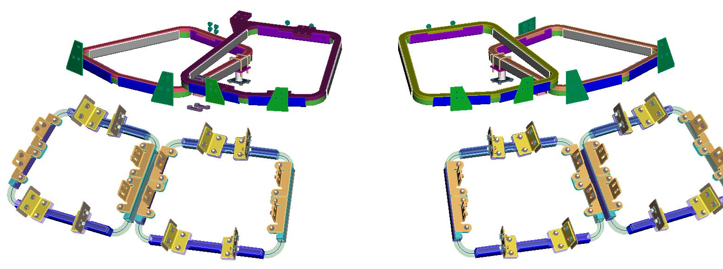

Figure ‎2-1 Trim Coils A and B

- Conductor: The conductor is a continuous length of 2mm square copper pre-insulated with one half lap layer of .007 inch thick Kapton and then one half lap layer of .005 inch thick “dayglass” tape

- Ground Insulation: The ground insulation is .125 inches thick and consists of multiple layers of fiberglass tape surrounding the winding pack.
- Layer to Layer Insulation: The layer to layer insulation is pre-applied to the conductor and is supplemented by one .006 inch layer of E glass in the vertical plane between each layer as depicted in SE133-041 and SE133-031. This extra layer of glass is meant to help wick the epoxy into the coil during the VPI process.
- Coil Leads: There are no lead blocks applied to the coil turns as they exit the coil. The coil conductor is to be sleeved with extra Teflon insulation which extends into the coil body and is firmly fastened to the coil to prevent damage in shipping as depicted in SE133-041 and SE133-031.

Characteristics

Performance

Electrical Requirements

DC Resistance
The total coil resistance measured at room temperature (20ºC) shall be within +/-2% of the calculated resistance given in Table 1:
Table 1- Coil Resistance
Coil Identification | Calculated Coil Resistance Ohms
TR-A | 1.358
TR-B | 1.212

Voltage Standoff, Terminal- to-ground
The Assembly shall provide a standoff capability between the electrical circuit (conductor) and ground or any other component of 4.5 kV with a minimum resistance of 1000 MΩ. [Calculated voltage standoff capability is 18.9 kV] The maximum test voltage must be held for 1 full minute during testing to allow reading to stabilize.

Voltage Standoff, Turn-to-turn
The Trim Coils shall provide a voltage standoff capability between adjacent conductors or leads adequate to withstand a peak terminal-to-terminal voltage of 1.0 kV with a maximum of 10 µA of current leakage.

Physical Characteristics

Component Characteristics

Conductor and Turn to Turn Insulation
The conductor is a continuous length of 2mm square copper pre-insulated with one half lap layer of .0017 inch thick (including adhesive) Kapton and then one half lap layer of .0012 inch thick “Dayglass” tape. The copper material is ETP C110 with a minimum yield of 9 KSI. The total build of the conductor with insulation is .090 inches +/- .003 inches square. The Conductor can be purchased from Superior Essex, Fort Wayne, IN in spool quantities up to 1750 lbs with P/N C0005A00612024A.

Ground Insulation
The ground insulation is applied over the coil turns and is composed of 0.012 inch thick by one inch wide E glass. The E glass is applied in half lap layers to bring the total build of the turn-to-turn insulation to 0.125- 0.135 inches and the external width and height of the coil to match the dimensions on the referenced drawings. (SE133-041 and SE133-031). The number of layers of the ground wrap insulation shall be determined by measurement and adjusted to achieve a sum total of 10% compression for both the ground wrap and turn to turn glass insulation. The number of layers of E glass used shall be approved by PPPL prior to fabrication.
The completed ground wrapped assembly is to be vacuum impregnated using CTD 101K epoxy. The number of layers of ground insulation is to be optimized so that the compression of the coil in the VPI mold is sufficient to minimize resin rich areas. To eliminate resin rich areas, voids in the corners of the VPI mold are to be eliminated with the use of radiused fillers or a machined radiused surface.

Insulation for Lead Area
As the leads exit the coils they are to be insulated with an extra layer of Teflon sleeve material as specified on the drawings (SE133-041 and SE133-031). The Teflon sleeve is to extend a minimum of ½ inch below the surface of the groundwrap.

Vacuum-Pressure-Impregnation [VPI]
Each finished Trim Coil shall be vacuum pressure impregnated [VPI] using the pre-selected epoxy resin system identified below.
  - Epoxy Description: CTD-101K: a modified 3-part anhydride cured epoxy system with excellent performance at cryogenic temperatures.
  - Manufacturer: Composite Technology Development Inc.
1505 Coal Creek Drive
Lafayette, Colorado 80026
Phone: (303) 664-0394
  - Epoxy Working and Cure Temperatures
- Mixing Temperature: 40-60 degrees C
- Cure Cycle: 5 hours @ 110 degrees C
- Post Cure: 16 hours @ 125 degrees C

Final Inspection and Tests
The inspections and tests identified in Section 4.0 shall be performed when the coil is in a deliverable state.

Design and Construction

Materials, Processes, and Parts

Production Drawings
The Assembly shall be fabricated in accordance with the models and drawings listed in Section 5.1.

Metrology
Inspection reports shall be provided to verify dimensions are within tolerance as specified in coil drawings identified in Section 5.1. Dimensions shall be checked in every corner at the center of each leg of the coil and at a minimum of every 6 inches per side.

Labels
The Assembly shall have a permanent label with the following minimum information – NCSX Trim Coil Assembly, P/N [coil drawing number], the serial number of the item, the manufacturer of the item, and the date of manufacture (month and year). The label shall be located at the location specified in reference drawings (SE133-041 and SE133-031).

Workmanship
During Assembly fabrication and finishing, particular attention shall be given to freedom from blemishes, defects, burrs, and sharp edges; thoroughness of cleaning; quality of brazing and alignment of parts. Copper conductor shall be stored and processed in an environment free from metallic dust or other contaminants. Materials shall be protected from skin oil, etc., by requiring shop personnel to handle conductors only while wearing clean, lint free, white cotton or latex gloves.

Quality Assurance Provisions

General
The vendor has sole responsibility for inspection and testing of all Trim coil assemblies.

Verification

Performance Verification

Electrical Requirement Verification
The time at test voltage for all electrical verifications shall be a minimum of one minute

Verification of DC Resistance
The total coil resistance shall be measured at room temperature (20ºC) in order to verify compliance with Section 2.2.1.1.1. This test shall be performed:
- Prior to ground wrapping the coil
- After Coil VPI

Verification of Terminal-to-ground Voltage Standoff
Each Trim coil assembly shall be Megger tested at room temperature (20ºC) during acceptance testing to verify compliance with Section 2.2.1.1.2. This test shall be performed prior to and after VPI operations. The values are identified below:
- Prior to ground wrapping the coil at 1kV
- After Coil VPI at 4.5 kV

Verification of Turn-to-turn Voltage Standoff
Each Trim coil assembly shall be tested for turn to turn dielectric strength. The vendor shall propose a testing plan for achieving this turn to turn test. Compliance with the values identified in 2.2.1.1.3 is required. In addition the inductance of each coil is to be measured and recorded after VPI. The turn to turn test shall be performed:
- Prior to ground wrapping the coil
- After Coil VPI

Verification of Physical Characteristics

Verification of Component Characteristics

Verification of Conductor
The conductor width is to be verified and recorded before winding begins on each coil.

Verification of Ground Insulation Parameters
Measurements of insulation build and the number of layers are to be recorded in the winding procedure for each coil to verify compliance with paragraph 2.2.2.1.2

Geometry
Each completed Trim Coil assembly is to be measured with all dimensions documented. Inspection reports are to note nominal dimensions and deviations from those dimensions along with allowable tolerances.

Appendices

Drawings
Drawing Number | Description
SE133-031 | Trim Coil -A
SE133-041 | Trim Coil -B

