NCSX

Product Specification

Twisted Racetrack Coil Winding Form

NCSX-CSPEC-141-02-00
November 25, 2003

Prepared By: ___________________________________________________________
D. Williamson, WBS Manager for Modular Coils (WBS 14)

Concurred By: __________________________________________________________
P. Heitzenroeder, Technical Representative for Modular Coil (WBS 14) Procurements

Concurred By: __________________________________________________________
F. Malinowski, PPPL Procurement QA Representative

Approved by: __________________________________________________________
B. Nelson, Project Engineer for Stellarator Core Systems (WBS 1)
Controlled Document
This is a controlled document. Check the NCSX Procurement Web prior to use to assure that this document is current.
REVISIONS

Revision No. | Affected Pgs. | Date
Rev. 0 (Initial Release) | All | 11/25/03
TABLE OF CONTENTS

1 INTRODUCTION AND SCOPE 1
1.1 Introduction 1
1.2 Scope 1
2 APPLICABLE DOCUMENTS 1
2.1 Design Documents 1
2.2 Codes and Standards 2
3 REQUIREMENTS 2
3.1 Winding Form Definition 2
3.2 Characteristics 3
3.2.1 Performance 3
3.3 Design and Construction 4
3.3.1 Production Drawings 4
3.3.2 Standards of Manufacture 5
4.0 Quality Assurance Provisions 5
5.0 DOCUMENTATION REQUIREMENTS…………………………………………………...10
6.0 DELIVERABLES…………………………………………………………………...……....10
7. Preparation for delivery 10
7.1 Marking 10
7.2 Cleaning 11
7.3 Crating 11
7.4 Shipping 11

INTRODUCTION AND SCOPE

Introduction
Stellarators are a class of magnetic fusion confinement devices characterized by three dimensional magnetic fields and plasma shapes and are the best-developed class of magnetic fusion devices after the tokamak. The National Compact Stellarator Experiment (NCSX) is the first of a new class of stellarators known as “compact stellarators.” The NCSX project is managed by PPPL in partnership with the Oak Ridge National Laboratory. This Subcontract will be administered by PPPL. Operation of NCSX is scheduled to begin in July 2007

Scope
This specification establishes the manufacturing and acceptance requirements for the National Compact Stellarator Experiment (NCSX) Twisted Racetrack Coil Winding Form.

APPLICABLE DOCUMENTS

Design Documents
Table 2.1-1 Design Documents
Document no.  (filename) | Revision | Description | Document  file type
SE140-084  (se140-084.drw) | 0 | Twisted Racetrack Winding Form drawing | Drawing
(SE140-084.prt) | 0 | Twisted Racetrack Winding Form part | Pro-E part file
(SE140-084.stp) | 0 | Step file for complete part | Step file
(SE140-084df.stp) | 0 | “de-featured” step file | Step file
(SE140-084wc.txt) | 0 | Datum points for winding trajectory | Text file
(SE140-084xv.txt) | 0 | Datum points for “x-vector” | Text file
(SE140-084ss.txt) | 0 | Datum points for spherical seat centers | Text file

Codes and Standards

ASTM (American Society for Testing and Materials )

A703/A703M-01 “Specification for Steel Castings”.
A800/A800M-01 “Standard Practice for Steel Casting, Austenitic Alloy, Estimating Ferrite Content Thereof”.

A802/A802M–95 “Standard Practice for Steel Castings, Surface Acceptance Standards, Visual Examination”.

A 903/A903/M–99 “Standard Specification for Steel Castings, Surface Acceptance Standards, Magnetic Particle, and Liquid Penetrant Inspection”.

Manufacturers Standardization Society of the Valve and Fittings Industry, Inc.

MSS SP-54-2001: “Quality Standard for Steel Castings for Valves, Flanges, Fittings, and Other Piping Components; Radiographic Inspection Method”.

REQUIREMENTS

Winding Form Definition
The winding forms are austenitic (non-magnetic) stainless steel structures which are one of the most important components of the modular coils. The winding forms perform two very important functions: (1) the conductors are wound on the winding forms, and are located in precise position by these forms; (2) the winding forms serve as their structural support during assembly and operation.
The twisted racetrack winding form is much smaller than the production winding forms, but is designed to capture the most difficult geometric features from the production forms. It is a cast and machined structure with an approximate racetrack configuration. There is a machined tee-shaped feature that protrudes from one side. The twisted racetrack winding form is illustrated in Figure 3.1-1

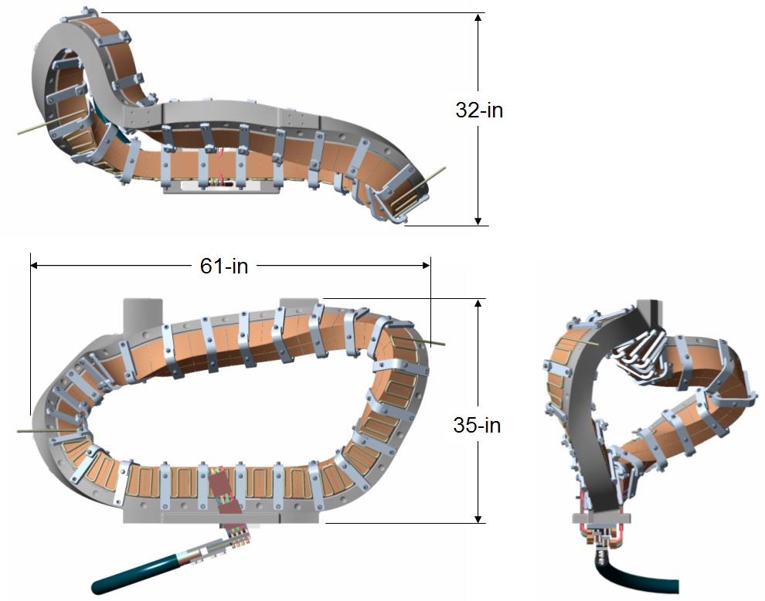
Figure 3.1-1 Twisted Racetrack Winding Form

Characteristics

Performance

Mechanical and Physical Properties of Casting Alloy
Background
For the twisted racetrack winding form, the casting alloy is not specified. This is done to allow potential suppliers the opportunity to propose casting alloys that they feel are superior from the standpoints of cost and performance. Mechanical properties similar to those of cast SS316 at 77K are considered adequate for this application. Subcontractors shall use the same alloy as proposed for their NCSX Prototype Winding Form. Higher strength, lower electrical resistivity, and higher thermal conductivity would all be favorable. Slightly less favorable properties might be tolerable. Such alloys might be considered if there were compelling reasons to do so.
Requirement
The twisted tee winding form shall be fabricated from stainless steel alloy that meets the following requirements:
0.2% Yield strength: >180 MPa (>26 ksi) at room temperature (RT); >360 MPa ( >52 ksi) at 77K.
Ultimate tensile strength: >360 MPa (52 ) at RT; >690 MPa (104 ksi) at 77 K.
Elongation: 30% (min.) at RT and 77 ⁰K.
Thermal conductivity: >9.5 W/m-K at RT; >7W/m-K at 77K
Electrical Resistivity: >83 x 10⁻⁸ Ω−m at RT; >64 x 10⁻⁸ Ω−m at 77K

Surface Finish
All machined surfaces must have a RMS (root mean square) surface finish <125 μ-inches. Uniform “scallops” which exceed 125 μ-inches, which may result from some machining processes, may be acceptable, subject to PPPL approval. Areas less than 4 sq. in. which have depressions less than 10% of the wall thickness may be filled with an epoxy paste, subject to PPPL’s approval on a case-by-case basis. The epoxy paste chosen must be capable of withstanding 200 C for 4 hours (for coil bake-out) and be capable of sustained operation at 77 K (for normal operation). It must have a compressive strength >83 MPa (12 ksi ).

Relative Magnetic Permeability
The local relative magnetic permeability shall not exceed 1.02.

Design and Construction

Production Drawings
The Pro/Engineer CAD files listed in Table 2.1-1 shall be used to manufacture the twisted tee winding form. Tolerance requirements are provided in the drawings , models and specification.
The Pro/ENGINEER models and drawings of the machined winding forms are available through the PPPL anonymous FTP server.
The files may be accessed through a web browser using the following URL address:
ftp://ftp.pppl.gov/pub/ncsx/manuf/twisted racetrack_winding_form

Standards of Manufacture

Heat Treatment
The casting is to be heat treated per the applicable ASTM specification for the alloy chosen and as required for dimensional stability and materials property control prior to final measurements of mechanical properties and relative magnetic permeability. Heat treatment records shall be prepared and maintained as defined in S21 of ASTM Spec. A703/A703M, and supplied to PPPL. Test specimens shall be heat treated together with the castings they represent per Supplementary Requirement S22 of ASTM Spec. A703/A703M.

Repairs
Unacceptable defects must be repaired. Major repairs shall be welded and documented as defined in Sections S12 and S20 of ASTM Spec. A703/A703M. Repairs shall be considered major when the depth of the cavity prepared for welding exceeds 10% of the actual wall thickness or 1”, whichever is smaller, or when the extent of the cavity exceeds approximately 10 in². Non-conformance reports for major repairs (which includes in the disposition the proposed corrective action) shall be prepared for each major weld repair and is subject to the prior approval of PPPL. Weld preparation shall be per Section S10 of ASTM Spec. A703/A703M. Weld repairs are to be inspected per Sections 4.2.6, 4.2.7, and 4.2.8 of this specification.

Quality Assurance Provisions
  - QUALITY ASSURANCE
    - Authorized representatives of PPPL and the U. S. Government shall have the right at all reasonable times to visit the Subcontractor's premises and those of Subcontractor's suppliers during the performance of the Subcontract for the purposes of inspection, surveillance, audit and/or obtaining any required information as may be necessary to assure that items or services are being furnished in accordance with specified requirements. Such visits shall be coordinated with the Subcontractor's personnel to minimize interference with the normal operations of said premises. The Subcontractor shall make available records and documentation necessary for this function and shall provide all reasonable facilities and assistance for the safety and convenience of PPPL and/or U. S. Government representatives in the performance of their duties. PPPL and the U. S. Government recognize the Subcontractor's right to withhold information concerning proprietary processes.
    - Neither PPPL review and/or approval of Subcontractor's documents nor PPPL inspection of Subcontractor's items or services shall relieve the Subcontractor of responsibility for full compliance with requirements of the purchase order/contract. The Subcontractor is responsible for assuring that all requirements and restrictions are imposed on any sub-tier suppliers.
    - The Subcontractor shall establish and maintain an effective Quality Assurance Program to assure that the Subcontractor’s work meets the required quality and is performed in accordance with contractual requirements. Subcontractor’s quality assurance function shall be organized to have sufficient authority and independence to identify quality problems, verify conformance of supplied items or services to specified requirements and obtain satisfactory resolution of conflicts involving quality.
    - Each item to be delivered to Princeton shall be inspected and tested by the Subcontractor to verify that such items meet Princeton's requirements (acceptance/rejection criteria). Unless otherwise agreed to in writing, inspection shall include all drawing dimensions for all items. Testing shall include magnetic permeability. Inspections and tests shall be performed in accordance with written procedures referencing criteria for acceptance or rejection. Actual data and accept/reject status for each drawing dimension and each test performed.

    - Inspections and tests shall be performed using properly calibrated measuring and test equipment. Calibration standards shall be traceable to the National Institute for Standards and Technology (NIST) or equivalent acceptable to PPPL and shall not be used for shop inspections, but instead be protected against damage or degradation.
    - Material and equipment identification shall be maintained throughout the program and be traceable to the records. Status of acceptability shall be readily discernible through the Subcontractor's use of tags, stamps, serial numbers or other positive means.
    - Subcontractor shall use trained and qualified personnel and qualified written procedures in accordance with specified requirements for the performance of special processes, including but not limited to, soldering, brazing, welding, plating, heat treatment, nondestructive examination, etc. Copies of special process procedures shall be available for review by Princeton.
    - Nonconforming items shall be positively identified, and, where possible, segregated to prevent use. The Subcontractor shall document each nonconformance. The written approval of Princeton is required prior to the use of the nonconforming item. The Subcontractor's system shall provide not only for timely resolution of nonconformances but also for analysis of nonconformances to determine root causes and to implement appropriate and effective corrective actions.
    - Subcontractor shall have a signed "Product Quality Certification and Shipping Release" Form (Attachment 1 of this SOW) prior to NCSX Project acceptance of procured items or services for full or partial shipment. NCSX Project reserves the right to refuse to accept shipments unless accompanied by a signed "Shipping Release Form”
    - PPPL will perform Receiving Inspection on items or services supplied by Subcontractor, using either a sampling plan or 100% inspection. Discrepant items or services will be rejected and returned to Subcontractor or reworked by PPPL.
  - Quality Conformance Inspections.
    - General
      - Tests shall be conducted at the supplier’s facility or otherwise suitable location.
      - The responsibility for performing all tests and verifications rests with the supplier. PPPL reserves the right to witness or separately perform all tests specified or otherwise inspect any or all tests and inspections
    - Verification of Mechanical and Physical Properties of Casting Alloy
      - Yield Strength: The yield strength at 0.2% elongation for the cast stainless steel in the as heat-treated condition at room temperature shall be provided. Tensile test specimen coupons shall be cast with the twisted tee casting in accordance with ASTM A703/A703M-01, Supplementary Requirement 7
      - Ultimate Tensile Strength and Elongation: The ultimate tensile strength and elongation for the cast stainless steel in the as heat-treated condition at room temperature shall be provided. Tensile test specimen coupons shall be cast with the twisted tee in accordance with ASTM A703/A703M-01, Supplementary Requirement 7.
      - Chemical Composition: The material chemical composition shall be measured and provided.
    - . Verification of Surface Finish
All machined surfaces shall be inspected for compliance with surface finish requirements specified in Section 3.2.1.2.

    - Verification of Relative Magnetic Permeability
All cast surfaces and features shall be checked with a calibrated Severn Permeability Indicator for compliance with Section 3.2.1.3. Machined surfaces and edges shall be checked at locations no greater than 2 inches apart and at all weld repairs. Relative magnetic permeability measurements on all other surfaces shall be made at locations approximately 2” apart (to approximate a 2” x 2” grid). Relative magnetic permeability of any final machined casting that exceeds 1.02 must be documented on a nonconformance report and will require approval on a case-by-case basis.

    - Dimensional Inspection
All cast surfaces and features shall be dimensionally checked on a maximum of 1-inch centers using instruments having resolution at least ten times the tolerance and compared to the tolerances indicated on the applicable drawings listed in Table 2.1-1. All out-of-tolerance conditions shall be documented on nonconformance reports. With experience and based on the repeatability of manufacturing tolerances, the granularity of the measuring grid may be increased upon PPPL’s written approval.

    - Visual Inspection
Visual surface inspection and treatment of unacceptable surface defects shall be performed per ASTM Spec. A703/A703M, paragraph 10.1. Evaluation criteria shall be per ASTM A802/A802M, Level II using graded reference comparators available from Castings Technology International.
    - Liquid Penetrant Inspection
The casting shall be examined for surface discontinuities using liquid penetrant inspection per Supplementary Requirement S6 of ASTM Spec. A703/A703M. Evaluation criteria shall be per ASTM A903/A903M Level I for those regions of the winding forms shown shaded in the drawings in Attachment 1 and Level II for all other areas. Certified test reports are required per ASTM A903, Supplementary Requirement S1.
    - Inspection for Internal Defects
The casting shall be examined for internal defects as defined in ASTM Spec.A703/A703M using radiographic inspection per Supplementary Requirement S5. Acceptance criteria shall be per MSS SP 54 for radiography
5.0 DOCUMENTATION REQUIREMENTS
5.1 Subcontractor shall provide one copy of a Process History with the shipping release request (see 4.1.9) and two copies with the completed assembly. The Process History shall include the following:
5.1.1 Copies of the original reports of all required inspections, tests and examinations, which have been properly validated by authorized personnel. At least one set of radiographic films documenting the inspection in 4.2.7 shall accompany the shipment.
5.1.2 Material Test Reports traceable to the actual material and showing actual relevant chemical, and mechanical properties of Subcontractor-provided materials used. One copy is to be submitted upon Subcontractor acceptance for use.
6.0 DELIVERABLES
6.1 Documentation listed in 4.1 above—one copy with the shipping release and two (other than the radiographic film) with the shipment.
6.2 All tooling specially fabricated for the performance of this SOW shall become the property of the United States Government.
6.3 Complete winding form per this specification.

7. Preparation for delivery

7.1 Marking
The winding form shall have a serial number and its weight engraved or stamped at a convenient location on the back surface (“back surface” is the opposite side of the “tee” feature) with characters 1/4” high.

7.2 Cleaning
The winding form shall be degreased/cleaned using a solvent, which has been agreed upon by both parties. This solvent must be able to dissolve grease, oils and other soils, and be residue free. .

7.3 Crating
The crate shall protect the winding form from shock and weather conditions, including precipitation. The crate shall be built for moving on rollers, handling with slings from overhead cranes, and transport by forklifts.

7.4 Shipping
Subcontractor is responsible arranging shipment, and for the safe arrival of the twisted tee winding form at PPPL in Princeton, New Jersey, USA. Subcontractor’s name, shipper, purchase order number, contents and gross weight shall be marked on the shipping container.
PRINCETON UNIVERSITY
PLASMA PHYSICS LABORATORY—PPPL
PRODUCT QUALITY CERTIFICATION AND SHIPPING RELEASE
PROJECT | ITEM DESCRIPTION |  |  |  |  | SHIPMENT NUMBER
PPPL SUBCONTRACT/  ORDER NO. | REV. | ITEM NO. | SUPPLIER REFERENCE NO. |  | REV. |  | QUANTITY SHIPPED
SUPPLIER'S CERTIFICATION

This is to certify that the products and services identified herein have been produced under a controlled quality assurance program and are in conformance with the procurement requirements including applicable codes, standards and specifications as identified in the above-referenced documents unless noted below. Any supporting documentation will be retained in accordance with the procurement requirements.

SIGNED: _________________________________________ DATE: __________________________

TITLE: _________________________________ COMPANY: _______________________________
PPPL (AUTHORIZED REPRESENTATIVE) SHIPPING RELEASE

This is to certify that evidence supporting the above Supplier's Certification statement has been audited and no product/service nonconformances from procurement requirements have been found unless noted below. This product/service is hereby released for shipment.

This section serves as the Quality Assurance release for the above described product for shipment. It does not constitute an acceptance thereof and does not relieve the Vendor, Manufacturer or Contractor of any and all responsibility or obligation imposed by the purchase contract. It does not waive any rights the Purchaser may have under the purchase contract, including the Purchaser's right to reject the above described material upon discovery of any deviations from requirements of the purchase contract, drawings and specifications.

NONCONFORMANCES FROM PROCUREMENT QUALITY REQUIREMENTS:

REMARKS/PRODUCT SERIAL NUMBERS:

BY PPPL QA REPRESENTATIVE (OR DESIGNEE) |  |  |  | DATE

Publications are available from http://www.astm.org/cgi-bin/SoftCart.exe/index.shtml?E+mystore.
Publications are available from Manufacturers Standardization Society of the Valve and Fittings Industry, Inc., 127 Park Street, NE , Vienna, Virginia 22180 . Tel. (703)-281-6613.
http://www.castingsdev.com/

