Specification
For

NCSX Modular Coil

Autoclave Design

NCSX-BSPEC-142-01-00

Prepared by: Steve Raftopoulos, Cognizant Engineer for Modular Coil Tooling

Concur:
J. Chrzanowski, Cognizant Engineer for Modular Coil Winding & Assembly, WBS 142

Concur:
D. Williamson, WBS Manager for Modular Coils, WBS 14

Concur:
Judy Malsbury, NCXS QA Representative

Approved by:
B. Nelson, Project Engineer for Stellarator Core Systems, WBS 1

Controlled Document
This is a controlled document. Check the NCSX Procurement Web prior to use to assure that this document is current.

- SCOPE

  - This document specifies the performance, design, documentation, and quality assurance requirements of the NCSX Modular Coil Autoclave System.

- APPLICABLE DOCUMENTS

  - Design Standards

    - ES&H 5008 “PPPL Health and Safety Manual”
    - ENG-008 "Failure Modes and Effects Analysis"Rev.0
    - ENG-032 "Work Planning Procedure" Rev.1
    - ENG-033 "Design Verification" Rev. 1
    - ESH-004 "Job Hazard Analysis" Rev. 1
    - NCSX Modular Coil VPI Autoclave FMEA

  - Testing Standards

    - ENG-014 "Hydrostatic and Pneumatic Testing"Rev.0

  - Other

    - NCSX-CSPEC-142-01-00 “Autoclave Vessel Fabrication Specification”
    - NCSX-CSPEC-142-02-00 “Autoclave Heating System Fabrication Specification”

- REQUIREMENTS:

  - System Definition

    - An autoclave is a pressure chamber used to cure materials at elevated temperatures, pressures, and/or vacuum applied during the process cure cycles. The application and sequence of heating, cooling, pressure and vacuum are predetermined by the process specifications that detail the fabrication and treatment of parts. The NCSX Modular Coil Autoclave has been specifically designed to accommodate the NCSX Modular Coils, and to provide the necessary operational parameters for the Vacuum Pressure Impregnation (VPI) process that is employed in the production of these coils.

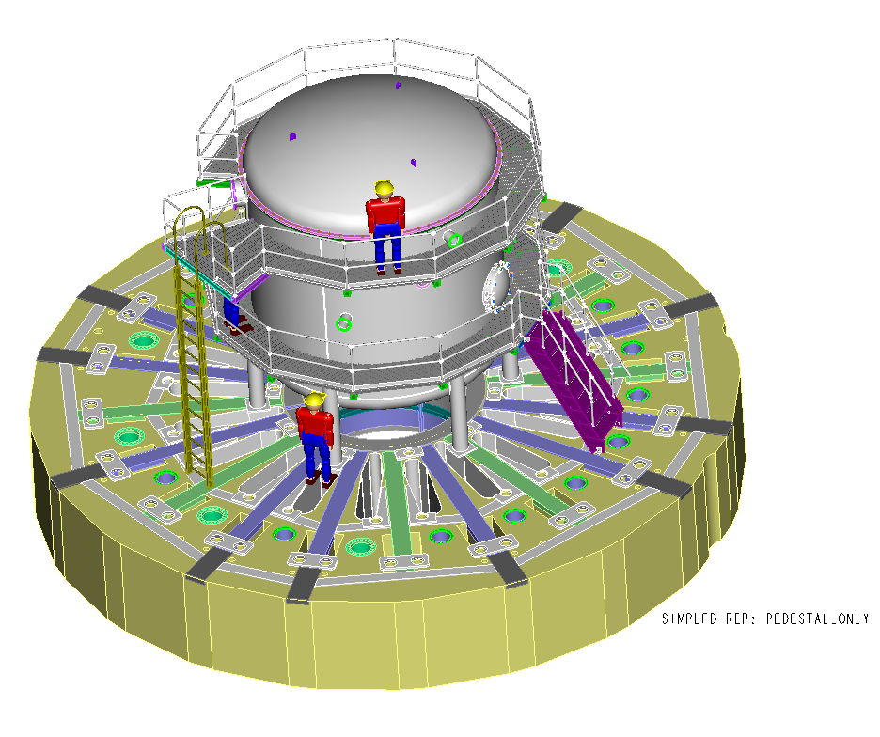
    - NCSX Autoclave CAD Rendering

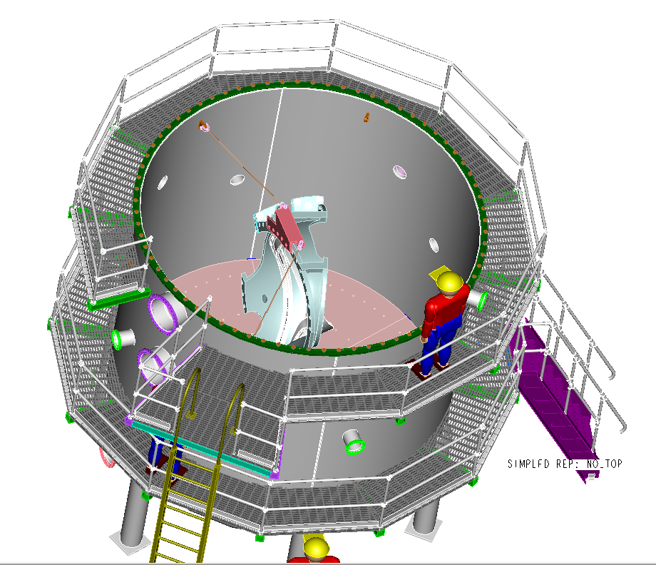

Blower
Heating element
Valve (typ)
Pressure & Vacuum gauges (typ)
50-scfm vacuum pump
Autoclave
LN2 Cryo-trap
Relief valves (2)
Lighting
Modular coil

NCSX Autoclave Block Diagram

    - Interface Definition

      - The Autoclave shall be located in the TFTR Test Cell. It is a stand-alone device and does not interface with any PPPL systems.
      - The Autoclave requires 480V 3-phase, and 110V single-phase power to operate its components.
      - Exhausts from Autoclave operation shall be vented directly into the TFTR Test Cell.

    - Major Component List

      - N/A

    - Government Furnished Property List
      - N/A

  - Characteristics

    - Performance

      - Vacuum/Pressure requirements:

        - Pumpdown a base pressure equal to or less than 1 torr.
        - Pumpdown to base pressure in 4 hours or less.
        - Rate of rise (empty chamber, no pumping) to be less than 5 torr per hour.
        - Capable of withstanding 30 psia (15 psig) internal pressure.

      - Heating requirements:

        - Circulating fluid (gaseous) heating system than can heat the modular coil sections to 50 degrees centigrade in 15-hour period.
        - Wall heating (resistive) capable of maintaining inner temperature (under vacuum) at 50^{+/-}2 degrees centigrade.
        - Outer wall insulation temperature not to exceed 38 degrees Centigrade.
        - Provide heated air for venting from vacuum condition.

      - Instrumentation and Control

        - Temperature readouts of:

- Modular coil
- Autoclave walls
- Internal air/fluid
- Vacuum readout.
- Environmental readouts; Oxygen, combustible gas, hazardous gas
- Feedback control of wall heating system.
- Feedback control of internal heating system.

      - Operational requirements

The design shall meet the requirements of the typical cycle for the impregnation and curing of the modular coil conductor as follows:

        - Remove autoclave lid, lower (wound) modular coil section into chamber and secure.
        - Connect epoxy sprues and thermocouple leads.
        - Install lid and secure.
        - Start vessel-heating system. Heat at a rate not greater than 10 degree centigrade per hour to a temperature of 55 C. [+/- 5 degrees C]
        - Initiate wall-heating mode to maintain coil temperature at 55 C [+/- 5 degrees C] while under vacuum.
        - Evacuate autoclave to a pressure of 0.5 to 1 torr
        - Initiate epoxy impregnation by directing flow to lower sprue(s).
        - Observe through viewports as impregnation process proceeds. Valve in additional sprus as necessary.
        - Increase epoxy delivery pressure, as well as autoclave internal pressure correspondingly, as necessary to enhance epoxy flow.
        - Continue impregnation process until epoxy flows from top (exhaust) sprues. Valve off epoxy when coil is fully impregnated.
        - Vent autoclave with 55 degree C air to 0 psig.
        - Initiate heating system and heat at a rate not greater than 10 degree centigrade per hour to a temperature of 110 C.
        - Hold at 110 degree C for 5 hours.
        - Raise temperature to 125 degree C. Hold for 16 hours.
        - Turn off heating, and cool to room temperature.

    - Physical Characteristics

      - The autoclave shall be sized to contain the largest NCXS modular coil assembly. Approximately four meter diameter, by four meter tall.
      - Removable lid for installing coils.
      - Man-access door for rapid entry. Preferably a swing open, quick access type.
      - Ladders and platforms for set-up and entry when lid is removed.
      - Flat floor for personnel use built into lower dome.
      - Burst disk or pressure relief valve to vent overpressure.
      - Internal lighting system, compatible with air and vacuum environments.
      - View ports: Six, 8” ports; 3 per side.
      - Feedthrough/service ports for the following:
- Heating fluid (typical 2 eight-inch ports)
- Vacuum pump/vent (typical 2 four-inch ports)
- Temperature control and monitoring (2) 32-pin feedthroughs)
- Drain (1 three-inch on bottom dome)
- Pressure monitoring (2 locations)
- 110 volt power for lighting
- Epoxy delivery system (40 sprues). ½-inch tubing using a Wilson type vacuum feedthrough.
- Spare feedthroughs

    - Reliability
      - The Autoclave shall be capable of performing at least 50 cycles (section 3.2.1.4) without requiring scheduled maintenance.

    - Maintainability
        - Components that require lead times longer than one week to acquire, should be available as spares.

    - Environmental Conditions
      - N/A

    - Transportability
      - The Autoclave will be fabricated at PPPL, therefore there are minimal transportation issues

  - Design and Construction

    - Materials, Processes and Parts

      - Materials

        - Tank (and domes) shall be fabricated from 304-stainless steel.
        - The use of carbon steel for components is permitted as long as the proper welding techniques are applied. See EM-002. Carbon steel components should be painted with a rust protecting paint
        - Surface finish of tank shall be “hot rolled”

      - Welding

        - Welding shall be done in accordance with PPPL Procedure EM-002 “General Welding and Brazing Requirements”.
        - Weld inspections shall be identified on the part drawing.

    - Electromagnetic Radiation
      - N/A

    - Nameplates and Product Marking
      - N/A for the Autoclave
      - Valves and instrumentation shall be uniquely identified.

    - Workmanship

In addition to adherence to PPPL procedures, best shop practices shall be employed. Remove burrs and sharp edges.

      - Remove burrs and sharp edges.
      - Completed parts must be clean of dirt, grease, cutting fluids and other foreign matter.
      - Vessel internal surfaces must be free of scale.
3
    - Interchangeability
      - N/A

    - Safety
      - Adherence to ES&H 5008 “PPPL Health and Safety Manual”.

    - Human Performance/Ergonomics
      - N/A

  - Documentation
    - Maintain and forward copies to the Operations center of all material tests, certifications and inspections, accumulated during the fabrication, setup and pre-operational testing phases

  - Logistics
    - N/A

  - Personnel and Training
    - The Autoclave shall be operated by approved procedure. Technicians must be trained in this procedure prior to operating the Autoclave system.

  - Major Component Characteristics
    - N/A

  - Precedence
    - N/A

- Quality Comformance
  - The following chart delineates the actions to be taken to verify the requirements listed in section 3.2.1

Requirement | Description | Verification | Remarks
3.2.1.1 | Vacuum/Pressure
3.2.1.1.1 | Achieve < 1 torr | Demonstrate | Integrated Systems Test Plan
3.2.1.1.2 | Pumpdown < 4 hrs | Demonstrate | Integrated Systems Test Plan
3.2.1.1.3 | Rate of rise | Demonstrate
3.2.1.1.4 | Withstand 30 psia | Demonstrate
3.2.1.2 | Heating
3.2.1.2.1 | Heating rate | Demonstrate | With prototype coil
3.2.1.2.2 | Wall heating | Demonstrate | Integrated Systems Test Plan
3.2.1.2.3 | Insulation Temp | Demonstrate | Integrated Systems Test Plan
3.2.1.2.4 | Circulating hot air | Demonstrate | Integrated Systems Test Plan
3.2.1.2 | Instrumentation
3.2.1.2.1 | Temp readouts | Test | Integrated Systems Test Plan
3.2.1.2.2 | Vacuum readouts | Test | Integrated Systems Test Plan
3.2.1.2.3 | O2 readout | Test | Integrated Systems Test Plan
3.2.1.2.4 | Feedback control | Demonstrate | Integrated Systems Test Plan
3.2.1.4 | Operational
3.2.1.4.1 to 3.2.1.4.6 | Impregnation cycle heating phase | Demonstrate | ISTP and/or with prototype coil
3.2.1.4.7 to 3.2.1.4.15 | Epoxy injection & cure phases | Demonstrate | Only if we decide to impregnate the prototype or twisted tee.
3.3.1.2 | Welding
3.3.1.2.1 | Process | Inspection | Comply with EM-002
3.3.1.2.2 | Inspections | Inspection | Conformance to drawings
3.3.4 | Workmanship
All | All | Inspection

