NCSX
Specification

System Requirements Document (SRD)
for the
Coil Structures System (WBS 15)

NCSX-BSPEC-15-00

28 Nov 2006

Prepared by: __________________________________________________________________________
F.Dahlgren, Coil Structure System Cog.E (WBS 15)

Concur: ______________________________________________________________________________
B. Nelson, Project Engineer for Stellarator Core Systems (WBS 1)

Concur: ______________________________________________________________________________
M. Zarnstorff, Head, Project Physics

Concur: ______________________________________________________________________________
R. Simmons, Systems Engineering Support Manager

Concur: ______________________________________________________________________________
W. Reiersen, Engineering Manager

Concur: ______________________________________________________________________________
J. Levine, ES&H

Concur: ______________________________________________________________________________
J. Malsbury, Quality Assurance

Approved by: _________________________________________________________________________
G. H. Neilson, NCSX Project Manager
Controlled Document
This is a controlled document. Check the NCSX Engineering Web prior to use to assure that this document is current.
Record of Revisions

Revision | Date | ECP | Description of Change
Rev. 0 | 11/28/2006 | - | Initial issue.
TABLE OF CONTENTS
1 Scope 1
1.1 Document Overview 1
1.2 Incomplete and Tentative Requirements 1
2 Applicable Documents 2
2.1 NCSX Documents 2
3 Subsystem Requirements 3
3.1 Subsystem Definition 3
3.1.1 Subsystem Diagrams 3
3.1.1.1 Functional Relationships 3
3.1.1.2 Functional Load Path Block Diagram 4
3.1.2 Interface Definition 4
3.1.2.1 Base Structure (WBS 172) 5
3.1.2.2 Conventional Coils (WBS 13) 5
3.1.2.3 Modular Coils (WBS 14) 5
3.1.2.4 Vacuum Vessel (WBS 12) Error! Bookmark not defined.
3.1.2.5 Cryostat (WBS 171) 5
3.1.2.6 Field Period Assembly (WBS 18) 5
3.1.2.7 Torus Vacuum Pumping System (WBS 22) 5
3.1.2.8 Wall Conditioning Systems (WBS 23) Error! Bookmark not defined.
3.1.2.9 Diagnostics (WBS 3) 5
3.1.2.10 Electrical Power Systems (WBS 4) 6
3.1.2.11 Central I&C (WBS 5) 6
3.1.2.12 Helium Bakeout System (WBS 64) Error! Bookmark not defined.
3.1.2.13 Test Cell Preparations and Machine Assembly (WBS 7) 6
3.1.3 Major Component List 6
3.2 Characteristics 6
3.2.1 Performance 6
3.2.1.1 Perform Initial and Pre-run Verification 6
3.2.1.1.1 Initial Facility Startup 6
3.2.1.1.1.1 Initial Verification of Operability 6
3.2.1.1.1.2 Design Verification 6
3.2.1.1.2 Pre-Run Facility Startup 7
3.2.1.2 Prepare for and Support Experimental Operations 7
3.2.1.2.1 Subsystem Verification and Monitoring 7
3.2.1.2.2 Coil Cool Down 7
3.2.1.2.3 Field Error Requirements 7
3.2.1.2.4 Disruption Handling 8
3.2.1.2.5 Pulse Repetition Rate 8
3.2.1.2.6 Discharge Termination 8
3.2.1.2.6.1 Normal Termination 8
3.2.1.2.6.2 Abnormal Termination 8
3.2.1.3 Facility Shutdown 8
3.2.1.3.1 Coil Warm-up Timeline 9
3.2.2 Physical Characteristics 9
3.2.2.1 Configuration Requirements and Essential Features 9
3.2.2.1.1 Coil Structure Sub-assemblies (WBS 121) 9
3.2.2.1.2 Coil Structure Local I&C (WBS 125) 9
3.2.3 System Quality Factors 10
3.2.3.1 Reliability, Availability, and Maintainability 10
3.2.3.2 Design Life 10
3.2.3.3 Seismic Criteria 11
3.2.4 Transportability 11
3.3 Design and Construction 11
3.3.1 Materials, Processes, and Parts 11
3.3.1.1 Magnetic Permeability 11
3.3.1.2 Coil Structure Shell Material 11
3.3.1.3 Structural and Cryogenic Criteria 11
3.3.1.4 Corrosion Prevention and Control 11
3.3.1.5 Metrology 11
3.3.2 Electrical Grounding 11
3.3.3 Nameplates and Product Marking 12
3.3.3.1 Labels 12
3.3.4 Workmanship 12
3.3.5 Interchangeability 12
3.3.6 Environmental, Safety, and Health (ES&H) Requirements 12
3.3.6.1 General Safety 12
3.3.6.2 Personnel Safety 12
3.3.6.4 Flammability 12
3.4 Documentation 13
3.4.1 Specifications 13
3.5 Logistics 13
3.5.1 Maintenance 13
4 Quality Assurance Provisions 14
4.1 General 14
4.2 Verification Methods 14
4.3 Quality Conformance 14
Appendix A – Quality Conformance Matrix 15

Table of Figures
Figure 1-1 PF & TF Outer Coil Support Structure
Figure 1-2 Coil Support Structure - Full Period
Figure 3-1 Coil Structure System functional relationships
Figure 3-2 Load Path block diagram

Table of Tables

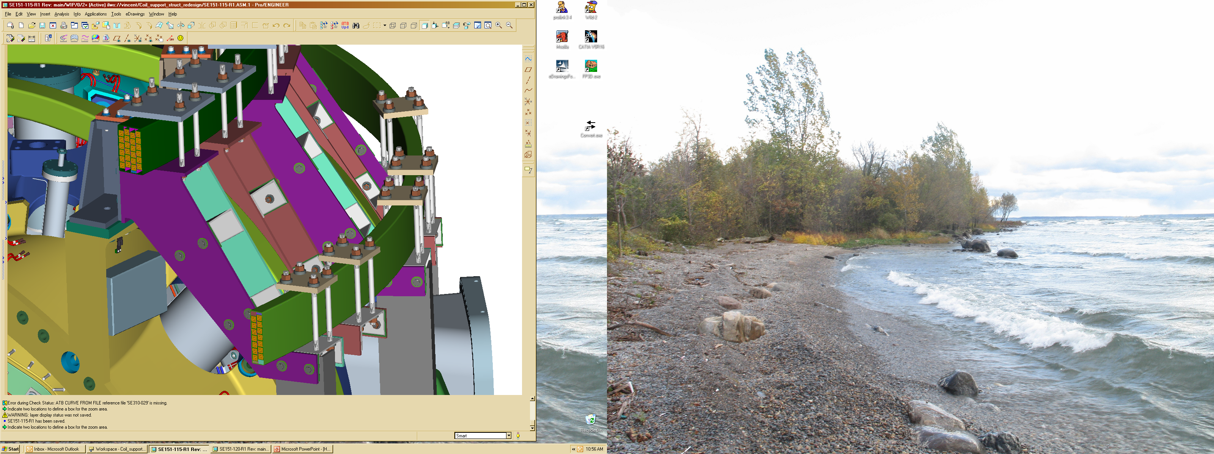

Figure 1-1 Outer PF & TF Coil Support Structure

Scope
The National Compact Stellarator Experiment (NCSX) is an experimental research facility that is to be constructed at the Department of Energy’s Princeton Plasma Physics Laboratory (PPPL). Its mission is to acquire the physics knowledge needed to evaluate compact stellarators as a fusion concept, and to advance the understanding of 3D plasma physics for fusion and basic science.
A primary component of the facility is the stellarator core, an assembly of four coil systems that surround a highly shaped plasma and vacuum chamber. The four coil systems include the modular coils, the poloidal field (PF) coils, the toroidal field (TF) coils, and the external trim coils. These coils provide the magnetic field required for plasma shaping and position control, inductive current drive, and error field correction. A fiull period assembly of the PF/TF support structure, Modular coil winding form (MCWF), and TF coils is shown in Fig. 1-1 above and 1-2 below. Figure 1-3 shows the basic components of a typical interface between the stellarator core and the base support structure.
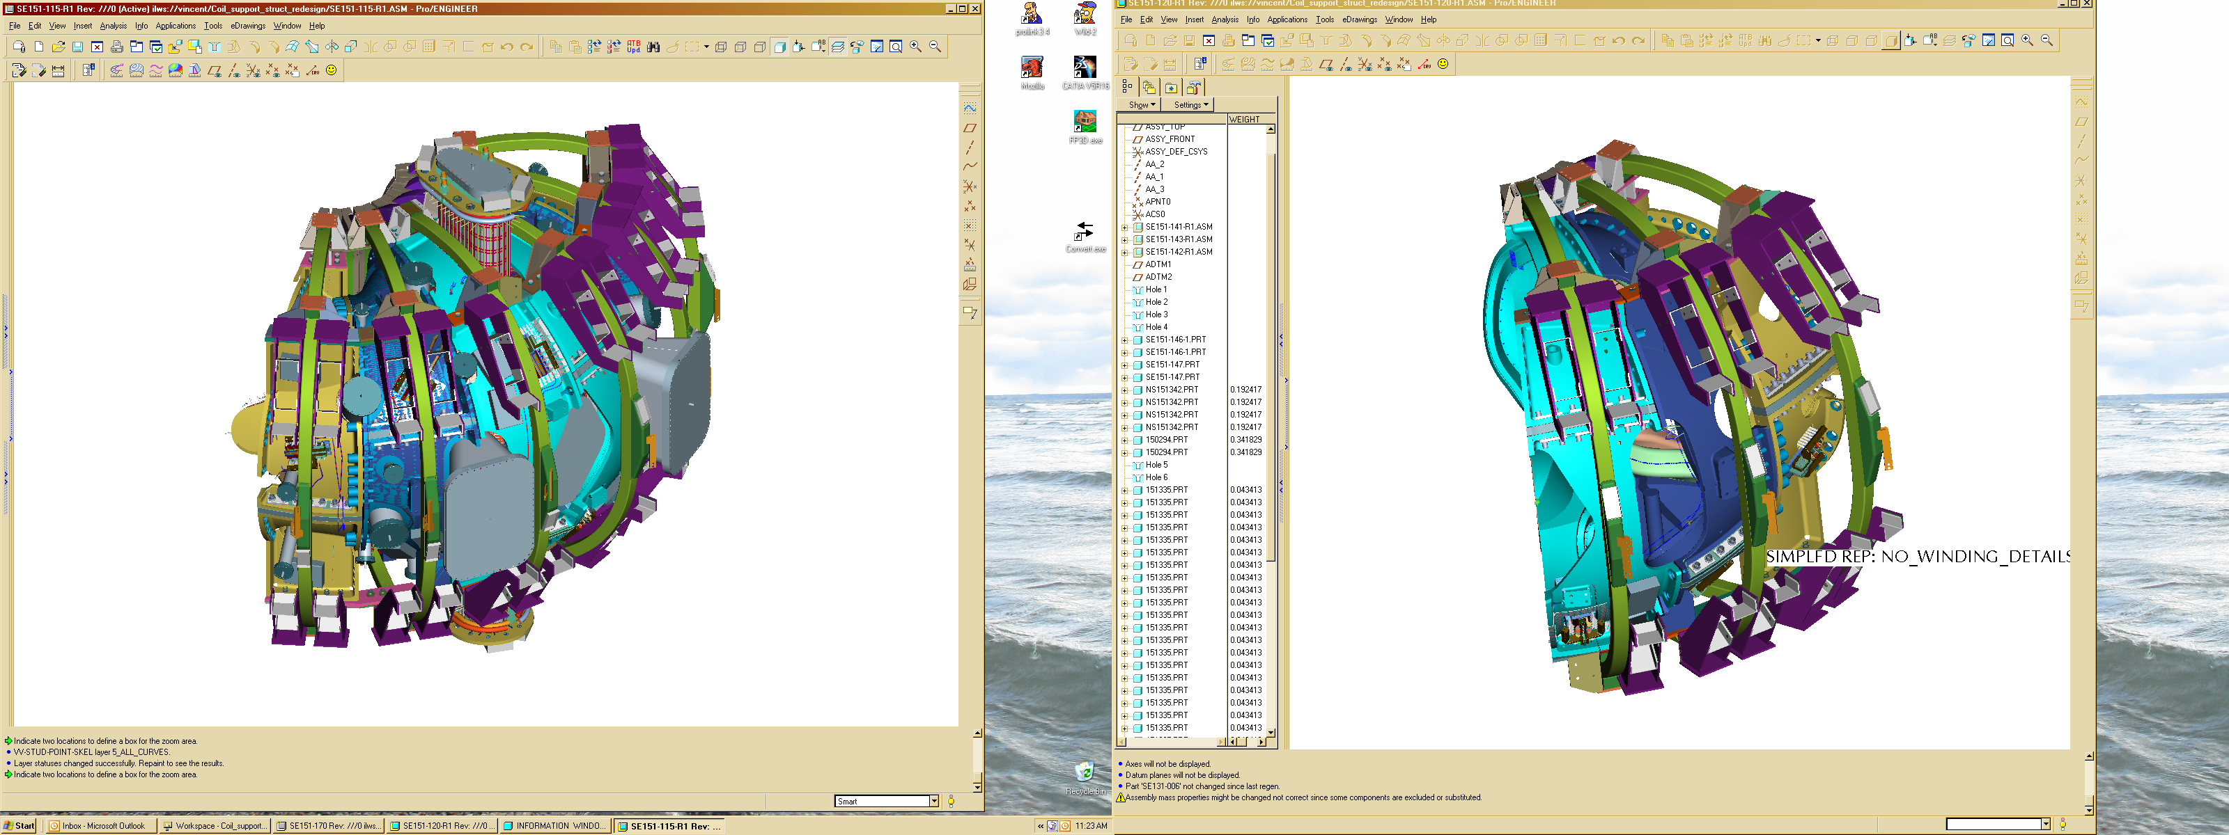

Figure 1-2 PF & TF Coil Support Structure - Full Period

Document Overview
This document, the System Requirements Document (SRD) for the Coil Structure System (WBS 15), is the complete development specification for this subsystem. Performance requirements allocated to this subsystem in the system specification, the General Requirements Document (NCSX-ASPEC-GRD-02), have been incorporated in this document. In this document, the term “the system” refers to the overall device and facility and the terms “the subsystem” and “coil support structure” refer to the Coil Structure System (WBS 15).
The specification approach being used on NCSX provides for a clear distinction between performance requirements and design constraints. Performance requirements state what functions a system has to perform and how well that function has to be performed. Design constraints, on the other hand, are a set of limiting or boundary requirements that must be adhered to while allocating requirements or designing the system. They are drawn from externally imposed sources (e.g., statutory regulations, DOE Orders, and PPPL ES&H Directives) as well as from internally imposed sources as a result of prior decisions, which limit subsequent design alternatives.

Incomplete and Tentative Requirements
Within this document, the term “TBD” (to be determined) indicates that additional effort (analysis, trade studies, etc) is required to define the particular requirement. The term “TBR” (to be revised) indicates that the value given is subject to change.
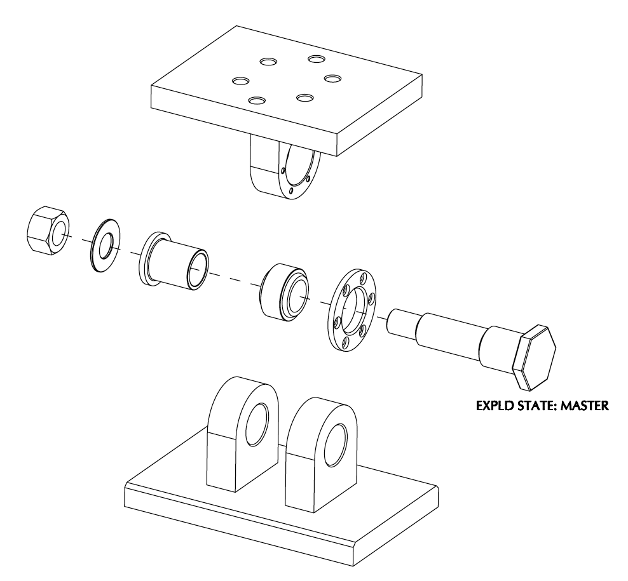
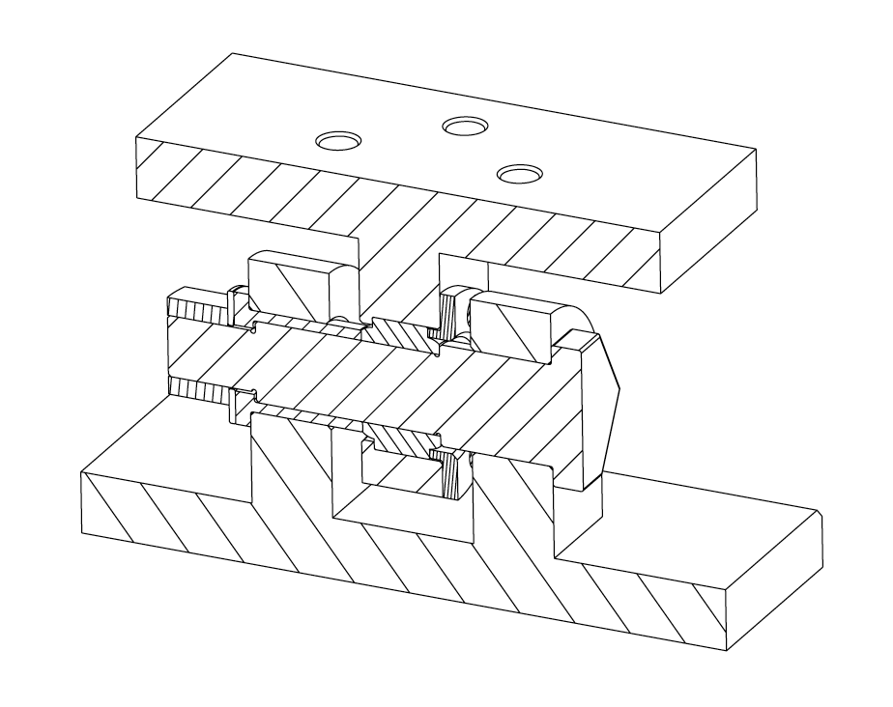

Figure 1-3 Typical interface of the Stellarator core to the base structure
Applicable Documents
The following documents form a part of this specification to the extent specified herein. In the event of a conflict, the contents of this specification shall be considered a superseding requirement.

NCSX Project Documents
Project Execution Plan (NCSX-PLAN-PEP-01)
General Requirements Document (NCSX-ASPEC-GRD-02)
Stellarator Core Systems (WBS 1) WBS Dictionary (NCSX-WBS1-02)
Structural and Cryogenic Design Criteria (NCSX-CRIT-CRYO-00)
Seismic Design Criteria (NCSX-CRIT-SEIS-00)
Reliability, Availability, and Maintainability (RAM) Plan (NCSX-PLAN-RAM-00)

Non-project Documents

AWS D1.6
ASTM A479
ASTM A484
DOE-STD-1020-02
DOE-STD-1021-93
DOE-STD-1024-92
IBC-2000
PPPL Proc.# ENG-037.

Subsystem Requirements

Subsystem Definition
The Stellarator core contains four coil systems: Modular Coils (MC), Poliodal Field Coils (PF), Toroidal Field Coils (TF), and Trim Coils (TC). The Coil Structure System (WBS 15) provides the structural support and load paths required to maintain the structural integrity and equilibrium under Gravity, Seismic, Electro-Magnetic, thermal, and pre-load loading conditions for these coil systems.
All work required to execute the Project has been identified in the Stellarator Core Systems (WBS 1) Work Breakdown Structure Dictionary. A listing of Level 4 (3-digit) WBS elements included in the Coil Structure System (WBS 15) is provided below:
- Coil Support Structure (WBS 151)

Subsystem Diagrams

Functional Relationships
A block diagram of the Coil Structure System and its environment is depicted in Figure 3-1.
Figure 3-1 Coil Structure System functional relationships

Functional Load Path Block Diagram
A Load Path block diagram is provided in Figure 3-2 below.

Figure 3-2 Functional Load Path block diagram

Interface Definition

Base Support Structure (WBS 17)
The Coil Support Structure (WBS 15) is connected to the Base Support Structure at six locations, the outer being 120 degrees apart at the C-C MCWF joints and at an elevation of 94” and at a nominal radius of 79.5”. The inner support columns are located at 120 degree intervals at the A-A MCWF joints at an elevation of 90” and a nominal radius of 36.875”. These interfaces must provide structural continuity between the floor, base structure, and coil structure for gravity and seismic loading. All EM loads will be reacted within the MC structure and TF-PF interconnections. The six interfaces at the base/coil support structure will be bolted with G11 insulating plates, washers, and bushings, to provide both electrical isolation for ground loops , and thermal insulation to minimize heat transfer from the warmer base structure to the cold coil support structure. Spherical bearings will be used to allow for for any angular misalignments between the MCWF/coil structure and base supports and will also eliminate any moment constraints being transmitted to the MCWF due to rotational flexing of the modular coils. To provide radial compliance between the core and supporting structure, a low friction PTFE surface will be used between the column pedsestal and spherical bearing lower clevises. Z-shaped channels bolted to the base support pedestals will capture the sliding lower clevises to restrict lateral (circumferential) sliding and any vertical lifting of the core (as a result of seismic over-turning motions). All gravity loads and loads from any seismic events are reacted through these interfaces to the test cell floor, and ultimately, to the basement floor.

Conventional Coils (WBS 13)
Conventional Coils (WBS 13) include the toroidal field (TF), poloidal field (PF), and external trim coils. The innermost interfaces between the TF coils and Coil Support Structure are a pair of slotted tension rings located at the inboard top and bottom of the coils and provide a radial pre-load force of 8,000 lbs via jacking screws at each of the 18 TF coil wedge castings. Additionally, there are brackets which clamp the TF Coils on all 18 of the inboard and outboard locations that attach to the MCWF. These wedge shaped bracket weldments provide for lateral (circumferential) clamping of the coils via a spring loaded mechanism which provides a nearly constant pre-load clamping force during cooldown. G10 spacer blocks with curved surfaces bonded to the TF coil O.D. and I.D. provide vertical constraints at the top and bottom of the TF Coils. These spacer blocks are vertically captured by bridge plates which span the wedge shaped bracket weldments and bolt to them, thus providing additional vertical clamping of the TF coils. The TF Coils have been designed to be self supporting (via wedging and internal stresses) for all in-plane loads. The Coils operate between 77 K and 100 K.
The interfaces with the PF Coils are machined flat pads welded to canteleverd brackets which are bolted to the inboard and outboard TF supports. There are twelve cantilevered brackets (6 top and six bottom) for the PF4 coils and 68 (34 top and 34 bottom) for the PF5 &6 coils. These brackets and pads provide the vertical connection and load path contact between the PF Coils and the MCWF support structure. The interface will include shims to properly locate the PF Coils in the vertical direction and will include radial adjustment via leveler brackets which bolt to the PF support brackets at the coil O.D. All PF Coils are designed to be self supporting in the radial direction and will operate between 77 K and 115 K.
The interfaces with the Trim Coils are bracket clamps which hang off the outer PF5 & 6 cantilevered brackets .

Modular Coils (WBS 14)
The Modular Coil shell (MCWF) has periodic machined flat surface interfaces with the PF & TF Coil Support Structure located near the inboard and outboard radius of the shell castings. These flat mounting pads are roughly square and vary in elevation so the interconnecting short columns to the Coil Support Structure will vary in height. Each mounting pad is drilled and tapped at four locations to accept the bolting hardware attaching the short columns to the shell. The Coil Structure is supported off the Modular Coil structural shell for both vertical and lateral loads. The Modular Coil structural shell (MCWF structure) provides the connection from the top to the bottom of the coil support and is also the torsional resistive element between the upper and lower TF/PF coils. As such it provides the load path for all vertical gravity and EM loads in the PF Coils, and all gravity and over-turning (lateral) loads in the TF Coils. Both the Coil Support Structure and the modular coils operate at cryogenic temperature.

Vacuum Vessel (WBS 12)
The Coil Support Structure has no direct physical interface with the vacuum vessel but must provide sufficient clearance for vacuum port ducts and penetrations. It also supplies the ultimate load path for gravity and disruption loading from the vessel transmitted through the Modular Coil Shell (MCWF) to the lower Coil Support Structure, to the base structure.

Cryostat (WBS 171)
The Coil Support Structure is located inside the cryostat. Each of the three support columns represents a penetration of the cryostat. The function of the cryostat is to maintain a cold, dry nitrogen environment for the cryo-resistive coils inside the cryostat. The Coil Structure operates at LN2 (77 K) temperature, so it must be thermally isolated from the external room temperature environment.

Field Period Assembly (WBS 18)
The Coil Structure will have interfaces with the tooling and metrology equipment required for field period assembly, including lifting points and monuments to facilitate position measurements.

Torus Vacuum Pumping System (WBS 22)
Functionally, the Torus Vacuum Pumping System (TVPS) provides the vacuum pumping required to achieve ultra-high vacuum conditions inside the vacuum vessel. This is requires that ample port access be provided for attaching the TVPS to the Vacuum vessel. The Coil Support Structure has adequate clearance for this system.

Diagnostics (WBS 3)
There are many diagnostic penetrations from the vacuum vessel adjacent to the Coil Support Structure. Sightlines and view angles are critical for port-mounted diagnostics. The Coil Structure has been designed with as much port access as possible to accommodate (as a future upgrade) the full complement of required diagnostics. Since the vessel and port extensions adjacent to the Coil Support Structure will be operating at temperatures well above room temperature, adequate clearance including thermal insulation must be provided by WBS-11.

Electrical Power Systems (WBS 4)
Electrical power systems provide the electrical grounding for the Coil Structure.

Central I&C (WBS 5)
Central I&C (WBS 5) is responsible for taking the output from the sensors provided in the local I&C in the Coil Structure System (WBS 15), processing those signals, displaying and storing the data, and providing the signals to the machine protection system. These will include (at a minimum) one thermocouples per TF support bracket for a total of 72 plus a minimum of 6 thermocouples per PF coil/support assembly, for a total of 36.

Test Cell Preparations and Machine Assembly (WBS 7)
The Coil Structure may (TBD) have interfaces with the tooling and metrology equipment required for field period assembly.

Major Component List
There are no major components for which additional development specifications are planned.

Characteristics

Performance

Perform Initial and Pre-run Verification

Initial Facility Startup
Background
Initial facility startup includes all activities required to verify safe operation of NCSX systems after their initial assembly and installation, or after a major facility reconfiguration, and before plasma operations. Initial facility startup activities would be performed prior to First Plasma and will include subsystem pre-operational test procedures (PTPs) and an Integrated System Test Program (ISTP) to verify that the system operates safely and as expected prior to plasma operation. For example, the ISTP will include verification of proper coil polarities and power supply connections. The ISTP will also include verification that, at First Plasma, the system demonstrates a level of system performance sufficient for the start of research operations, as specified in the Project Execution Plan (NCSX-PLAN-PEP-01). A subset of the ISTP will be conducted before the start of a run.

Initial Verification of Operability
The subsystem shall provide the capability to perform subsystem PTPs and support a comprehensive ISTP, to verify, prior to plasma operation that the system is properly configured, functioning correctly, and can be operated safely. [Ref. GRD Section 3.2.1.1]

Design Verification
The subsystem shall be instrumented such that key Coil Structure performance parameters (deflections, temperatures, etc.) can be measured and compared to calculated values to assure that the subsystem is performing consistent with the design intent prior to First Plasma.

Pre-Run Facility Startup
Background
Pre-run facility startup includes all activities required to verify safe operation of the NCSX subsystems after a major maintenance outage or a minor facility reconfiguration (one affecting a small number of subsystems). Pre-run facility startup activities would typically be performed prior to the start of a run period and would include a subset of the full PTP and ISTP activities referred to in Section 2.2.1.1.1
Requirement
The subsystem shall support the capability to perform a controlled startup of the facility, and verify that the subsystem is properly configured, functioning correctly, and can be operated safely. [Ref. GRD Section 3.2.1.2]

Prepare for and Support Experimental Operations

Subsystem Verification and Monitoring
Background
Pre-operational initialization and verification activities would generally cover those activities required prior to the start of an operating day following an overnight or weekend shutdown. Pre-pulse initialization and verification activities cover those activities required prior to the start of each pulse (plasma discharge). The Coil Structure System (WBS 15) should be verified and monitored to ensure that the subsystem is functioning correctly and configured properly at the start of an operating day and prior to the start of each pulse. Extreme events should signal termination of a pulse.
Requirement
The subsystem shall provide the capability to verify that the subsystem is properly configured, functioning correctly, and can be operated safely prior to the start of an operating day and prior to the start of each pulse (plasma discharge). [Ref. GRD 3.2.1.3 and GRD 3.2.1.4]

Coil Cool Down
Background
Prior to experimental operations, the cryo-resistive coils must be cooled down from room temperature to a pre-pulse operating temperature of approximately 77 K. The coils are located in a dry nitrogen environment that is provided by the cryostat, which surrounds the magnets. In order to gain access to the interior of the cryostat, the coils must be warmed up from operating temperature to room temperature. The anticipated operational plans are expected to result in up to less than 150 cool-down and warm-up cycles between room temperature and operating temperature over the lifetime of the machine.
Requirement
The Coil Structure shall be capable of maintaining a temperature differential of no more than 50ºC during and after the time the cryo-resistive coils are being cooled down from 293K to 77 K and the machine is not being pulsed. [Ref. GRD Section 3.2.1.2.1]

Field Error Requirements
Background
Field errors are a major concern in the design of the Coil Structure. The fundamental global requirement is that the toroidal flux in island regions due to fabrication errors, magnetic materials, and eddy currents shall not exceed 10% of the total toroidal flux in the plasma (including compensation). To implement this requirement, external trim coils will be provided for field error correction. The Coil Support Structure is constructed out of austenitic stainless steel (Stellalloy for cast parts or 316L for welded) because of its high strength and toughness at low temperature, high stiffness, and high electrical resistivity. Austenitic stainless steels (304L & 316L) also have a very low magnetic permeability, which minimizes the impact of magnetic materials on field errors. The Coil Structure has been designed with G11 insulating electrical breaks between field periods, thus further mitigating the impact on the plasma from field errors related to eddy currents.

Disruption Handling
The Coil Structure shall be designed to withstand electromagnetic forces due to major disruptions characterized by instantaneous disappearance of the plasma at a nominal 1.4 Meter radius, with a maximum plasma current of 320 kA. [Ref. GRD Section 3.2.1.5.5]
Note: Instantaneous decay is assumed for simplicity and is conservative for EM load calculations. Induced voltage effects due to disruptions are ignored because of the relatively low plasma current and discontinuous Coil Structure in NCSX.

Pulse Repetition Rate
The Coil Structure shall be designed for pulses to be initiated at intervals not exceeding 15 minutes when constrained by cool-down and 5 minutes otherwise. [Ref. GRD Section 3.2.1.5.10]

Discharge Termination

Normal Termination
Background
Normal termination includes all system actions necessary to shutdown the plasma and associated subsystems at the conclusion of a pulse in preparation for the next pulse.
Requirement
The Coil Structure shall accommodate a controlled shutdown of the plasma and associated subsystems at the conclusion of a pulse.

Abnormal Termination
Background
Abnormal termination consists of all system responses necessary to remove conditions that occur during experimental operations that could cause significant damage to the NCSX system or cause injury to personnel.
Requirement
The Coil Structure shall accommodate the loading caused by a rapid shut down of the plasma and associated subsystems (including the TF & PF Coils) if a condition occurs during experimental operation that could cause significant equipment damage or cause injury to personnel.

Facility Shutdown
Background
Facility shutdown involves the shutdown of NCSX equipment following the termination of a discharge (per Section 2.2.1.2.6) in preparation for a brief (overnight or weekend) or extended (between run periods) shutdown.
Requirement
The NCSX system shall provide the capability to perform a controlled shutdown of the facility.

Coil Warm-up Timeline
The Coil Structure shall be capable of maintaining a temperature differential of 50 K while the cryo-resistive coils (TF, PF, and modular coils) are being warmed up from operating temperature (77 K) to room temperature (293K) within a period of 96 hours.

Physical Characteristics

Configuration Requirements and Essential Features

Coil Support Structure (WBS 151)
Background
The Coil Structure provides a load path for reacting or transmitting all gravity, seismic, and unbalanced electro-mechanical loads from the TF, PF, and Trim coils. This must be accomplished while providing sufficient radial compliance at the coil interfaces to avoid introducing significant bending stresses in the coils. Vertical support columns of several lengths are required to tie the Coil Structure to the modular coil shell pads. These supports must accommodate gravity loads, net electromagnetic loads, and seismic loads. In addition, lateral & vertical support connections from the coil support structure to the base structure are required for reacting seismic loads and any vacuum vessel disruption loads transmitted through the Modular Coil shell (MCWF). During operation the structural components will be operating at or near liquid nitrogen temperatures (77 K), therefore the connection to the base support must be thermally (and electrically) insulated.

Requirements
- The upper and lower Coil Support Structure assemblies (weldments) shall be supported by vertical columns attached from the Coil Support Structure inboard & outboard coil clamp brackets to the modular coil shell (MCWF) mounting pads. Upper vertical supports shall be designed to accommodate gravity loads, net downward PF & TF Coil loads, and seismic loads. Lower vertical supports shall be designed to accommodate, gravity, upward PF & TF Coil loads, and seismic loads. The PF Coil will be self-supporting in the radial direction (via the internal hoop tension in the coils). The TF Coils will be self supporting with respect to in-plane loads (via nose wedging and internal tension and bending). The coil supports shall be required to react the various in-plane and out of plane EM loading conditions as defined in the GRD and specifically the reference operational scenarios as described in the GRD Paras. 3.2.1.5.3.3.1.1 to 3.2.1.5.3.3.1.7 inclusive. The safe operational limits to the flexibility requirements (GRD Para.3.15.3.4) that fall outside the range of coil parameters defined in the above reference scenarios shall be established on an ad-hoc basis.
[Ref. GRD Section 3.2.1.5.3.3.1]

- Vertical support assemblies shall be provided between the Coil Structure and base structure to react gravity and seismic loads and accommodate the radial contraction due to the transition from 77 K to room temperature. This will require an interface with both radial and rotational compliance.
- Coil Structure supports shall be designed to minimize the flow of heat to the Coil Structure cold mass from the base structure.
- The Coil Structure supports shall electrically isolate the Coil Structure and modular coils.
- The Coil Structure supports shall be designed and shimmed such that the midplanes and major axes of the TF & PF coils and Modular Coil Structure are aligned at 40ºC and at 77 ºK.
- The Coil Structure supports shall be adjustable with shims and permit minimal radial constraints to thermal expansion and contraction of the TF & PF Coils over the full range of operating temperature conditions.

Coil Structure Local I&C (WBS 125)
Background
This WBS element provides the local I&C required by other WBS elements included under Coil Support Structure Systems (WBS 15).
Requirements
- Sensors shall be provided to monitor the temperature of the Coil Structure during coil cool-down at designated points per dwg# TBD.
- Sensors (strain gages) shall be provided to monitor the strains at critical locations (TBD) in the Coil Structure.

System Quality Factors

Reliability, Availability, and Maintainability
Background
The overall objective is to provide a device with high operational availability, meaning that the number of plasma discharges achieved in a run period is a large percentage (greater than 75%) of the number planned after the initial shakedown and commissioning phases of the facility. Bottoms-up reliability predictions are difficult to perform and have large uncertainties for first-of-a-kind experimental devices such as NCSX. Therefore, quantitative RAM requirements on NCSX will be few. Rather, NCSX will rather rely on sound engineering practice to assure high availability in NCSX, which has been the tried-and-true approach on similar scale fusion devices. Sound engineering practices include:
- Applying design principles that promote reliability (e.g., employing an adequate factor of safety on mechanical and electrical stresses, avoiding unnecessary complexity, using proven design approaches and well characterized materials, etc.)
- Optimizing designs for reliability and maintainability through systematic evaluation of design options,
- Performing failure modes, effects and criticality analysis (FMECAs) for RAM design improvement and verification, and
- Employing peer reviews as a mechanism to enhance the design process.
The NCSX RAM Plan defines the processes that will be used by the Project to achieve a device with high availability.
Requirements
- The Coil Structure shall incorporate reliability and maintainability features in the design that are consistent with achieving a high (greater than 95%) operational availability.
- Provisions for recovery shall be made for every credible failure mode.
- The Coil Structure shall be capable of being disassembled and reassembled to permit replacement of any part or machine reconfiguration that would require disassembly.
- Provisions for lifting, e.g. lifting eyes, other sling attachment provisions, or equivalent provisions, shall be made in the design of the Coil Structure.
[Ref. GRD Section 3.2.4.1]

Design Life
- The Coil Structure shall have a design life of >10 years.
- The Coil Structure shall be designed for the following maximum number of pulses based on the factors for fatigue life specified in the NCSX Structural and Cryogenic Design Criteria Document:
- 100 per day;
- 13,000 per year; and
- 130,000 lifetime.
[Ref. GRD Section 3.2.4.2]

Seismic Criteria
Background
NCSX systems shall be designed in accordance with seismic design and evaluation criteria for Performance Category 1 (PC1) facilities, per DOE-STD-1020-2002, “Natural Phenomena Hazards Design and Evaluation Criteria for Department of Energy Facilities.” The NCSX Seismic Design Criteria provides an NCSX-specific interpretation of those requirements
Requirement
The Coil Structure shall be designed in accordance with the NCSX Seismic Design Criteria (NCSX-CRIT-SEIS-00). [Ref. GRD Section 3.3.1.5]

Transportability
All Coil Structure assemblies and components shall be transportable by commercial carrier via highway, air, sea, or railway. [Ref. GRD Section 3.2.5]

Design and Construction

Materials, Processes, and Parts

Magnetic Permeability
All materials (including weld materials) used in the Coil Structure must have a relative magnetic permeability less than 1.02 unless otherwise authorized by the Project. [Ref. GRD Section 3.3.1.1]

Coil Structure Material
The Coil Structure and assembly hardware will be manufactured from 304L, 316L, or other non-magnetic materials

Structural and Cryogenic Criteria
The Coil Structure shall be designed in accordance with the NCSX Structural and Cryogenic Design Criteria. [Ref. GRD Section 3.3.1.3]

Corrosion Prevention and Control
Materials, processes, and protective surface treatments or finishes shall be provided to ensure that equipment capability during its service life is not degraded due to corrosion. Where possible, contact between dissimilar metals shall be avoided. [Ref. GRD Section 3.3.1.4]

Metrology
The Coil Structure shall provide features (e.g., fiducial markers) to facilitate accurately measuring and locating components relative to the magnetic field for the life of the machine. [Ref. GRD Section 3.3.1.6]

3.3.1.6 In-process Fabrication inspection

A visual weld inspection and acceptance criteria for all welds shall be shall be conducted per AWS D1.6 and PPPL Proc.# ENG-037.

Electrical Grounding
- The Coil Structure shall be connected to a single-point electrical grounding system, provided in accordance with the NCSX Grounding Specification for Personnel and Equipment Safety.
- Voltage isolation shall be provided between the Coil Structure and systems attached to the Coil Structure, in accordance with the NCSX Grounding Specification for Personnel and Equipment Safety.
- RF Shielding shall be provided in accordance with the NCSX Grounding Specification for Personnel and Equipment Safety.
[Ref. GRD Section 3.3.5.7]

Nameplates and Product Marking

Labels
Equipment and any parts of that equipment to be used by personnel shall be identified with appropriate labels. Labels shall indicate clearly and concisely the function and purpose of the item being labeled. Hierarchical labeling shall be used to facilitate component location on control panels. The terminology used for equipment, procedures, and training materials shall be the same for each case. Label design shall be consistent to promote simplicity and avoid clutter. The use of abbreviations and acronyms shall be minimized. Permanent labels shall be attached to the specific component or equipment in such a manner that environmental conditions or usage by personnel will not remove or destroy the label. Temporary labels shall be used only when necessary and shall not obscure other information or equipment. If a temporary label is to designate a device that is out of service, the label shall be applied so that it prevents the use of that device. Labeling shall be legible and conform to human visual capabilities and limitations in regard to physical characteristics. [Ref. GRD Section 3.3.2.1]

Workmanship
During Coil Support fabrication and finishing, particular attention shall be given to freedom from blemishes, defects, burrs, and sharp edges; accuracy of dimensioning radii of weld fillets; making of parts; thoroughness of cleaning; quality of brazing, welding, riveting, painting, and wiring; alignment of parts; and tightness and torquing of fasteners. [Ref. GRD Section 3.3.3]

Interchangeability
Design tolerances shall permit parts and assemblies of the same part number to be used as replacement parts without degrading the specified performance of the parent item. [Ref. GRD Section 3.3.4]

Environmental, Safety, and Health (ES&H) Requirements

General Safety
- When utilized within its intended use and within specified environments, the safe operation, test, handling, maintenance and storage of the subsystem hardware and software shall be provided.
- The subsystem shall not present any uncontrolled safety or health hazard to user personnel.
- The subsystem shall detect abnormal operating conditions and safeguard the NCSX system and personnel.
[Ref. GRD Section 3.3.5.1]

Personnel Safety
The subsystem shall meet all applicable OSHA requirements in accordance with 29CFR1910. The system shall limit personnel exposure to hazardous materials to below their OSHA permissible exposure limit (PEL). [Ref. GRD Section 3.3.5.3]

Flammability
The use of flammable materials shall be minimized. [Ref. GRD Section 3.3.5.4]

Documentation

Specifications
A specification shall be developed for the configuration item shown in Table 3-1.

Table 3-1 Coil Structure specifications
Configuration Item | Specification Identifier | Specification Type
Coil Support Structure | NCSX-CSPEC-151-01-XX | Product specification – forms the basis of the coil structure procurement

Logistics

Maintenance
The Coil Structure shall be maintained using, to the extent possible, standard/common tools and existing multi-purpose test equipment. Use of new/special tools and the number of standard/common tools shall be minimized through maximum commonality of fasteners, clamps, adapters, and connectors.

Quality Assurance Provisions

General
This section identifies the methods to be used for verification of requirements in Section 2.2 of this specification. General definitions of basic verification methods are outlined in Section 3.2. Verification of subsystem requirements will require additional testing in operational or near-operational environments.

Verification Methods
Verification of qualification shall be by analysis, demonstration, inspection, or test. Definition of analysis, demonstration, inspection, and test is as follows:
Analysis: Verification of conformance with required characteristics by calculation or simulation, including computer modeling based on established material or component characteristics.
Inspection: Verification of conformance by measuring, examining, testing, and gauging one or more characteristics of a product or service and comparing the results with specified requirements.
Test: Verification by physically exercising a component or system under appropriate loads or simulated operating conditions, including measurement and analysis of performance data.

Quality Conformance
Background
This section establishes the specific evaluation criteria for verification of the subsystem characteristics in Section 2.2. In general, all requirements shall be verified under operational or near-operational conditions as possible given test constraints.
Requirements
Test methods for each of the performance characteristics in Section 2.2 are identified in the Quality Conformance Matrix in Appendix A.

Appendix A – Quality Conformance Matrix
Section | Characteristic | Analysis | Inspection | Test | Comments
3.2 | Characteristics
3.2.1 | Performance
3.2.1.1 | Perform Initial and Pre-run Verification
3.2.1.1.1 | Initial Facility Startup
3.2.1.1.1.1 | Initial Verification of Operability |  |  | X
3.2.1.1.1.2 | Design Verification |  |  | X
3.2.1.1.2 | Pre-Run Facility Startup |  |  | X
3.2.1.2 | Prepare for and Support Experimental Operations
3.2.1.2.1 | Subsystem Verification and Monitoring |  |  | X
3.2.1.2.2 | Coil Cooldown |  |  | X
3.2.1.2.3 | Field Error Requirements
3.2.1.2.4 | Disruption Handling | X
3.2.1.2.5 | Pulse Repetition Rate |  |  | X
3.2.1.2.6 | Discharge Termination
3.2.1.2.6.1 | Normal Termination |  |  | X
3.2.1.2.6.2 | Abnormal Termination
3.2.1.3 | Facility Shutdown |  |  | X
3.2.1.3.1 | Coil Warm-up Timeline |  |  | X
3.2.2 | Physical Characteristics
3.2.2.1 | Configuration Requirements and Essential Features
3.2.2.1.1 | Coil Support Structure (WBS 151) |  |  | X
3.2.2.1.2 | Coil Structure Local I&C (WBS 125) |  |  | X
3.2.3 | System Quality Factors
3.2.3.1 | Reliability, Availability, and Maintainability |  |  | X
3.2.3.2 | Design Life |  |  | X
3.2.3.3 | Seismic Criteria | X
3.2.4 | Transportability |  |  | X

