GROUNDING
FOR
PERSONNEL & EQUIPMENT SAFETY

NCSX-CSPEC-XX-00

October 16 2007

PREPARED BY:
S. Ramakrishnan

PPPL Electrical RLM:
A. vonHaller

ES&H:
J. Levine

QUALITY ASSURANCE:
F. Malinowski

NCSX ENGINEERING:
P. Heitzenroeder

Table of Contents

1.0 Scope 1
2.0 Applicable Documents 1
3.0 Definitions 1
4.0 Hazards 3
5.0 NCSX Facility Ground Description 3
5.1 NCSX General Grounding Overview 3
5.2 Perimeter Ground Loop 4
5.2.1 Pre-existing conditions 5
5.3 Lightning Protection 5
6.0 Single Point Ground Tree 7
6.1 “Pit” Ground 7
6.2 Single Point Ground Termination Methods 7
6.3 Diagnostic Single-Point Tree 7
6.4 Grounding the Fusion Device and Fusion Device Support Structures 8
6.4.1 PF and TF/MC Coil Grounding Plane 9
6.5 Isolation Standoff Voltages 11
6.6 Vacuum Vessel/Water System Interface Grounding 12
7.0 Personnel Electrical Interlocked Area Boundary 14
7.1 Review of D-SITE Experience 14
7.2 NCSX Electrical Interlocked Area Boundary 14
7.3 Electrical Interlocked Area Boundary Isolation 14
7.4 Access Corridor and Hot Access Zone 15
8.0 Power Distribution and Power Ground 15
8.1 20 KV DC Isolation 15
8.2 Power Circuits 15
8.3 AC Power Ground Decoupling 15
8.4 Diagnostics-Power Distribution 16
8.5 Diagnostic Rack Power Distribution 16
8.6 Pulsed Energy Power Systems 18
8.7 Standard AC Power for Noisy or High Power Equipment 18
9.0 Diagnostic Equipment Grounding 18
9.1 General Guidelines 18
9.2 CAMAC, VME/VXI and PLC Instrumentation Grounding 19
9.2.1 Small Signal Shield Grounding 19
9.2.2 Diagnostic Cable Raceway 20
9.3 Recommended Diagnostics Location 22
9.4 Isolation of “Noisy” Portions of Diagnostics 22
9.5 60 Hz AC Power Within the Test Cell 22
9.6 Single Point Ground Labeling 22
9.7 Separation Between Signal and 60 Hz AC Power Cabling 22
10.0 Ground Fault Monitoring 23
10.1 Monitored Conductors 23
10.2 Ground Monitoring Method 23
11.0 60 Hz Power Equipment 25
11.1 Cable Trays 25
11.2 Equipment Grounding 25
11.2.1 All Electrical Power Equipment 100 KVA and Above 25
11.2.2 Other Equipment Rated above 600 Volts. 25
11.2.3 Equipment Rated 600 Volts or less 26
11.3 Equipment Ground Cable Sizes 26
11.4 Equipment Instrumentation and Control 26
11.5 Power Cable Shields 26
11.6 Non-electrical Equipment 26
11.6.1 General 26
11.6.2 Fences 27
11.6.3 Metal Enclosures 27
11.7 Grounding Drawings 27
12.0 Electromagnetic Interference (EMI) Considerations for Fields 27
12.1 Conductors Exiting the Fusion Device 27
12.2 Fusion Device Ports Open to RF Heating Fields 27
12.3 Diagnostics Equipment RF Tight Enclosures, Racks, and Cabling 27
13.0 Zone Configuration for Services 28
14.0 Loop Exclusion Zone 29
14.1 Purpose 29
14.2 Structural Loop Exclusion Zone 29
14.3 Loop Break Zone 29
15.0 Testing and Independent Verification 30
16.0 References 31

Figures:
Figure 5.2-1 NCSX Facility Ground 4
Figure 5.2-2 NCSX Grounding Concept 6
Figure 6.4-1 Typical Fusion Device Single Point Grounding 10
Figure 6.6-1 Vacuum Vessel/Water System Grounding 13
Figure 8.3-1 Grounding and AC Power Distribution for one Diagnostic 17
Figure 9.2-1 Typical Grounding of Cable Shields 21
Figure 9.6-1 Single Point Ground Warning Label . 22
Figure 10.2-1 Ground Fault Monitoring Concept 24
Figure 13-1 Zone Configuration for Services 28
Figure 14-1 Loop Break Zone 30

Table I Isolation Standoff Voltages 11

1.0 Scope

This specification presents an overall grounding conceptual design encompassing all NCSX systems and addressing specific considerations of performance and safety.

The grounding philosophy is based on IEEE Standard 80 & 142 together with single point grounding concepts and design criteria as invoked by this specification and the following applicable documents.

2.0 Applicable Documents

The applicable documents specified below shall be followed in the design of NCSX grounding.

National Electrical Code (NEC), 2006 edition for new design. Contractual discrepancies shall be resolved with the NCSX project office and revised accordingly.
PPPL ESHD 5008, Section 2, Electrical Safety.
PPPL Electrical Engineering Standard ES-ELEC-001.
ANSI/IEEE 80 AC Substation Grounding.
ANSI/IEEE 142 Grounding of Industrial and Commercial Power Systems.
IEEE Std. 1100 Powering and Grounding Sensitive Electronic Equipment.
PPPL ESHD 5008, Section 5, Fire Protection.

3.0 Definitions

Terms used throughout this document are defined below. Terms used only within one section are defined therein.

AC Power: Any 60 Hz (fixed frequency AC) primary power source having grounding conductors conforming to NEC article 250.

Ceramic Break: A part or piece fabricated from ceramic material and designed for use as an electrical insulator.

Copper Cloud: Form of Electric Arc. In particular in high power, high energy buss work where a fault such as a loose connection may cause a break, a high concentration of energy may result in molten or vaporized copper splattering and being dispersed onto adjacent equipment.

Co-mingling: There are two conditions; 1) Mixing of isolated cables with non-isolated cables, for instance a cable leaving an interlocked area in a raceway and becoming mixed with cables outside the interlocked area resulting in the possibility of inducing hazardous potentials on adjacent cables in the raceway. 2) Mixing of high power system's cable with low power or diagnostics system's cable.

Diagnostic-Power: Separately derived, 60Hz, 120V up to 480V power supplied to diagnostic subsystems that are single point grounded, and are electrically isolated from AC Power sources (refer to figure 8.3-1).

Equipment Ground Bus - A copper bus bar provided inside of electrical equipment. Sized to accommodate ground fault currents, the copper bar shall run lengthwise through the equipment at a convenient location.

Facility Ground Grid - This system connects non-current carrying metal parts to the main ground grid. It is comprised of the structural steel in the plant buildings, the facility grid beneath the plant and all the grounds connected to the power equipment enclosures, switchgear, enclosures, racks and panels.

Grounding Conductor, Equipment (EGC): The identified equipment grounding conductor used to return ground fault current to its source (see ES-ELEC-001, Section 2). The EGC is a dedicated low impedance metallic path for ground fault currents from non-current carrying structures, equipment, and enclosures to designated terminals of the grounding system. Refer to the NEC, article 100, for more specific definition.

Grounding Electrode Conductor: The conductor that runs from the bonded neutral block or busbar in service equipment to the system grounding electrode. It is also the conductor used to ground the bonded neutral of a transformer secondary or a generator. Refer to the NEC, article 100, for more specific definition.

Loop Exclusion Zones: A zone surrounding NCSX within which coupling to the stray magnetic fields by closed loops of conducting structural materials (steel, pipe, cables, etc.) is not allowed.

“Pit” Ground: The point of connection between the building ground grid and the single point grounding system to which Fusion Device, diagnostic, and other single point grounding systems conductors are connected either directly or in a manner of a grounding tree.

Raceway: Per the National Electrical Code (NEC), Article 100, the definition of raceway includes all the enclosures used for running conductors between cabinets and housings of electrical distribution systems. Any raceway must be an enclosed channel for conductors. Cable Tray is a "support system" and not a raceway. When the code refers to "conduit" it means only those raceways containing the word "conduit" in their title.

Single Point Grounding Conductor: A conductor used to connect a system to the terminus called "pit " ground at the single point ground cage (section 6 this document).

4.0 Hazards

The hazards presented by NCSX and mitigated by the grounding systems include:
• Short circuits and ground faults originating in power systems,
• Arcs from the magnet coolant lines to the grounded inlet and outlet
headers,
• Plasma disruption currents inducing stray currents,
• Induced currents from changing magnetic fields,
• Lightning and switching surges,

• "Copper cloud" effect resulting from open circuit arc in large inductors.

5.0 NCSX Facility Ground Description

5.1 NCSX General Grounding Overview

The NCSX shall be integrated into the existing PPPL complex at “C & D” - sites. Note that NCSX will use C-Site power supplies only during the first phase. For upgrades the D-Site supplies will be used.

Each of the NCSX supporting structures, diagnostics, and other instrumentation within the Test Cell, Test Cell Basement, and Data Acquisition Rooms shall be grounded with a single point ground tree that has a central connection point of Building Steel. This tree is connected to earth at the perimeter ground but is otherwise isolated from any other ground.

All single point ground tree connections shall be automatically monitored if so required. The monitor shall alarm and indicate loop faults and connection integrity (refer to Sec. 10.0).

The grounding of several systems will remain substantially unchanged, for instance:

• The Power Conversion Equipment buildings and equipment grounding will remain substantially unchanged. This is also the case for 138 KV, 15KV, 5 KV, 0.48KV, and 0.208 KV AC power distribution systems.

• Future RF heating equipment shall be grounded following existing D-Site practice (refer to Sec. 11.0). The RF transmission lines shall be safety grounded to building steel at frequent intervals, interrupting ground continuity, with a ceramic break insulator located adjacent to NCSX.

• Neutral Beam equipment will follow existing D-Site practice, single point grounding, and electrical insulating breaks used successfully on D-SITE.

• The Motor Generator sets equipment grounding will remain substantially unchanged.

In addition, a personnel interlocked area boundary shall be established (refer to Sec. 7.0). All electrical conductors, except RF transmission lines and coil power busses exiting this area, shall be DC isolated for at least 5KV continuous, 5KV for 1 min. DC test 12, 13 (see section 8.1 note for NCSX application). This isolation limits the consequences of any electrical faults in the area from producing hazardous conditions outside of the area.

5.2 Perimeter Ground Loop

The NCSX shall utilize the existing C-Site & “D” site facility grounding system as applicable (figures 5.2-1, and 5.2-2 show D-Site , Figure for C-Site later ). A buried #500 kcmil bare copper cable ground loop is routed 5 feet beyond the perimeter of the D-SITE building exterior to form the grounding electrode system (GES). Connections to earth are enhanced by buried 10 foot long grounding electrodes placed every 30 to 60 feet and connected to the perimeter cable. The following systems are connected to the perimeter ground loop:

1) AC power distribution systems,
2) DC pulsed energy systems,
3) equipment grounding systems,
4) lightning protection systems,
5) building grounding electrode of concrete reinforcing bars,
6) the building structural steel.

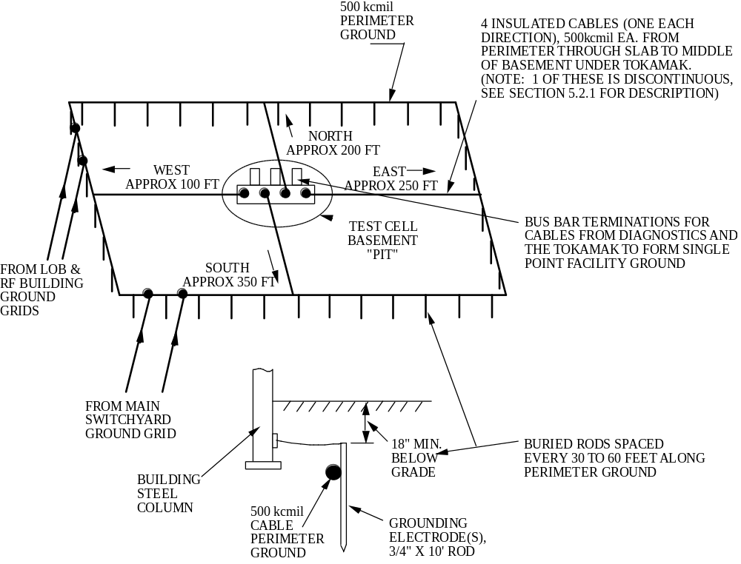
Figure 5.2-1 D-Site Test Cell Facility Ground

The perimeter ground cable is attached to the main switchyard ground grid and the LOB/RF Building ground grid via cables to prevent a potential difference with the C-site Switchyard.

NCSX shall evaluate the need for retesting the perimeter ground loop system to determine deterioration and present impedance.

5.2.1 Pre-existing Conditions
The following pre-existing conditions currently compromise the grounding concept described above. The NCSX grounding design will review these conditions and modify the existing grounding as required. Though the D-Site Test Cell grounding scheme does not affect the NCSX it is included as a general description for the PPPL site since the basic grounding concept is same for all experimental devices.

• The base columns of the D-SITE were connected (during installation) to the Test Cell floor steel and do not possess a single point ground as designed. The four T-bolts holding the columns at the basement floor were supposed to be insulated from the columns but the leveling nuts short the columns to the T-bolts. The T-bolts are tied to the reinforcement bars and floor steel in the basement floor concrete.

• The west pit to perimeter cable has an open circuited condition10.

5.3 Lightning Protection

The existing lightning protection system returns currents from lightning strikes to earth by conductors which connect the roof lightning shield directly to the perimeter ground loop. The junctions of those conductors and the perimeter ground loop are located at grounding electrodes spaced approximately 60 feet apart at alternate building columns.

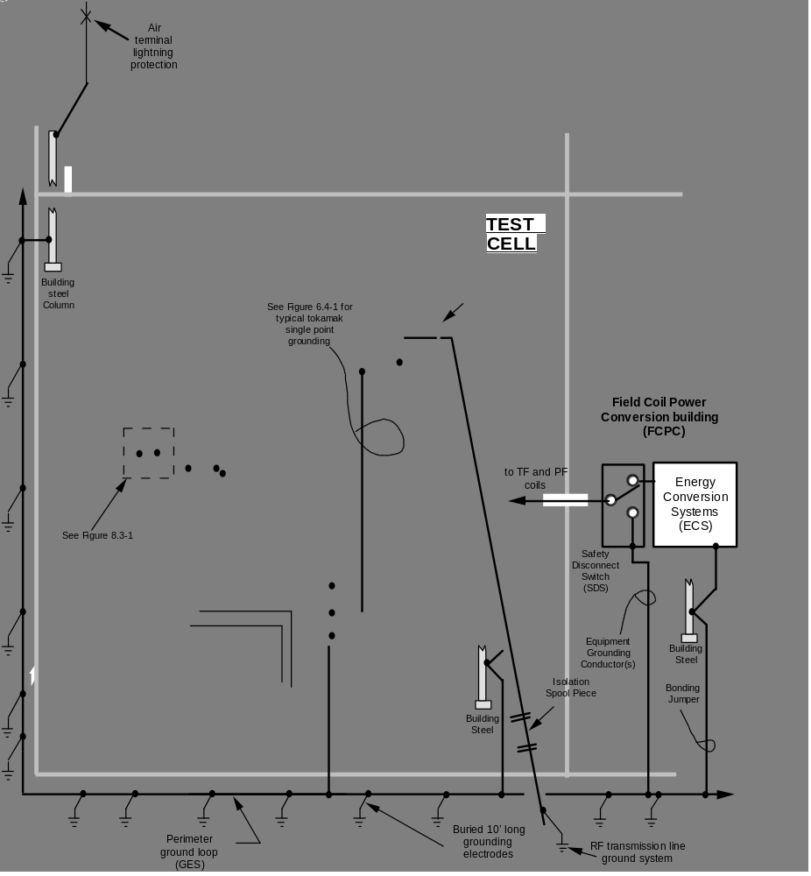

Figure 5.2-2 NCSX Grounding Concept

6.0 Single Point Ground Tree

6.1 “Pit” Ground
This is applicable to D-Site Test Cell only. For C-Site the description will be given in a later revision.
Four #500 kcmil insulated cables are connected from the perimeter ground loop (grounding electrode) at the cardinal points of the compass to a terminus called the single point “pit” ground. The D-SITE “pit” is located in the middle of the basement under the Fusion Device. The four cables achieve the shortest length practical; one each to the North, South, East, and West perimeters. Currently pre-conditions exist on D-SITE as defined in section 5.2.1 where one cable is open and has a high impedance to ground (Refer to Figure 5.2.1).

This terminus called “pit” ground, serves as the termination point for the single point ground of the Fusion Device, its support structure, diagnostic ground, and such other grounds which require the use of this terminus. The “pit” ground shall be a secure closed area to protect the integrity of the grounding system and personnel safety (Refer to Figure 5.2.1 and 5.2.2).

The “pit” ground shall be the trunk of the single point ground tree from which each of the branches of the tree originates. The tree shall comprise several individually monitored, conveniently situated branch end locations distributed around the NCSX building to form local tree terminus locations for equipment in that area.

One branch terminus location shall be dedicated to grounding the vacuum vessel and all structural components of the Fusion Device (refer to Section 6.4 for additional detail).

6.2 Single Point Ground Termination Methods

The four insulated cables connecting the “pit” ground bus to the perimeter ground loop shall be connected to a ground plate at the pit by welding. The attachment method for branch grounding conductors shall use Burndy or T & B (or equivalent) compression type bolt-on lug systems. The lugs and all ground related conductors shall be a copper alloy (aluminum not permitted).

Testing of terminations shall be in accordance with the requirements for testing (or verification) as described in Section 15 of this document.

6.3 Diagnostic Single-Point Tree

The diagnostic single-point ground shall be distributed to diagnostics via branches from the pit ground. This arrangement shall preclude any loop (more than one path) from any branch in the tree to the “pit” ground termination of the diagnostic single-point ground or from branch to branch.

All branch connections from the ground “tree” shall use either welded or compression type #2 AWG lugs connected to equipment and tagged with warning "do not remove without approved procedure" tags.

The ground “tree” shall emanate from insulated #500 kcmil cables. The only path from the ground tree to facility grounding electrode system (GES) shall be through the “pit” ground terminus. Conductors shall be insulated to prevent accidental contact with other single point or NEC grounds.

The grounding conductor branch connections of diagnostic equipment (racks or enclosures) and the grounding electrode conductors that connect the secondary common point of the ground-decoupling transformers to the ground tree #500 kcmil cables, shall be sized for the maximum fault current available, and be at least the equivalent of #2 AWG (refer to figure 8.3-1).

6.4 Grounding the Fusion Device and Fusion Device Support Structures

Electrically isolated sections of the Fusion Device and its support structures shall be grounded with a single point ground. The capability to isolate each section from ground and demonstrate a standoff voltage of at least 1KVDC, and TBD maximum leakage current shall be provided as a general rule. However, for specific standoff voltage values refer to Section 6.5, Table I. Each section shall be grounded through an insulated #500 kcmil cable connected to the “pit” ground Refer to section 10.2 for monitoring of ground currents.

The vacuum vessel, TF/MC coil quad segments, support structure quad segments, PF ring coils, PF coils and solenoid assembly, and cryostat shall each have an accessible single point ground. Appropriate grounding straps and jumpers shall be provided in grounding designs for support structures, PF and TF/MC coil structures, and the solenoid assembly structures to ensure ground integrity without causing ground loops. Figure 6.4-1 represents a typical pictorial presentation of the Fusion Device single point grounding concept. Hardware details such as Fusion Device local ground straps, bus bars and jumpers are omitted for clarity.

Grounding designs shall provide accessibility for inspection, test, and maintenance, and provide bracing and strain relief to prevent cable breaks. Exothermic connections shall be used where accessibility cannot be maintained. Ground pads shall be provided where Exothermic connections are made.

Ground isolation designs shall take into consideration transient suppression to provide high resistance shunt fault paths to minimize electrical stress on insulation breaks similar to methods utilized by D-SITE.

"Copper Cloud" effects and "co-mingling" shall be included in NCSX grounding designs. This shall include not mixing isolated cables with non-isolated cables, and routing of cables in conduit and covered raceways for protection from electrical arcs. High power system's cable shall not be mixed with low power or diagnostics systems.

6.4.1 PF and TF/MC Coil Grounding
The PF coils shall be insulated from the TF/MC quadrant coil structure brackets. The PF and TF/MC quadrants shall be single point grounded as indicated by figure 6.4-1.

A ground shall be established/painted on the insulated ground wall of the coils for the following design purposes:

• To establish a reference ground for instrumentation and protection as required.
• To ensure a uniform voltage gradient around the coil and the insulation. Any anomaly in this ground plane could cause high voltage gradients at that location and could result in excessive coronas and incipient insulation damage.
• Coil insulation and grounding allows a complete set of acceptance tests for copper to ground integrity. See Section 15 for testing and verification.

Figure 6.4-1 Typical Fusion Device Single Point Grounding

6.5 Isolation Standoff Voltages
Loop voltages created by changing magnetic fields from a plasma disruption or coil break down(s) could result if ground loops are not properly isolated and prevented. A list of isolation standoff voltages are presented in Table I (below) between several (but not limited to these) interface locations. As noted in the table the Neutral Beam and ICH system designs plan to re-use the standoff voltage isolation provided on D-SITE for NCSX, while the LHH system design plans to use the same isolation as provided on PBXM. The Diagnostic's standoff voltage indicated is based on D-SITE and shall be evaluated for each diagnostic application according to the general rule specified in section 6.4.

TABLE I
Isolation Standoff Voltages

 |  | Isolation
 |  | Dielectric
 |  | Break (KVDC),
From | To | @ TBD leakage current max.
Vacuum Vessel port penetrations | Cryostat | >1 KV
Vacuum Vessel pump duct penetrations | Cryostat | >1 KV
Magnet current lines, instrumentation leads and coolant line & Coolant line penetrations | Cryostat | 1 KV + 2 x Max. Applied Voltage
Water cooling line & associated penetrations | Cryostat | >1 KV
Vacuum Vessel | Cryostat | >1 KV
Vacuum Vessel | Neutral Beams | >9 KV
Vacuum Vessel | Diagnostics | >1 KV
Vacuum Vessel | Fueling & Vacuum Systems | >1 KV
Cryostat | Building Structural Steel/reinforced concrete | >1 KV
Fusion Device Support Structure | TF/MC Assembly & Cryostat | >1 KV

6.6 Vacuum Vessel/Water System Interface Grounding

The Vacuum Vessel shall be single point grounded to pit ground and isolation breaks shall be provided to interfaces as indicated by Table I in Section 6.5. Due to the use of borated water (whose resistivity is estimated to be 0.25 to 0.33 ohm-meter) the vacuum vessel in effect is extended out of the test cell and into the water system.

NCSX shall resolve open issues which presently exist relative to the Water System grounding design. The design shall take into consideration protecting personnel and equipment from hazards caused by current which will flow during disruptions.

The grounding system design for the water system shall include isolation breaks for metallic piping, and termination to facility ground, see figure 6.6.1. For instance an approach might be, run a large copper conductor in parallel with the inlet and outlet tubing (ideally in/out plumbing shall be tightly coupled), grounded every several feet to the piping. In addition the water system grounding design shall consider containing the borated water system piping in insulated trays. A "conceptual sketch" is depicted in figure 6.6-1.

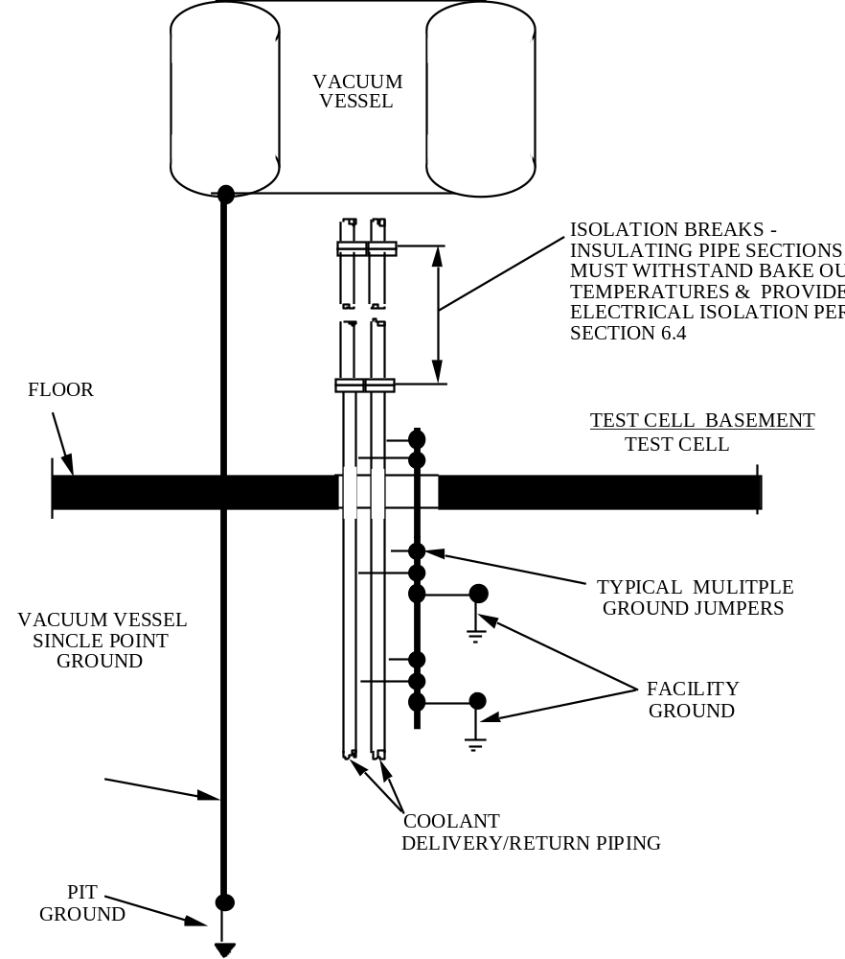

Figure 6.6-1 Conceptual Sketch - Vacuum Vessel/Water System Grounding

7.0 Personnel Electrical Interlocked Area Boundary

7.1 Review of D-SITE Experience
There is a large amount of energy concentrated in and around a Fusion Device experimental area. Therefore, for the safety of personnel, a barrier is set up as an interlocked boundary during Fusion Device operations. On D-SITE this boundary has been defined as the test cell, test cell basement, and OTHER walls. Inside this boundary is an interlocked area as defined by the PPPL ESHD 5008, Section 2. Any breach of this boundary shall immediately shut down the Fusion Device and render the interlocked area safe for personnel. A special access mode of operations is available, called “hot access,” which allows personnel to be safely positioned within the interlocked area while either the poloidal field or the toroidal field is pulsed, but not both simultaneously because of radiation concerns. It was decided that this can be accomplished on D-SITE because of the large amount of open area in the test cell and the ability to shield personnel from the potential hazards associated with Fusion Device operations; electrical and/or mechanical failure resulting in stray high voltage, arc blast and burns, or flying debris.

7.2 NCSX Electrical Interlocked Area Boundary

An interlocked boundary shall be established to exclude personnel from areas containing potential hazardous conditions or is cabled to areas containing hazardous sources. This area includes the test cell, test cell basement, and OTHER and all diagnostics or other systems that are not isolated from the test cell and the single point ground tree. As specified in the PPPL ESHD 5008, Section 2, Electrical Safety standard, whenever equipment which is capable of operating above 600V and having 50 joules or more of stored energy, the area shall be restricted for personnel access and shall require safety interlocks and personnel exclusion.

7.3 Electrical Interlocked Area Boundary Isolation

All signal, 60 Hz power, communication, and control conductors crossing the electrical interlocked boundary must have a 20 KV continuous (41 KV, test), direct current (DC) isolation “break” (see section 8.1 note for NCSX application) located adjacent to the boundary. This isolation shall prevent hazardous voltages and currents, caused by faults within the NCSX building, from endangering personnel outside of the area. Exceptions to this requirement are the rf heating transmission lines. They shall be bonded to the equipment grounding bus.

All voice and data equipment shall be fiber optic or transformer decoupled, or placed outside the electrical interlocked area boundary to avoid isolation considerations. NCSX shall adopt the D-SITE "three foot rule"11 which established an exclusion zone at the interior wall of the Test Cell to accommodate wiring associated with machine controls, communication, surveillance, and other purposes. The intent is to allow telephones, television cameras, and circuits like power disconnect position indicating circuits to be placed in safe positions on or near the test cell wall without energy blocks.

This exclusion zone consists of all space which is within 3 feet of a test cell wall and not within 3 feet of (a) the research device, (b) any electrical system or conductive hardware which is electrically connected to the device, or (c) any conductive system which itself comes to within 3 feet of the research device. Wiring in this zone shall be in grounded conduit, covered cable trays or other metal enclosures. Where the conduit, or cable tray passes through the test cell wall, or otherwise leaves the test cell, an isolation break shall be provided. The conduit (or cable tray) shall be grounded on both sides of the break to separate grounds in and outside of the test cell.

7.4 Access Corridor and Hot Access Zone

The test cell entry labyrinth shall be kept free from electrical hazards to form a hot access corridor into the test cell. During hot access, personnel with necessary approvals will be allowed to be present in the test cell while the NCSX coils are activated. Provision for personnel safety which include protection from arc blast and missiles shall be designed into the hot access location.

8.0 Power Distribution and Power Ground

8.1 20 KV DC Isolation

All 120 to 480 volt AC power to the OTHER area shall be supplied through isolation transformers rated for 20 KV DC continuous test, 41 KV DC one minute test. An appropriately rated disconnecting means shall be installed in the primary feeder to each 20 KV DC isolation transformer for the purposes of providing a localized branch circuit disconnect. This disconnecting device shall be installed outside of the OTHER area in the immediate vicinity of each transformer and shall incorporate suitable overcurrent and short-circuit protection as well as interlocking features.

8.2 Power Circuits

There are two independent AC power distribution systems:

Diagnostic 60 Hz, 120 V up to 480 V shall be designated for diagnostic signal conditioning, data acquisition, and control subsystems.

AC power 60 Hz, 120 V single phase (3 wire), and 208 V three phase (4 wire) shall be routed to subsystems as required for services not requiring diagnostic power.

8.3 AC Power Ground Decoupling

Within the Test Cell, Test Cell Basement, and OTHERS, power shall be furnished to equipment associated with the single-point ground tree through a ground decoupling transformer so as to break ground loops that would be formed if the electrical power ground and single-point ground were to be connected. A ground decoupling transformer shall not service more than one diagnostic or similar system (figure 8.3-1).

The enclosure of the ground decoupling transformer shall be connected to building ground. On the decoupled, secondary side, a grounded neutral circuit conductor shall be provided by connecting one of the transformer secondary conductors to the equipment grounding conductor (per PPPL Electrical Engineering Standard ES-ELEC-001). There shall be no metallic connections between the transformer secondary conductors and the transformer casing and primary conductors. The ground decoupling transformer primary-to-secondary (winding-to-winding) voltage isolation rating shall exceed 1500 volts AC.

8.4 Diagnostics-Power Distribution

To minimize noise effects, diagnostics-power 15, 20, and 30 amp branch circuits shall be distributed in a twisted lay, or shielded, insulated power cable with a neutral circuit conductor that is grounded only at the load side of the ground decoupling transformer as shown in figure 8.3-1.

8.5 Diagnostic Rack Power Distribution

A suitably sized EMI/RFI power line filter shall be installed at the power entrance point to each equipment rack. The filter shall be grounded per PPPL Electrical Engineering Standard ES-ELEC-001 in addition to having its case directly grounded to the rack structure, i.e. building ground (refer to figure to figure 8.3-1).

Power to plugmold® receptacles within the rack shall be 3 wire:

1)The “black” wire is the ungrounded transformer secondary (hot lead);
2)The “white” wire is the grounded side (neutral lead);
3)The “green” wire (ground lead) originates at the white wire connection at the transformer but does not contact the white wire except at that one point.

Note: NEC grounding systems use bare and green wire for the ground lead. Single point grounding systems shall be green with a tracer up to #6 AWG. Larger cables shall be re-identified where visible.

Plugmold® power receptacles shall be used to distribute Diagnostics-power within a given rack and shall not be used to power equipment in other diagnostic racks. When portable test equipment (such as an oscilloscope) is used, that equipment must plug into the internal 60 Hz Diagnostics-power plugmold® associated with the rack being serviced. Temporary monitoring equipment must not be powered from any power source other than the circuit associated with the specific system being monitored.
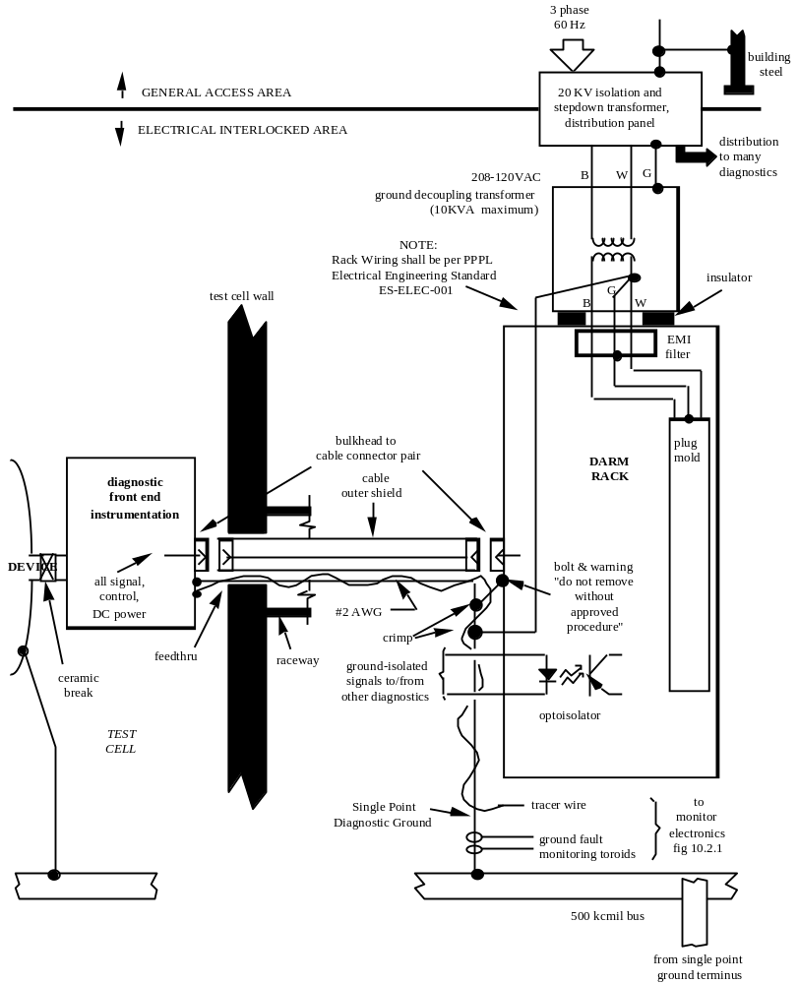

Figure 8.3-1 Typical Grounding and AC Power Distribution for one Diagnostic

8.6 Pulsed Energy Power Systems

All circuits which can operating above 600V and having 50 joules or more of stored energy, shall be interlocked to prevent their operation or testing with personnel in the Test Cell areas, or the area where any equipment is connected to the single-point ground system (see section 7.2). If design calculations are provided which show that, under the worst case conditions, the potential from any instrumentation ground point to a building or facility conducting material within 10 ft. exceeds the allowable IEEE Std. 80 step and touch potential, then the equipment may not be operated with personnel in the area.

Designs shall provide for under the worst case conditions, the potential from any instrumentation ground point to a building or facility conducting material within 10 ft. cannot exceed the allowable IEEE Std. 80 step and touch potential

Note: These restrictions will tend to limit the KVA capacity of the non interlocked power supplies in these circuits.

8.7 Standard AC Power for Noisy or High Power Equipment
Motors shall be powered from standard 60 Hz (rather than diagnostic power) and shall not be grounded to the single point ground tree. This shall also apply to other high power loads that are impractical to power through diagnostic transformer isolated power ground decoupling transformers.

Outside the interlocked area (Sec. 7.0) standard 60 Hz powered equipment shall be grounded in accordance with the NEC and the PPPL Environmental Safety & Health Manual. Within the interlocked area, the power source shall be transformer limited to 10 KVA installed per PPPL Electrical Engineering Standard ES-ELEC-001. When a branch circuit feeder line exceeds 10 KVA or 120 volts, the exterior conducting surface of the circuit including conduit, raceways, grounding conductors, junction boxes and metal enclosures shall be insulated or isolated to prevent a personnel touch potential hazard. Exceptions to this requirement shall require documented calculations that any step touch potential can not exceed that required in IEEE Std. 80.

9.0 Diagnostic Equipment Grounding

9.1 General Guidelines

Provided diagnostic instrumentation systems connected into the high voltage area, e.g. Test Cell or Test Cell Basement, are 100% optic, there is no problem with power or grounding and the 41KV break is provided by default. Diagnostics that will have electrically conducting connections into a high voltage area (e.g. thermocouples and strain gauges) shall be designed with appropriate isolation breaks and be installed into a controlled access area to keep personnel away from them during machine operation.

Where thermocouples are used, for instance the cryostat, nuclear shielding, vacuum vessel, cryopumps, etc., and where there is a choice between junction grounded or ungrounded thermocouples, the ungrounded thermocouples shall be used. But in either case appropriate shielding and high voltage isolation breaks to prevent ground loops shall be used. Emerging state of the art techniques using, for instance, fiber optics to measure temperature are becoming available and should be investigated for NCSX applications.

Superconducting magnet instrumentation must be isolated from both high voltage to ground and from 4 degrees Kelvin to room temperature. Immediate conversion to 100% fiber optic cable is a technical challenge, because neither electronics nor optoelectronics devices work at such low temperature. One option is to have an intermediate station at higher temperature, where the conversion to optical data transmission might be made. Another might be to use high voltage instrumentation feedthroughs and electrical isolation at room temperature.

All non-current carrying diagnostic equipment such as enclosures, racks, and support pedestals, shall be grounded. The nature and use of the equipment shall determine whether the diagnostic single-point ground tree or NEC grounding shall be used.

All inadvertent contact between diagnostic equipment connected to the single point ground and NEC grounding system shall be precluded by providing appropriate insulating barriers.

Each diagnostic system shall be independently grounded to the single-point ground tree. Separate sections of the same diagnostic shall be grounded in a “star” or series pattern originating at the only connection to the single point ground tree (as with the trunk of a tree, its limbs and branches).

Diagnostic equipment grounding conductors shall be routed through the raceway along the signal wires so that magnetic field induced voltage (proportional to the enclosed area) is minimized. The diagnostic grounding conductor shall be insulated with 600 volts AC class insulation to prevent contact to the raceway or any other ground structure. All single point grounding conductors shall be marked or colored green with yellow strips.

9.2 CAMAC, VME/VXI and PLC Instrumentation Grounding

Control and data acquisition systems, such as CAMAC, VME/VXI, or PLC equipment, which connects to a diagnostic shall be located and grounded as part of that diagnostic system. The CAMAC, VME/VXI, or PLC data highway shall be fiber-optic to preserve ground isolation.

9.2.1 Small Signal Shield Grounding

Procedures for shield grounding that are proper for low frequency interference reduction do not work for RF far field or inductively coupled noise. For instance, since shield currents induce inner conductor currents, shields shall be grounded at only a single point to prevent current flow. However, for RF interference reduction, shields shall be grounded at as many points as possible. For coax the shield is the signal return and must be grounded at both ends. Shield ground shall be a branch of the diagnostic ground tree and isolated from the raceway or the building structure. All shielded cable shall have an insulating jacket to prevent shorts from the shield to metallic supporting structures or the raceway system.

Shield grounding for both shielded twisted pair and coaxial cable are shown in Figure 9.2-1. Circuits A through D are grounded source with grounded or ungrounded amplifier. When the signal circuit is grounded at both ends as shown in A & B, the amount of noise reduction possible is limited by the difference in ground potential and the susceptibility of the ground loop to magnetic fields. In circuit A, the shield of the coaxial cable is grounded at both ends to force some ground loop current to flow through the lower impedance shield, rather than the center conductor. In the case of circuit B, the shielded twisted pair is also grounded at both ends to shunt some of the ground-loop current from the signal conductors. The grounded both ends approach (distributed grounds) is not recommended within the Fusion Device stray magnetic field. If additional noise immunity is required, the ground loop must be broken. This can be done by using transformers, optical couplers, or differential amplifier.6 Circuits E & F depict shield connections preferred for floating source grounded or ungrounded amplifier.

Grounding secondary shields of triax or "zip-ex" cable is shown in figure 9.2-1, G. This secondary (outer) shield is grounded at one end and return the other end to ground either with a capacitor to block DC or, if needed, another direct ground connection.

9.2.2 Diagnostic Cable Raceway

All diagnostic control, signal, transducer and detector cabling and grounding conductors shall be installed in the electrical raceways (cable trays or conduit) in accordance with the NEC and PPPL ESHD 5008. Cable routing shall be in accordance with NCSX designated service levels.

All metallic diagnostic raceways shall be isolated from contact with adjacent conducting surfaces by appropriate dielectric barriers, and shall be single point grounded to either the single point grounding tree or other appropriate grounds, and shall not be used as grounding conductors.

The diagnostic raceway system shall be constructed of aluminum or non-metallic material. Aluminum shall be used to the fullest extent practical. Cable trays shall be of the covered type. Non-metallic couplings shall be used to connect conduits to cable trays. The system shall be tested to withstand a potential difference of 300V DC between the raceway and ground with a current leakage of less than 1 milliamp. Testing shall be in accordance with the requirements for testing (or verification) as described in Section 15 of this document.

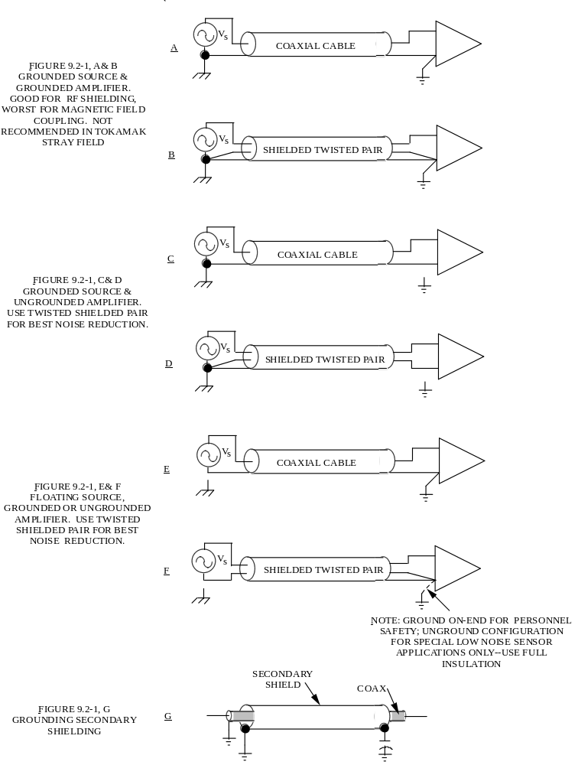

Figure 9.2-1 Grounding of Cable Shields

9.3 Recommended Diagnostics Location

Access to the interlocked areas will be limited because of the ionizing radiation environment and extended run periods. NCSX diagnostics, therefore, shall be pretested intact prior to installation including all interconnecting cabling. Then the equipment shall be installed in assembled major sections that are skid mounted. The cabling would be the terminated set used for testing where feasible.

It is recommended that the diagnostic sections be placed in a straight line radially out from the Fusion Device. The cable under-floor electrical raceway, the labyrinth through the test cell wall and overhead raceway shall be designed to allow easy installation of the terminated cabling.

9.4 Isolation of “Noisy” Portions of Diagnostics

Motors and other high power portions of a diagnostic system shall be grounded and powered in accordance with Sec. 8.7. They shall be electrically isolated by insulation or other means from the diagnostic sections that connect to the single point tree.

9.5 60 Hz AC and DC Power Within the Test Cell

Diagnostics instrumentation and supporting equipment in the test cell shall be supplied with low ripple DC power from power supplies mounted outside the test cell. The use of AC power cabled into the test cell shall be minimized, and utilized only where essential.

9.6 Single Point Ground Labeling

All single point grounded equipment and structures shall be identified with a tag and warning labels (ES-ELECT-001), see figure 9.6-1, and a label which indicates the wire number of the single point ground.
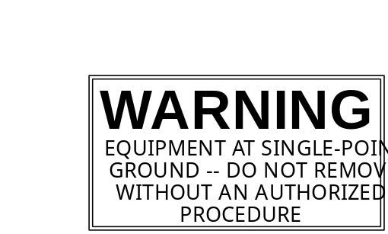

Figure 9.6-1 Single Point Ground Warning Label.

9.7 Separation Between Signal and 60 Hz AC or DC Power Cabling

60 Hz AC and DC power cables shall not be placed in the same raceway as signal level (24 volts or less) cables. The distance between 60 Hz power cables and signal cable trays when they run parallel shall be greater than 15 inches.

10.0 Ground Fault Monitoring

10.1 Monitored Conductors

All conductors which connect to the “Main” ground shall be monitored. In addition, all systems that are wholly or partially within the Test Cell and which connect to a branch of the single point ground tree shall be monitored at their connection location. Figure 8.3-1 shows a typical system with portions inside and outside the test cell.

10.2 Ground Monitoring Method

Every monitored ground shall have automatic verification of the integrity of the connection to the ground tree and also shall verify that there is no secondary connection to the ground tree or any other ground. Provisions for monitoring and display of ground currents and resistances shall be included in the design. Testing of the system shall be in accordance with the requirements for testing (or verification) as described in Section 15 of this document.

Ground fault monitoring techniques have evolved over the years since the system designed for D-SITE. Recent state of the art designs use Programmable Logic Controllers to multiplex, monitor and display resistance readings in quasi real time in the control room, such as the Alcator C-mod7 system. Other designs such as JET and JT-60 ground fault systems shall be reviewed by NCSX for latest designs. The D-SITE ground fault monitor8,9,10 is shown for reference in figure 10.2-1. The ground conductors run through toroids which drive small currents through the monitored grounds only when there is an unwanted short to another ground forming a closed loop. Similar toroids acting as receivers detect loop currents.

Ground connection integrity shall be checked by using a No. 12 AWG tracer wire connecting each of the ends of the monitored system to the ground monitoring equipment. This tracer wire shall spiral around the fault current sized conductor to keep enclosed area minimized but shall not run through the transmitter and receiver toroids. Periodically the tracer is shorted to ground by the monitor to detect a loop fault only if the prime ground connection is proper.

A diagnostic or other system cabling may be distributed to remote locations in a “star” pattern from a central location. The connection to the single point ground tree shall be the central site and ground monitor toroids placed at that connection. Since that ground as well as other cabling “stars-out" from the center, the NCSX ground monitor design shall evaluate the feasibility of as many tracer wires as end locations being installed as a means to insure ground connection integrity to all remote equipment.

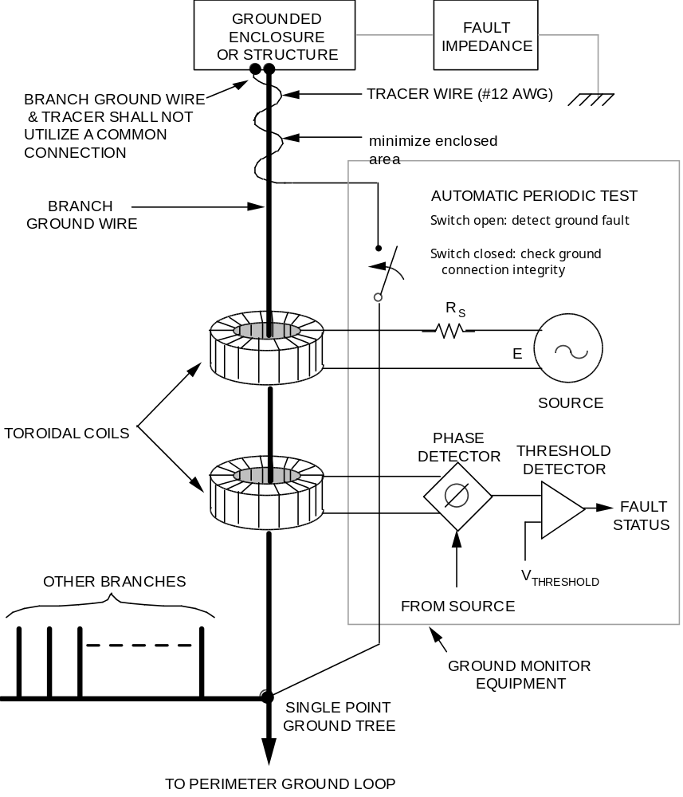

Figure 10.2-1 Ground Fault Monitoring Concept

11.0 60 Hz Power Equipment

This section applies to Energy Conversion equipment, RF Heating equipment Grounding, and 60 Hz power equipment located outside of the electrical interlocked exclusion area.

11.1 Cable Trays
Existing D-SITE nomenclature is used in the following paragraphs.

• All 15kV (S), 15kV (D), 5kV (Q), 480V (P), 208/120V (L), and 0-10V/40-20 ma signal (N) cable trays shall be grounded by installing a bare #500 Kcmil copper ground cable in each tray. Each cable tray section shall be bonded to the ground cable with a mechanical clamp.

• The #500 kcmil ground cable in the 15kV (D), 5kV (Q) and 15kV (S) trays shall be placed in a convenient location within the tray.

• The #500 kcmil ground cable carried in the trays listed in Section 11.2 shall be connected to the nearest dedicated facility ground grid connections at all power sources and at sufficient intervals along the run so as to limit any step touch potential to a safe value under all conditions including faults.

• All control (L) cable trays shall be bonded at intervals not exceeding 50 ft. Connection to the facility ground grid shall be accomplished by connections to the #500 kcmil ground cable in the N trays via 4/0 AWG cable.

11.2 Equipment Grounding

11.2.1 All Electrical Power Equipment 100 KVA and Above

Equipment enclosures shall have a minimum of two separate bare copper cable taps to the #500 kcmil grounding cable carried in the cable trays. These taps shall be fastened at opposite ends of the equipment ground bus and to points on the facility ground grid that will yield two different paths to ground. The equipment grounding cables shall be routed together in close proximity to the power conductors such that every power circuit shall have a ground cable associated with it back to the source.

11.2.2 Other Equipment Rated above 600 Volts.

Equipment energized with more than 600 V shall have two separate taps to the facility ground grid. These taps shall be fastened at opposite ends of the equipment and to points on the grounding network that will yield two different paths to ground via embedded ground plate.

For equipment located within 10 feet of building steel columns used for lightning ground paths, one ground shall be made directly to the closest building steel and the other required ground shall be made via the facility ground grid.

11.2.3 Equipment Rated 600 Volts or less

Equipment (less than 100 KVA) energized with 600 V or less shall require only standard NEC ground provisions.

11.3 Equipment Ground Cable Sizes

The equipment grounding cable sizes must satisfy or exceed the minimum size recommended by Table 250-95 of the NEC referenced in the applicable documents section.

11.4 Equipment Instrumentation and Control

Equipment will be provided (as applicable) with an insulated copper instrument ground bus. All equipment, internal instrumentation and control signal ground will be connected to this bus. The instrument enclosure and ground bus will be connected by means of a 600 V insulated green colored 4/0 copper cable to the ground in the cable tray. Installation personnel will be required to make this connection before the equipment is commissioned for operation.

11.5 Power Cable Shields

The tape/wire shields in medium voltage 3 phase AC power cables shall be grounded at both the transformer and power supply ends, using green covering or bare copper conductors.

11.6 Non-electrical Equipment

11.6.1 General

Non-electrical equipment shall be grounded to the closest facility ground grid with a No. 2 AWG copper cable if both of the following conditions exist:

•A metal surface is present, which can become energized.

• The equipment is subject to personnel contact.

11.6.2 Fences

Fences which enclose electrical equipment shall be grounded using a No. 4/0 AWG copper cable as a minimum size. When segmented, each fence section shall be grounded to the facility ground grid or to adjacent building steel.

11.6.3 Metal Enclosures

Metal cabinets or other structures which enclose electrical equipment and which are not welded or bolted to the equipment ground bus shall be grounded to the nearest facility ground grid or to adjacent building steel, using suitably sized copper conductors as outlined by Paragraph 11.3.

11.7 Grounding Drawings

These shall minimally depict the:

(1) Locations and extent of the facility ground grid.
(2) Outlines of all significant electrical and non electrical equipment to be grounded.
(3) Connection of the equipment to be grounded to the facility ground grid.
(4) Size of the grounding conductor.

12.0 Electromagnetic Interference (EMI) Considerations for Fields

12.1 Conductors Exiting the Fusion Device

Conductors (such as thermocouple cabling) that may couple to the internal Fusion Device RF heating field shall be filtered to attenuate conducted RF energy by 150 dB. Shielding shall be used to prevent RF from radiating from the conductor between its exit from the Fusion Device and the filter.

12.2 Fusion Device Ports Open to RF Heating Fields

RF radiation from ports shall be attenuated according to the limits specified by the PPPL ESHD 5008, Section 4, RF Field Safety, compared to fields at the internal Fusion Device wall. Attenuation may be accomplished by port throat geometry (waveguide beyond cutoff) and/or shielding.

12.3 Diagnostics Equipment RF Tight Enclosures, Racks, and Cabling

The AC power supplied to Diagnostic racks shall be EMI filtered.

Signal level connections between different diagnostics shall be fiber optic when practical. If conductors are used, they shall be ground decoupled to preserve single point grounding.

13.0 Zone Configuration for Services

Refer to Fig. 13-1. Various categories of services common to most equipment shall be distributed throughout the NCSX building within designated zones. The intent is to minimize awkward crossovers and specially designed installation by using standardized construction with short tap offs to end locations.

Note: At the time of this revision the NCSX facility configuration is not advanced enough to allow more detailed specification of the distribution of services in zones.

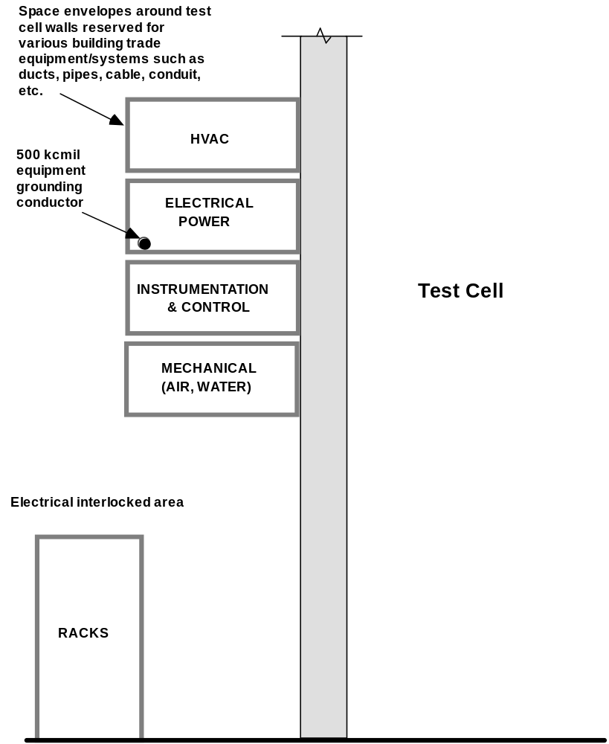

Figure 13-1 Zone Configuration for Services

14.0 Loop Exclusion Zone

14.1 Purpose

The NCSX stray magnetic field can induce currents to flow in closed low impedance loops. These eddy currents can disturb the NCSX confinement and controls. A zone surrounding NCSX is defined as a means to control closed loops in structural steel, water pipe, and electrical conductors.

14.2 Structural Loop Exclusion Zone

The loop exclusion zone is defined by a cylinder with a 35 foot radius and 70 feet high centered around the Fusion Device. All piping runs, hangers, and supporting devices shall be designed so as not to form any loops around or petals into the loop exclusion zone. Existing floor and reinforcement steel within that zone has insulated joints to prevent ground loops.

All hangers, support devices, conduits, piping, duct work enclosures or any other metallic components located within the loop exclusion zone shall be single point grounded and otherwise insulated from all other metallic components or conductors.

All insulation pieces shall be staked, trapped, bolted or glued in place. In all cases a 1/2” protrusion tracking path will be provided. Insulation to be used shall be G-11, glastic, or nylon bolts, washers, etc. Mylar is prohibited for the insulating members, but can be used in component construction. Wherever a point or line contact area is to be insulated a minimum thickness of 1/8” G-11 insulation shall be used. Wherever this load exceeds 2000 lbs. hanger load, 1/4” G-11 insulation shall be used. Where there is an area load (i.e. clevis clamp, conduit clamp, etc.) use 1/16” G-11 sheet if possible, otherwise 2-15 mil. G-11 sheets shall be used. All metallic diagnostic cable trays shall have 1/8” or 1/4” G-11 or glastic insulation. All other cable trays shall have a minimum thickness of 1/16” G-11 or glastic insulation.

Wherever the above methods are unable to be utilized, insulated sleeves and washers or threaded G-11 rods may be used.

Concrete shall be grounded by sections with insulation between sections to avoid loops. The sole grounding conductors shall be from the Fusion Device structure single point ground branch location.

14.3 Loop Break Zone

An imaginary vertical plane shall be established extending radially outward from the center of the Fusion Device bisecting the personnel access labyrinth and continuing to the building wall. This plane shall be called the loop break plane and a zone +8 degrees from the plane shall be the loop break zone, see figure 14-1. This zone shall be established to ensure that no metallic loops encircle the Fusion Device (excluding the Cryostat) and also to provide a narrow personnel safe corridor for hot access.
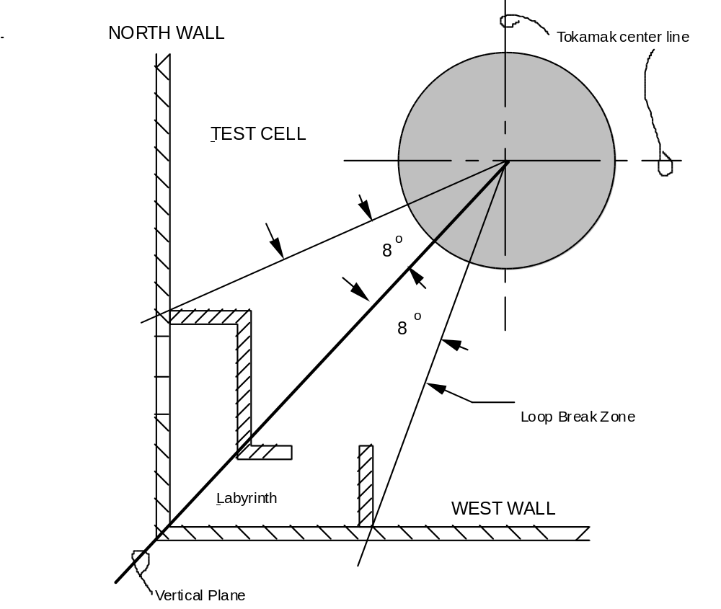
Figure 14-1 Loop Break Zone

15.0 Testing and Independent Verification

Required Quality Control testing or independent verification shall be done by qualified individuals not directly involved in the work to be tested or verified. Where testing or independent verification are required by this specification, details shall be specified in the installation procedure. The procedure must either address or invoke another document that addresses:
• personnel qualification,
• acceptable methods,
• instruments and their calibration requirements,
• acceptance criteria,
• test/verification conditions, and
• documentation of results.

16.0 References

1) D-SITE Diagnostics AC Power and Grounding Specification, D-SITE-9A2-010
2) CIT Grounding for Power, Equipment, and Personnel Safety Specification, J87- 0319-P-01
3) D-SITE Grounding System, IEEE paper, F. Faulkner, W. Moo, C. Neumeyer Ebasco Services Inc., H. Zuvers PPPL.
4) D-SITE "Ground Hunter's Guide" training document.
5) D-SITE Vacuum Vessel Hi-pot Test and Ground Fault Location Systems Operation Procedure OP-VV-30.
6) Noise Reduction Techniques in Electronic Systems, Henry W. Ott
7) Ground Fault Monitoring In Alcator C-mod, David Flanary, MIT, 15th IEEE Symposium on Fusion Engineering.
8) CIT Grounding for Power, Equipment, and Personnel Safety, M. Norris, F. Beane, J. Gulizio, J.G. Murray, M. Viola, K.M. Young, PPPL, 12th IEEE Symposium on Fusion Engineering.
9) Operation and Maintenance of the D-SITE Grounding System, M. Viola, D. Long, PPPL, 12th IEEE Symposium on Fusion Engineering.
10) D-SITE Grounding Scheme and Ground Monitor System, M. Viola, PPPL, 10th IEEE Symposium on Fusion Engineering.
11) D-SITE "Three Foot Rule," ESHD memo 91180-S-ELECT, Ellis Simon, May 15 1991
12) NCSX DC Isolation e-mail memo, C. Neumeyer to W. Rauch 6/9/94, cc: S. Ramakrishnan, G. Bronner, J. Bialek
13) NCSX Field Information and Magnetics Handbook, J. Bialek, A.W. Brooks
94-940729 PPPL/ ABrooks-00.

ADDITIONAL NOTES ON INTERPRETATION OF STANDARDS

Interpretation request
As mentioned in 12.1 of IEEE Std 80-1986, the ground resistance in case of distribution substation shall be within limit of 5 ohm, where as for transmission substation the same shall be within limit of 1 ohm. Please provide information whether 33kV/11kV substation falls under the category of distribution substation with relevant IEEE code of standard and with clause number.

Interpretation for IEEE Std 80-1986
Clause: 14.1 (IEEE Std 80-2000)
NOTE: IEEE Std 80-1986 has been revised as IEEE Std 80-2000. Subclause 12.1 of IEEE Std 80-1986 has been renumbered as 14.1 in the more current IEEE Std 80-2000.
It is really not essential to determine if the substation is a distribution or transmission substation to design ground grid. IEEE Std 80-2000, IEEE Guide for Safety in AC Substation Grounding is based on the safety criteria of acceptable touch and step potentials. Substations with low resistances are not an indication of safe design, nor is a substation with a high resistance necessarily an indication of an unsafe design. The resistivity of the soil, the magnitude of the available fault current, and the physical layout of the ground grid itself determines a safe design. The statement referring to the ground resistance being usually about 1 ohm or less for a transmission substation and 1 to 5 ohms for a distribution substation came from experience. It was based on typical resistance values for transmission and distribution substations throughout the United States in the 1950s, mainly determined by the physical size of the substation area. These values of resistance provided an acceptable ground for relay and fuse protection systems. Also, since these resistance values times the available fault current for various voltage levels did not exceed the flashover capabilities of the substation equipment. These values were not set specifically for substation safety, although it is obvious that the lower resistance may reduce the Ground Potential Rise (GPR). Before the original IEEE-80, the resistance of the ground grid was the primary concern of the design engineer. Again, that was to assure the system was effectively grounded.

